INSTALLATION ECLIPSE MAVEN AND DELL LAPTOP ON 20-09-2022

1.Dell laptop -All drive space

2.Mcaffee

3.Eclipse (Java)

4.Maven

5.Cucumber

6.SQL

7.Git Clone

8.SQL Installation

9.Error facing while setup maven

1.Windows 10 –Folder size

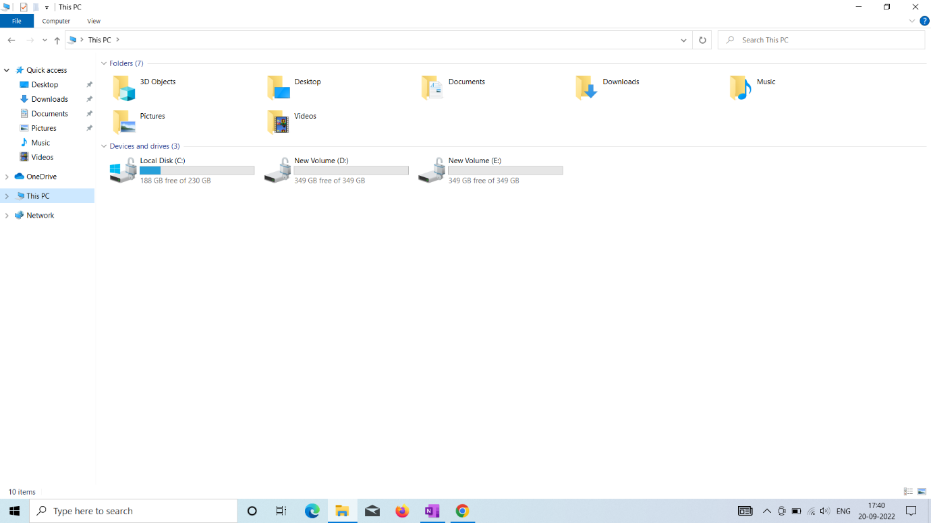

2.Mcafee serial no:

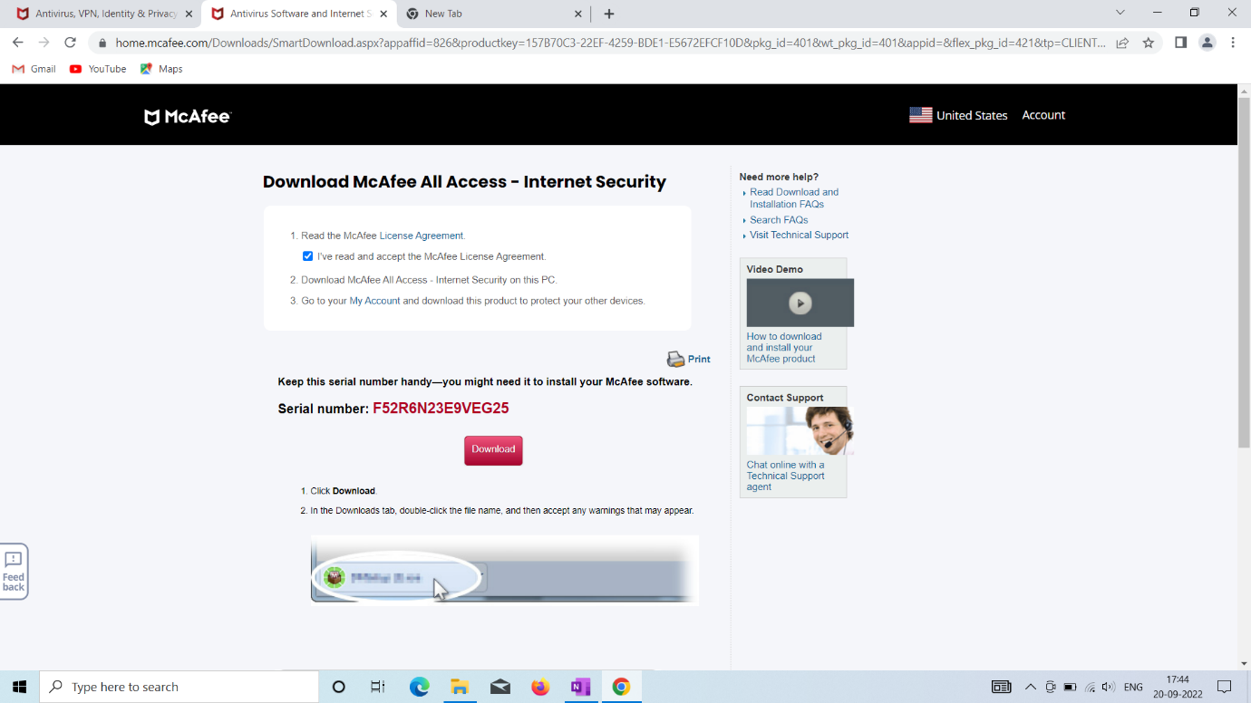



JAVA JDK 1.8 DOWNLOAD (NOT JRE)

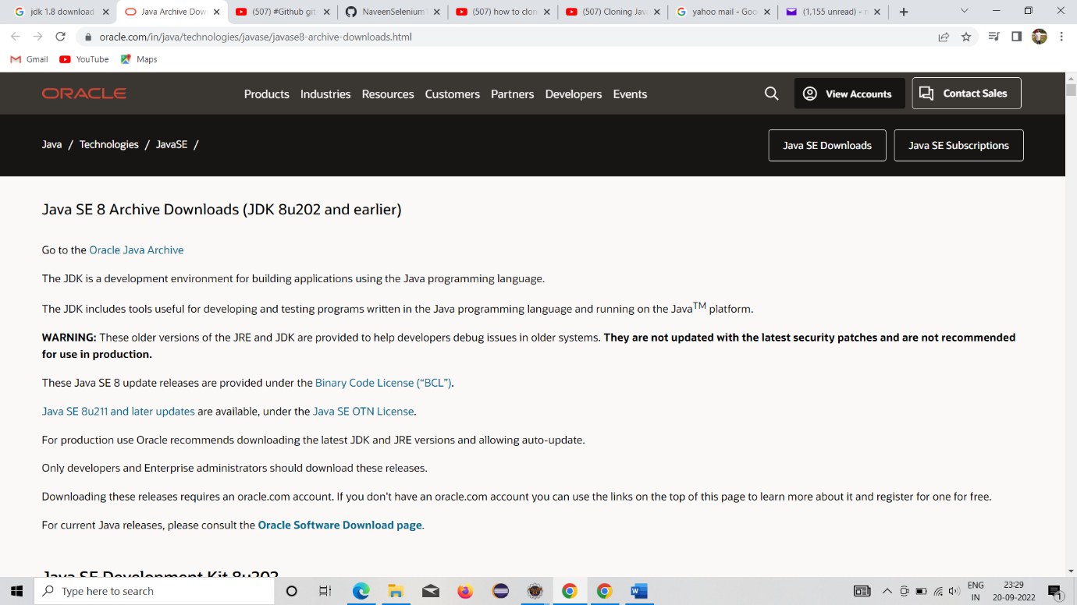



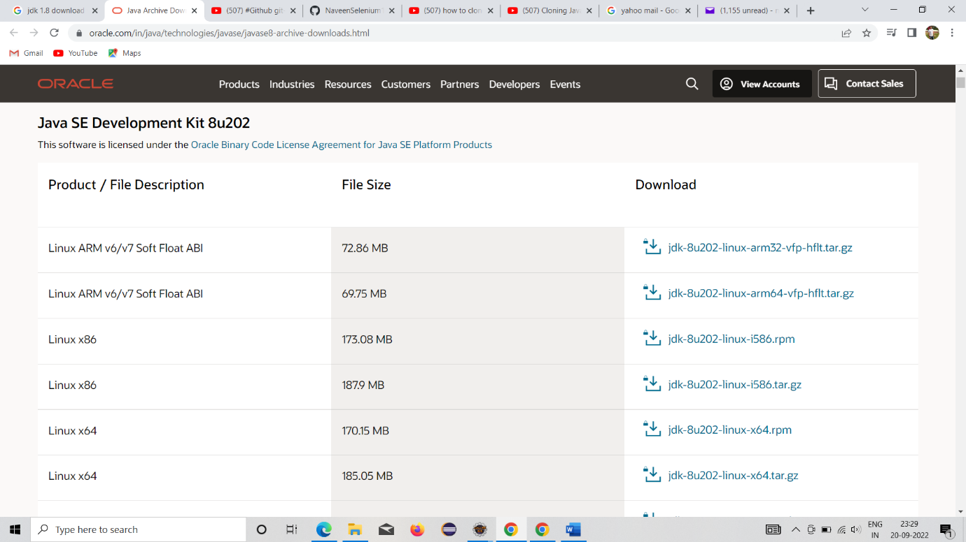



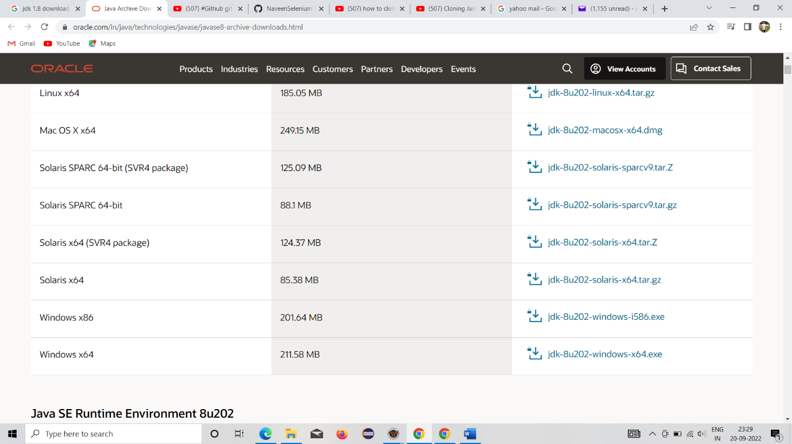



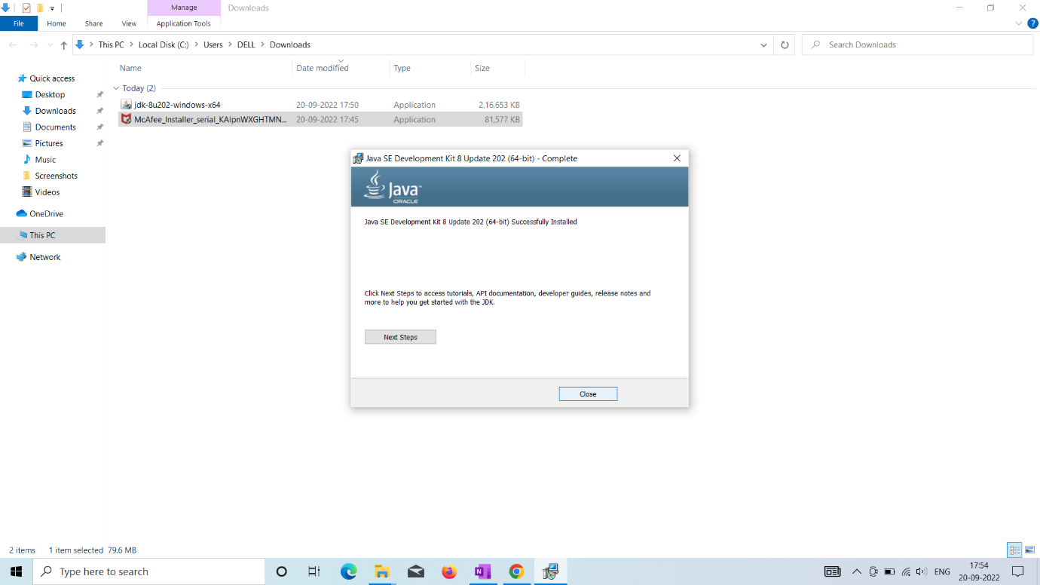



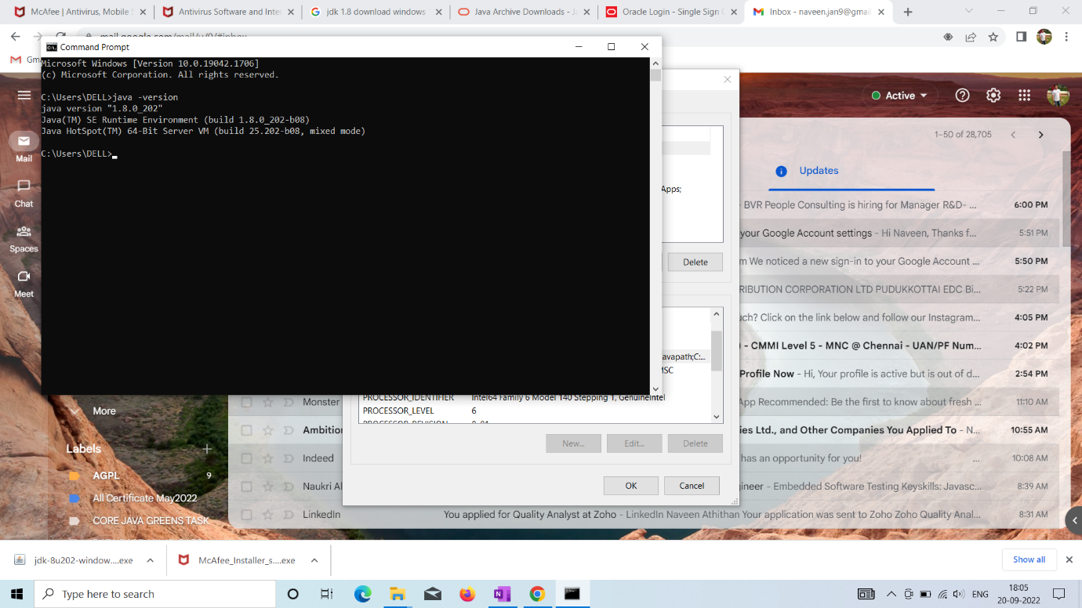



Enviromental Variable setup:

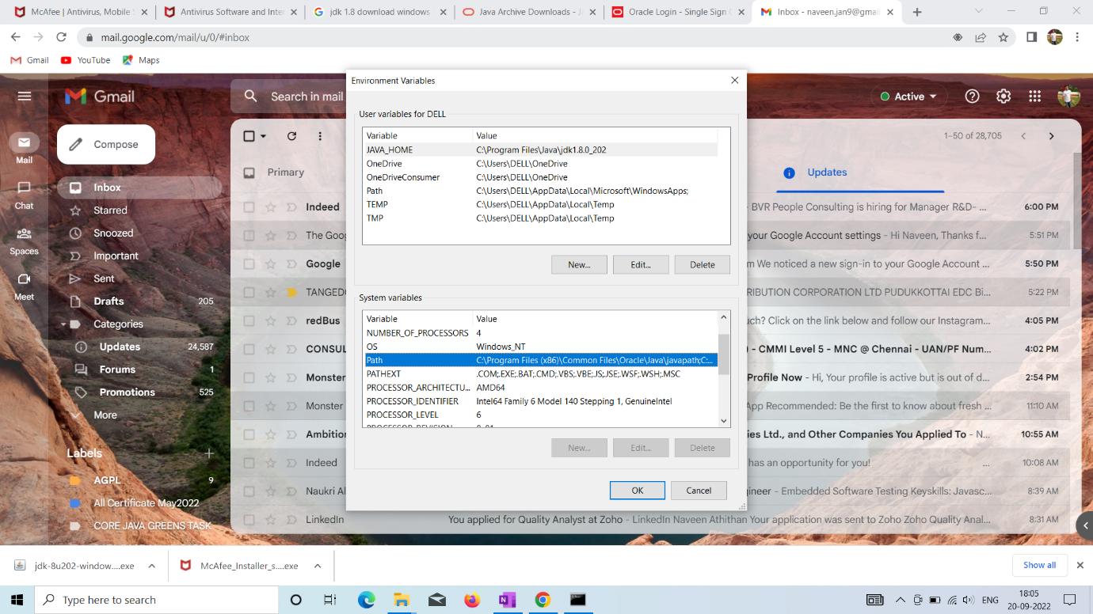



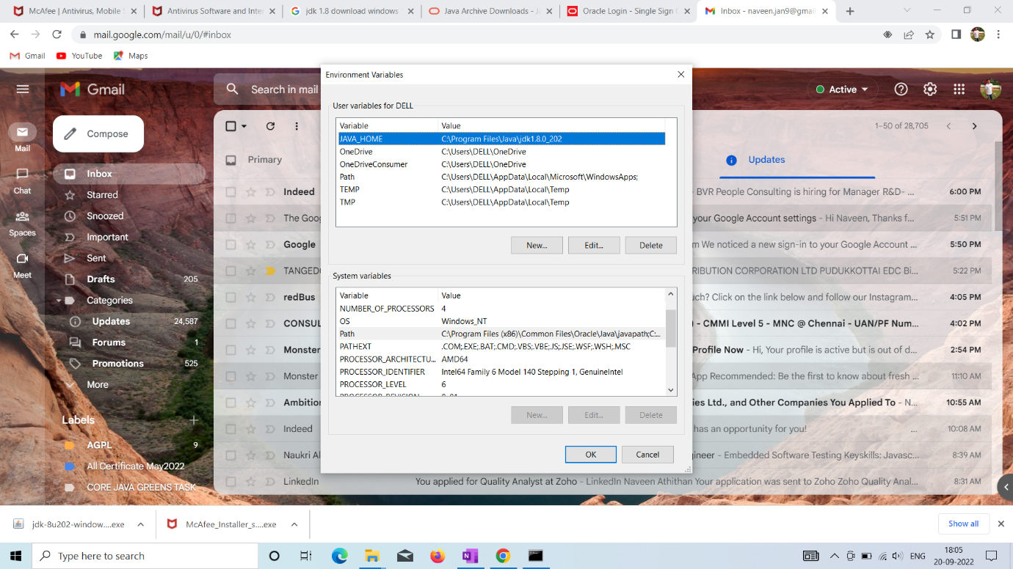

Eclipse oxygen 3A download

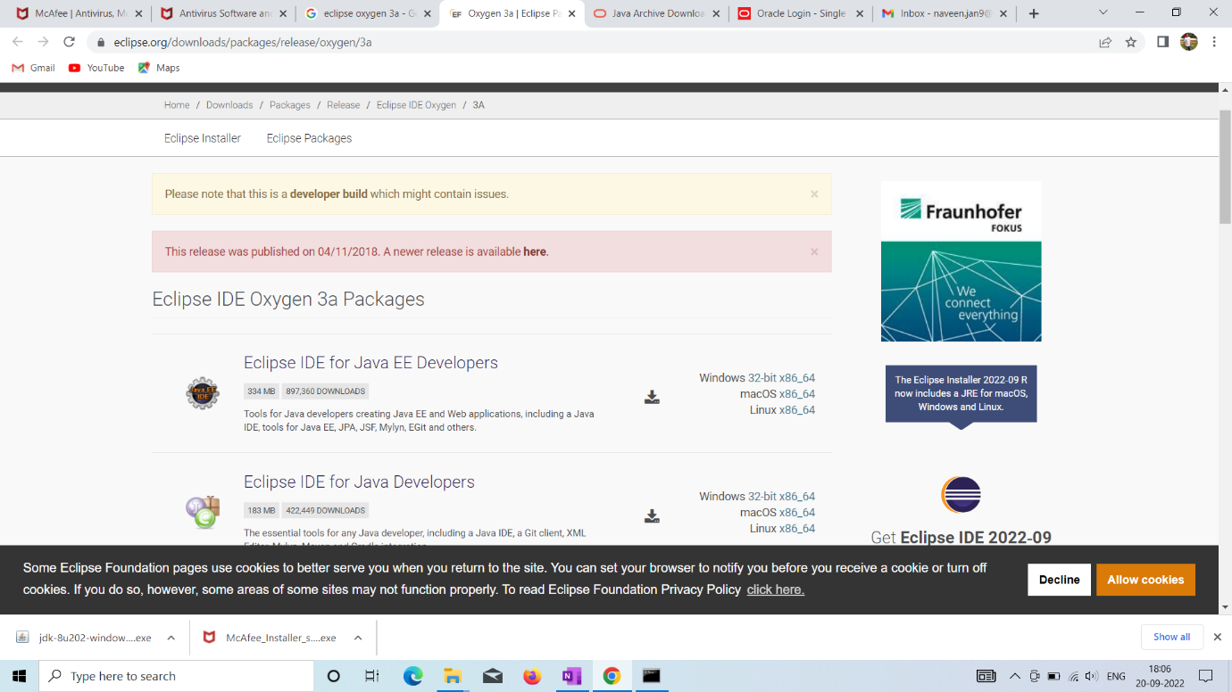



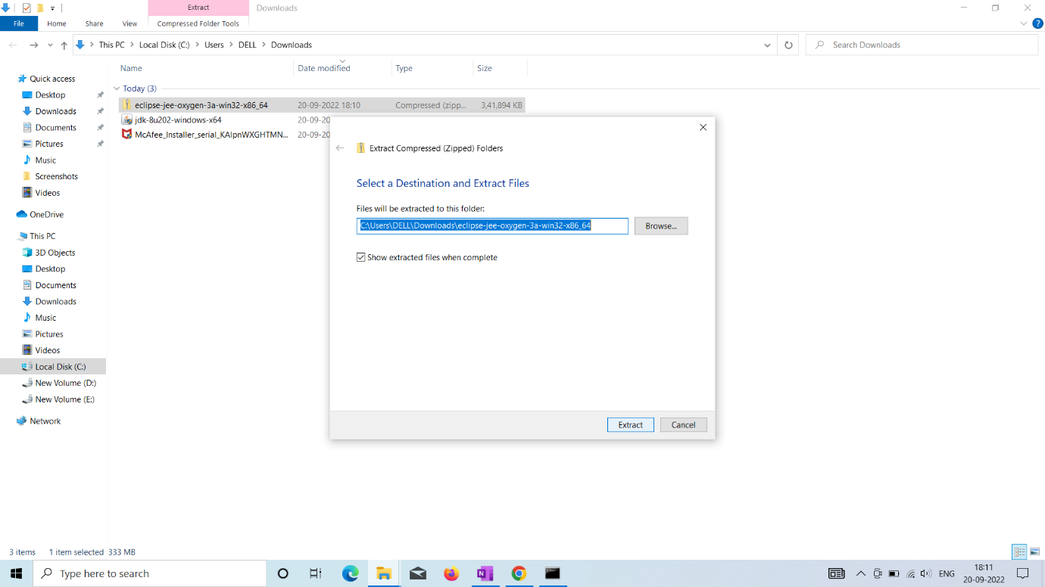



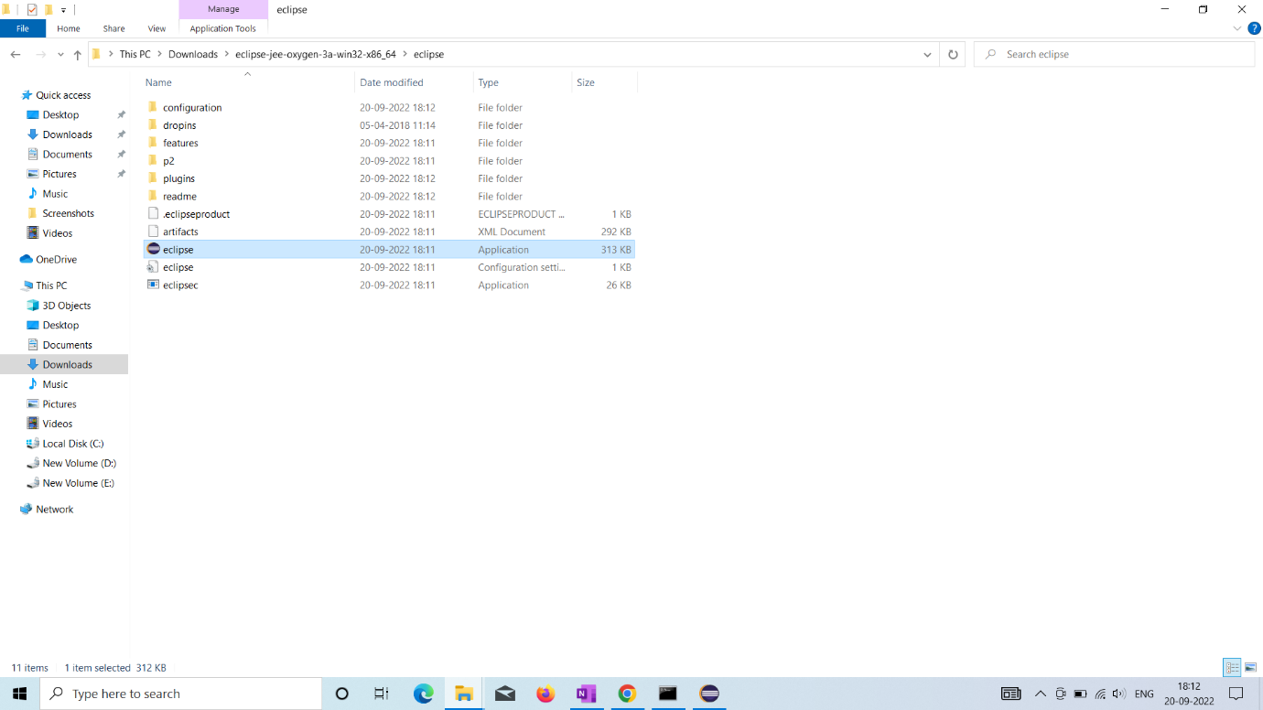



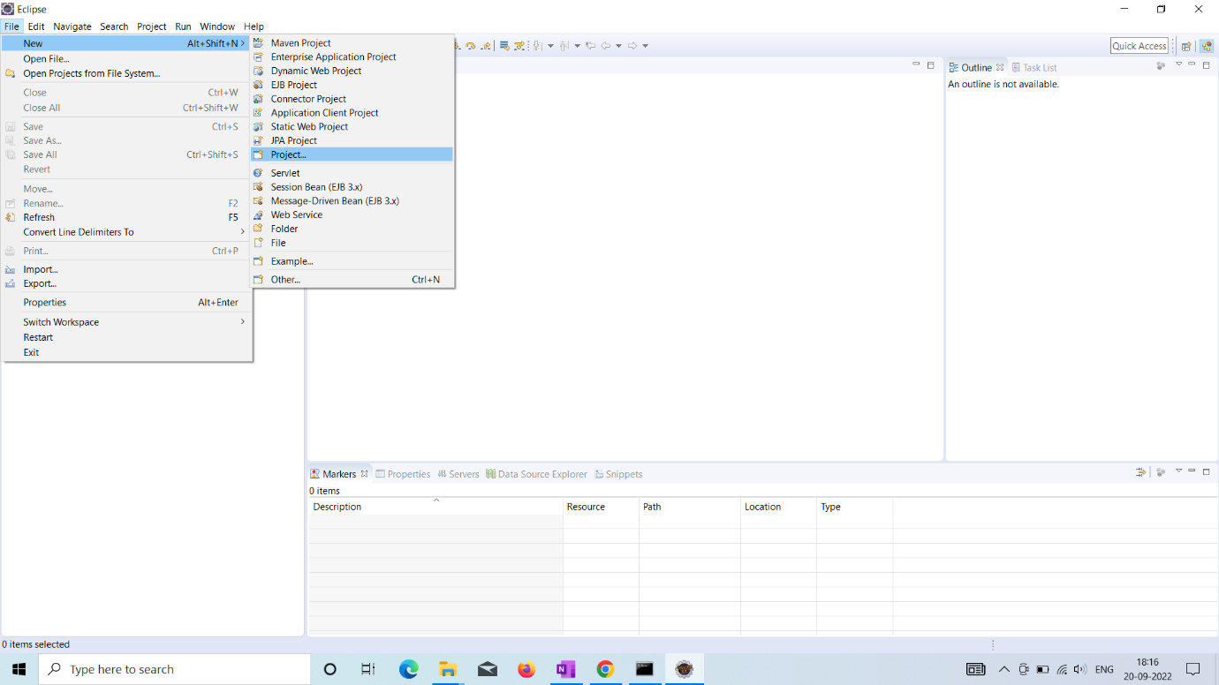

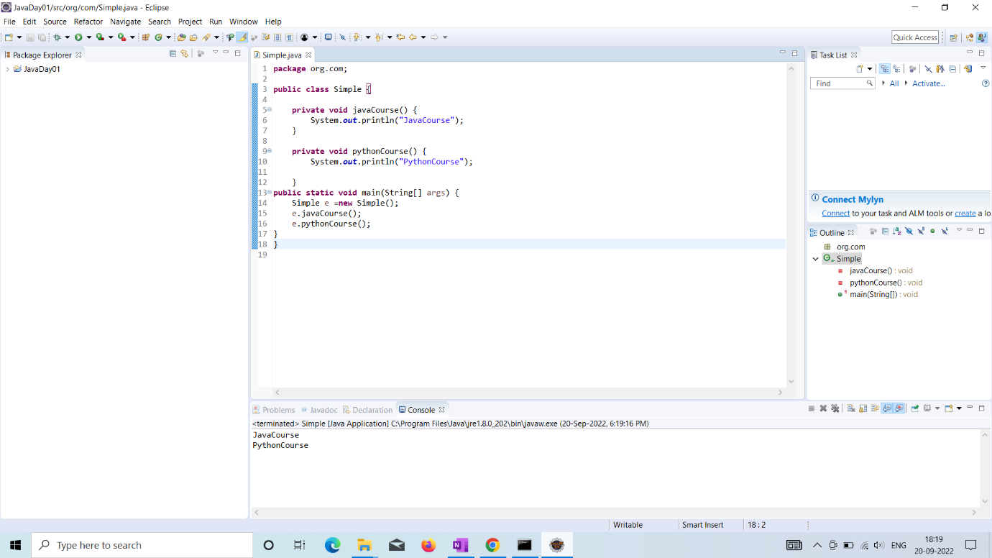

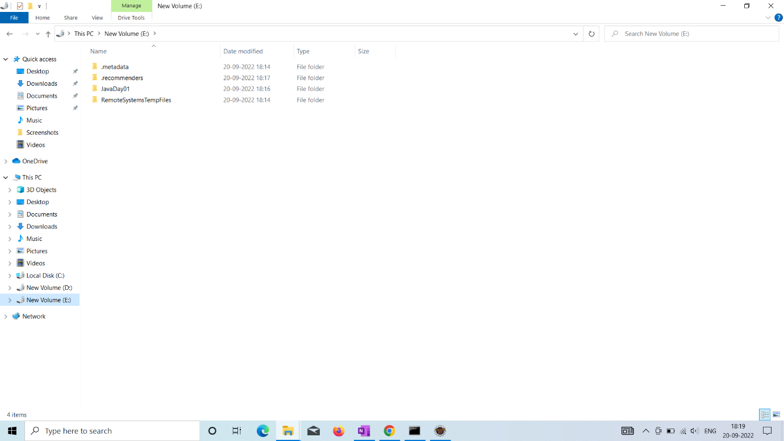

Selenium browser setup:

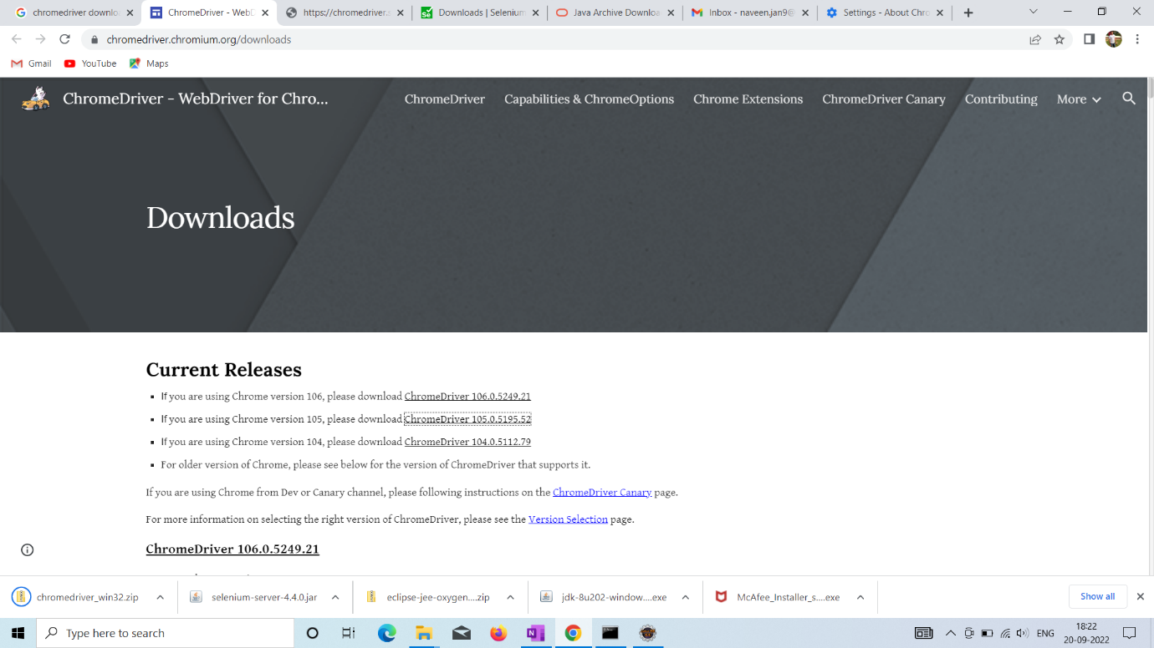



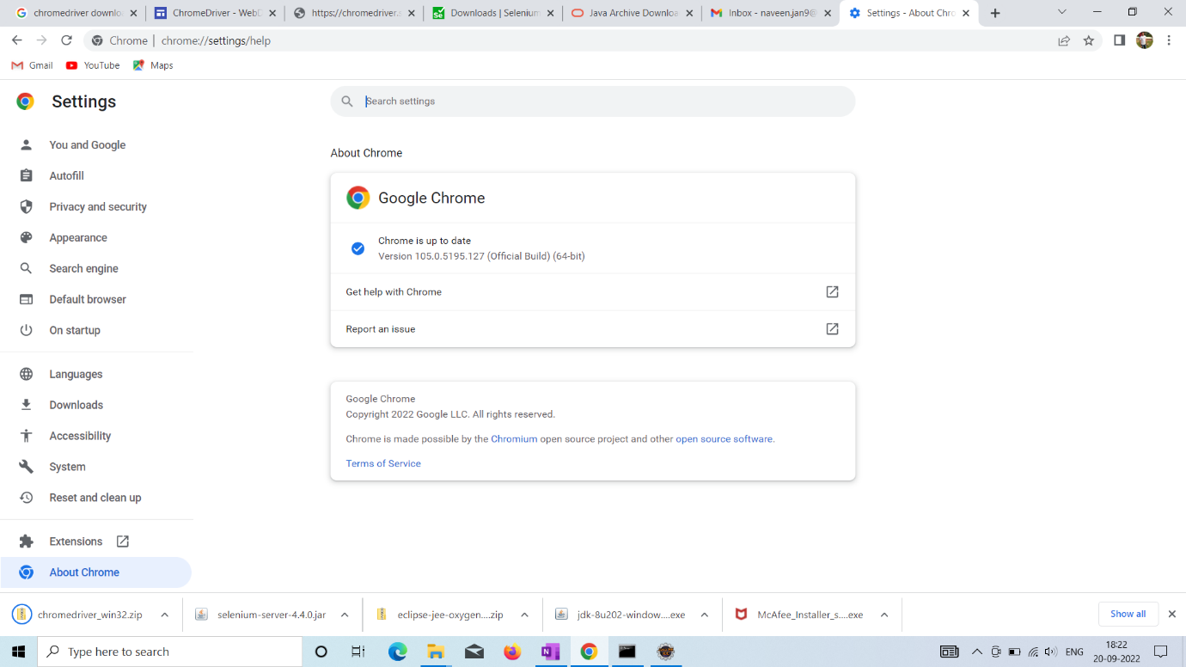



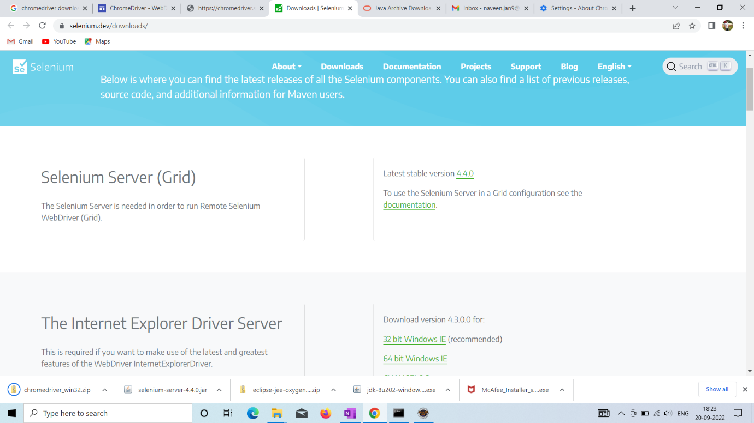



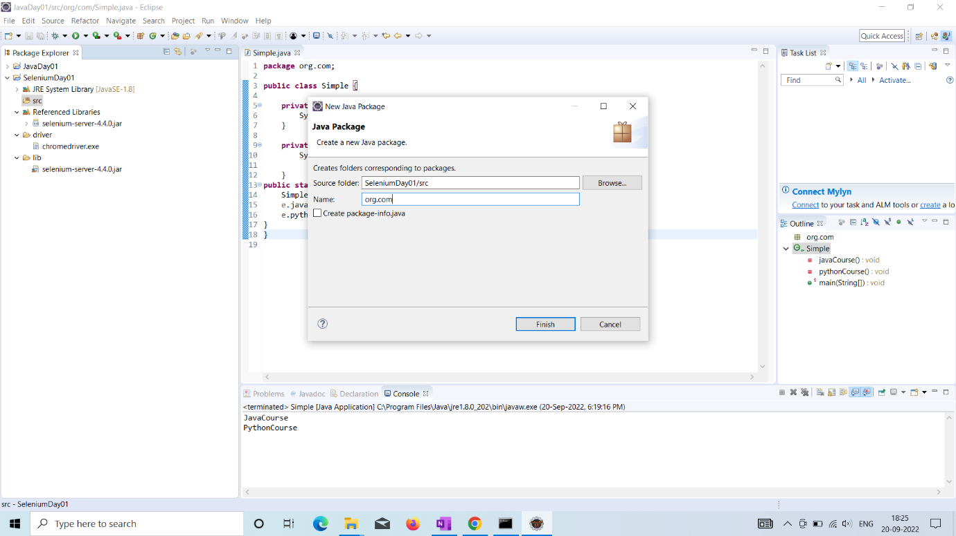

Maven installation

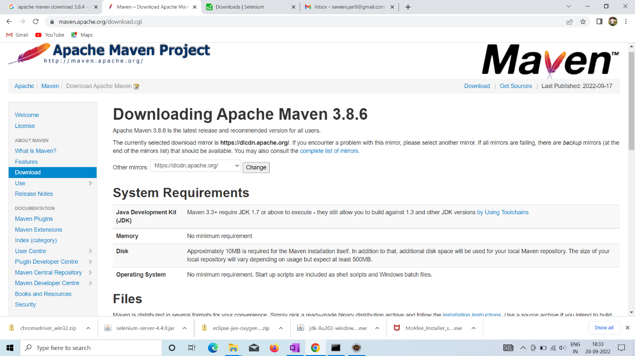



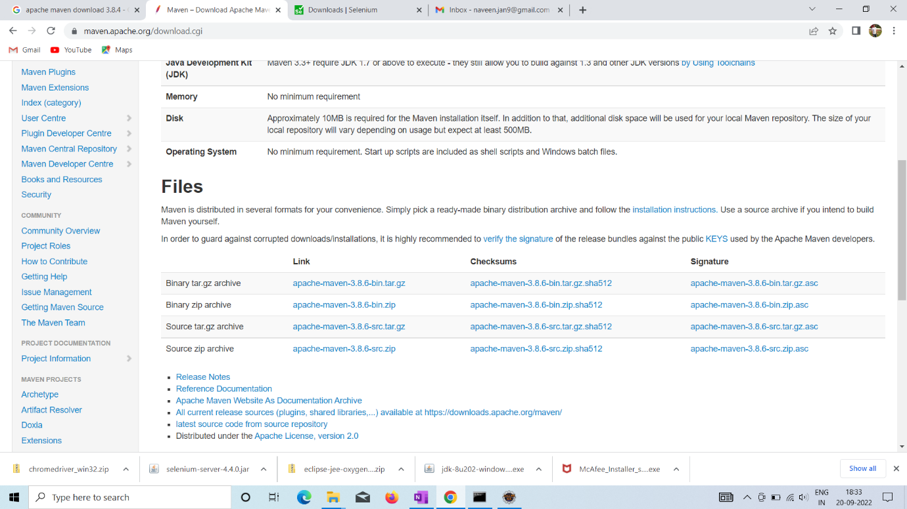



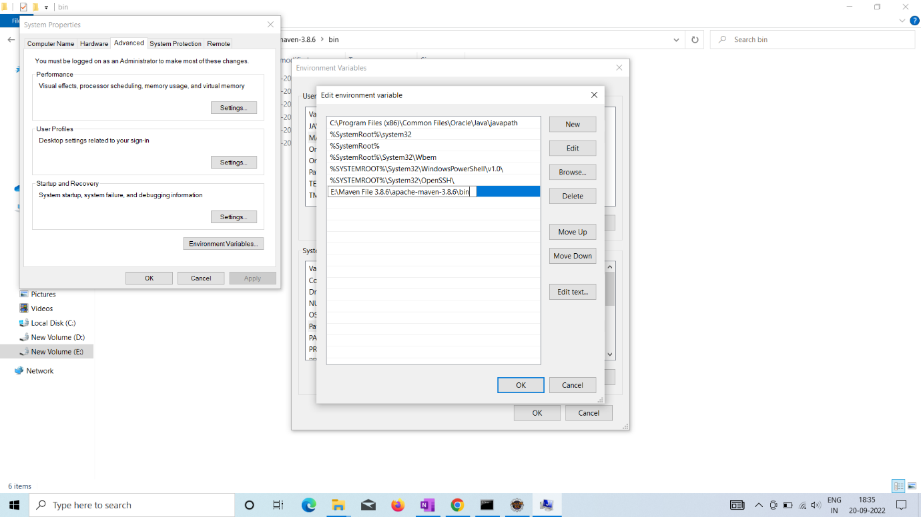



Click the path ,edit button-new -java and maven (inside bin setup)

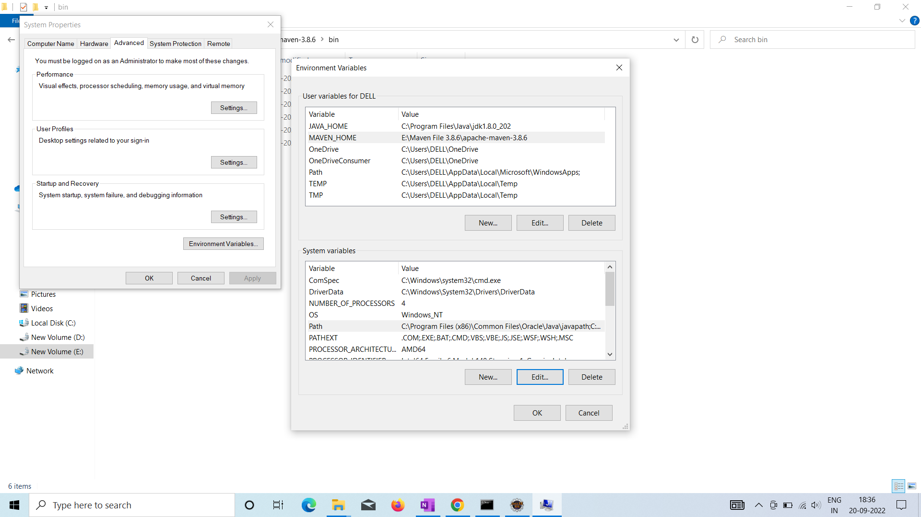





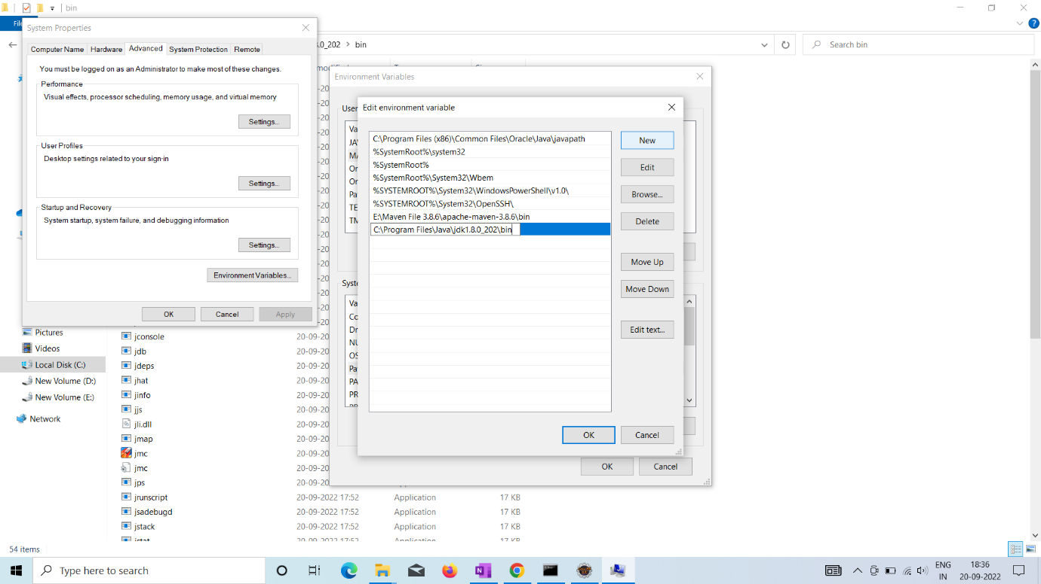



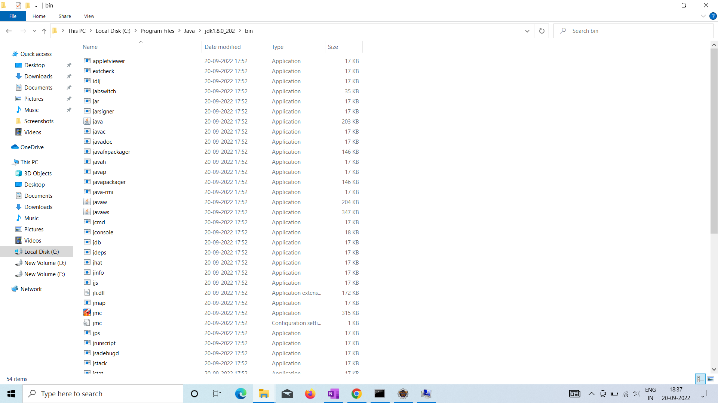



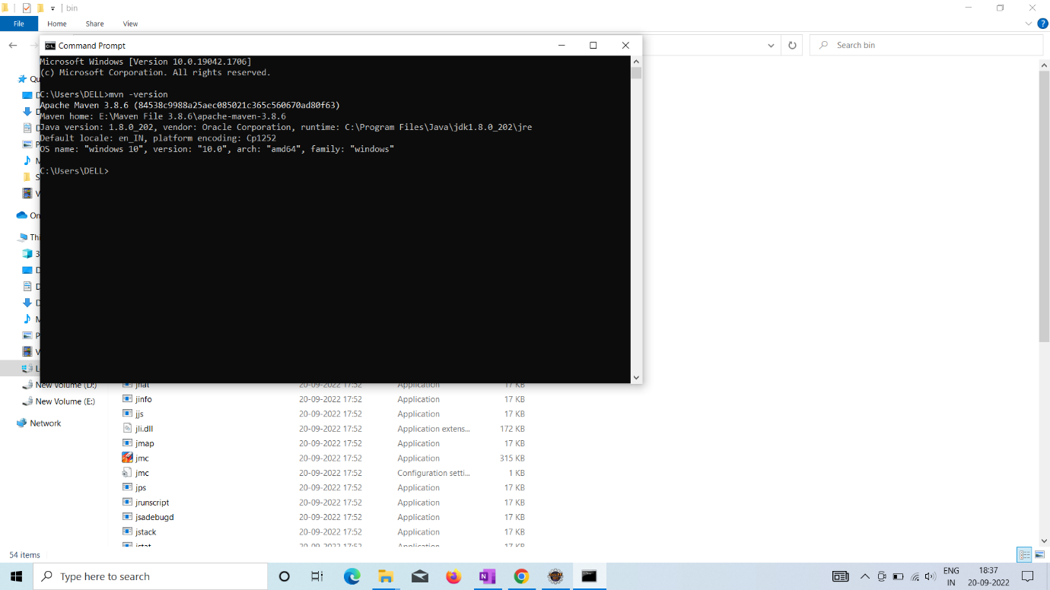



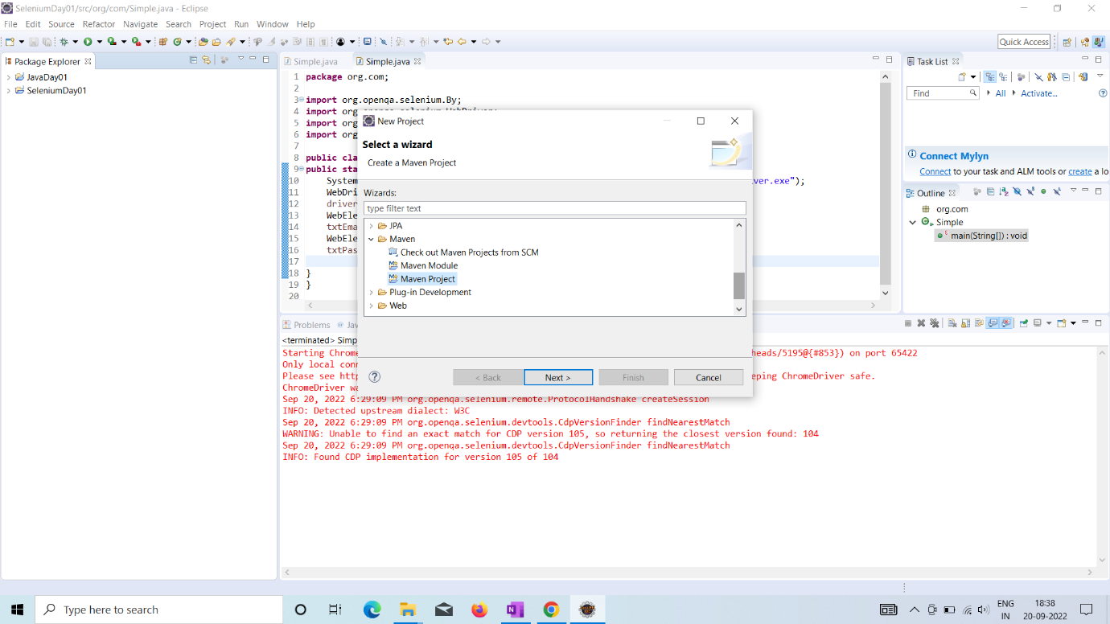

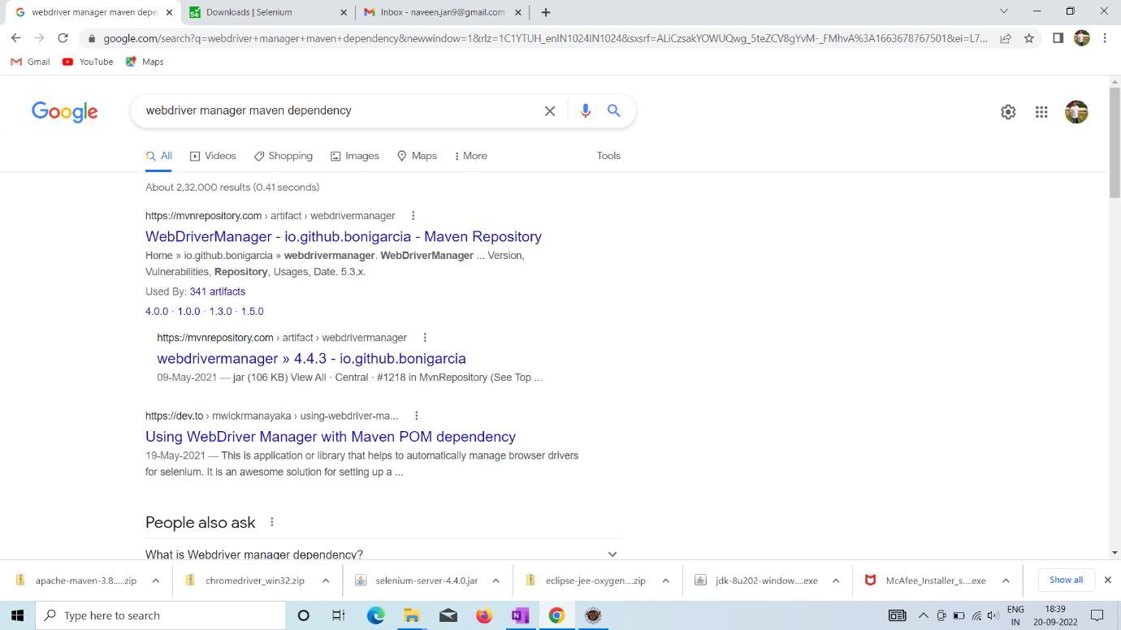

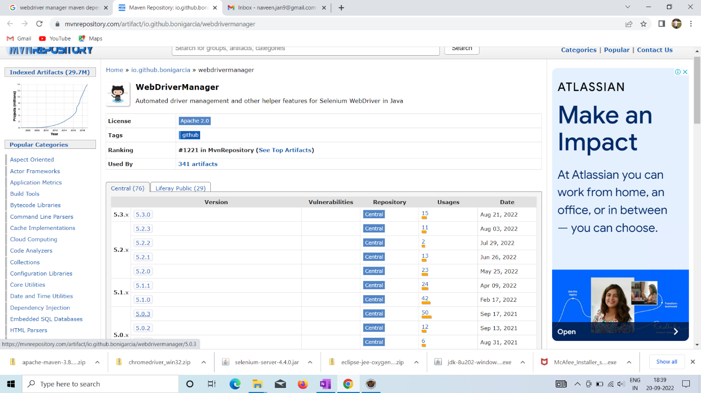



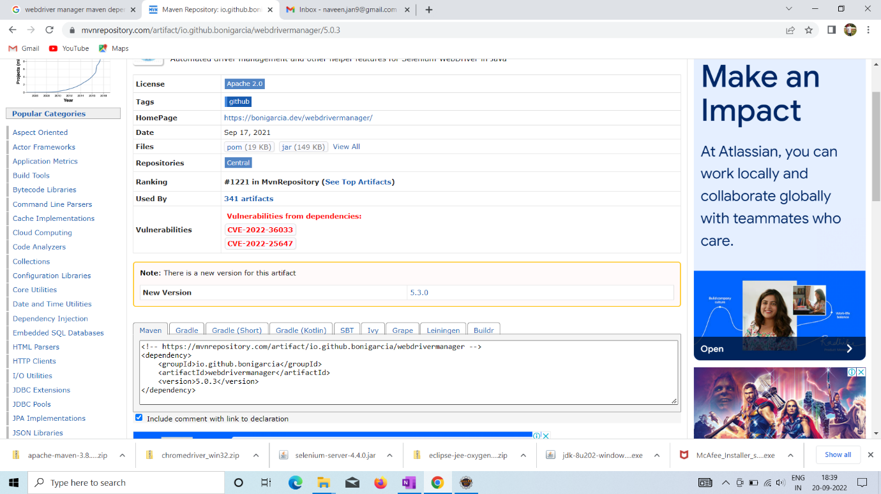



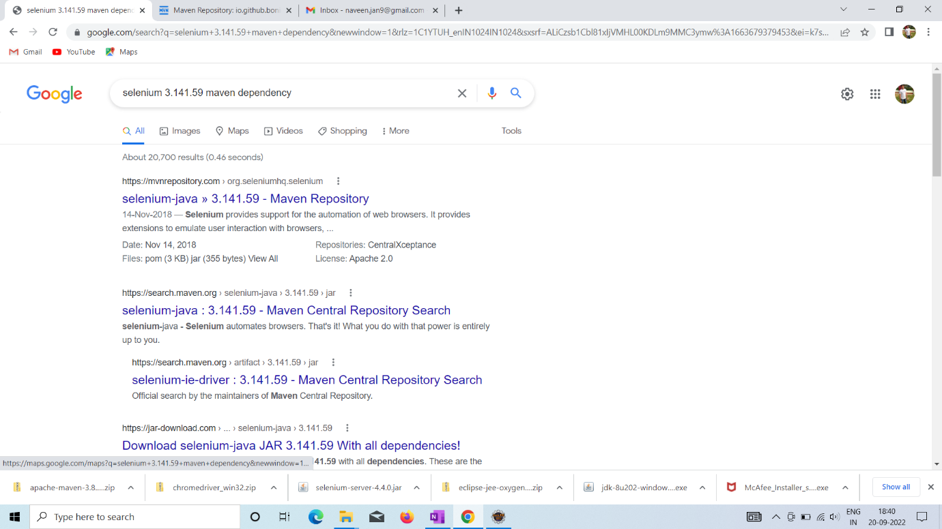

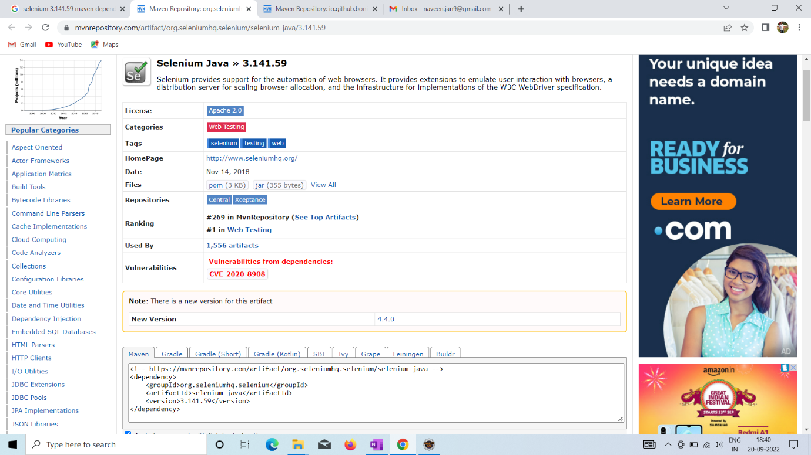



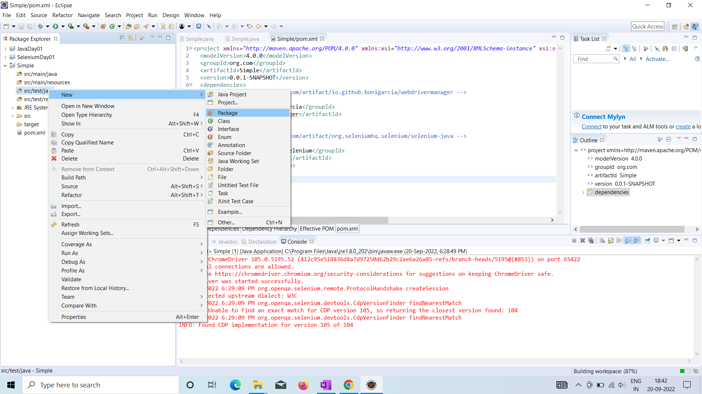

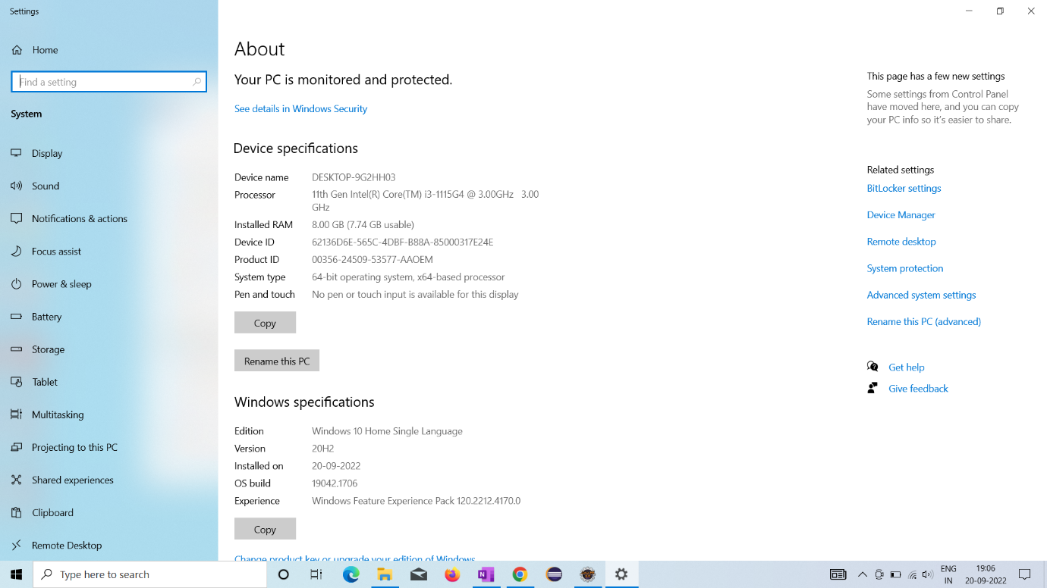



SQL INSTALLATION:

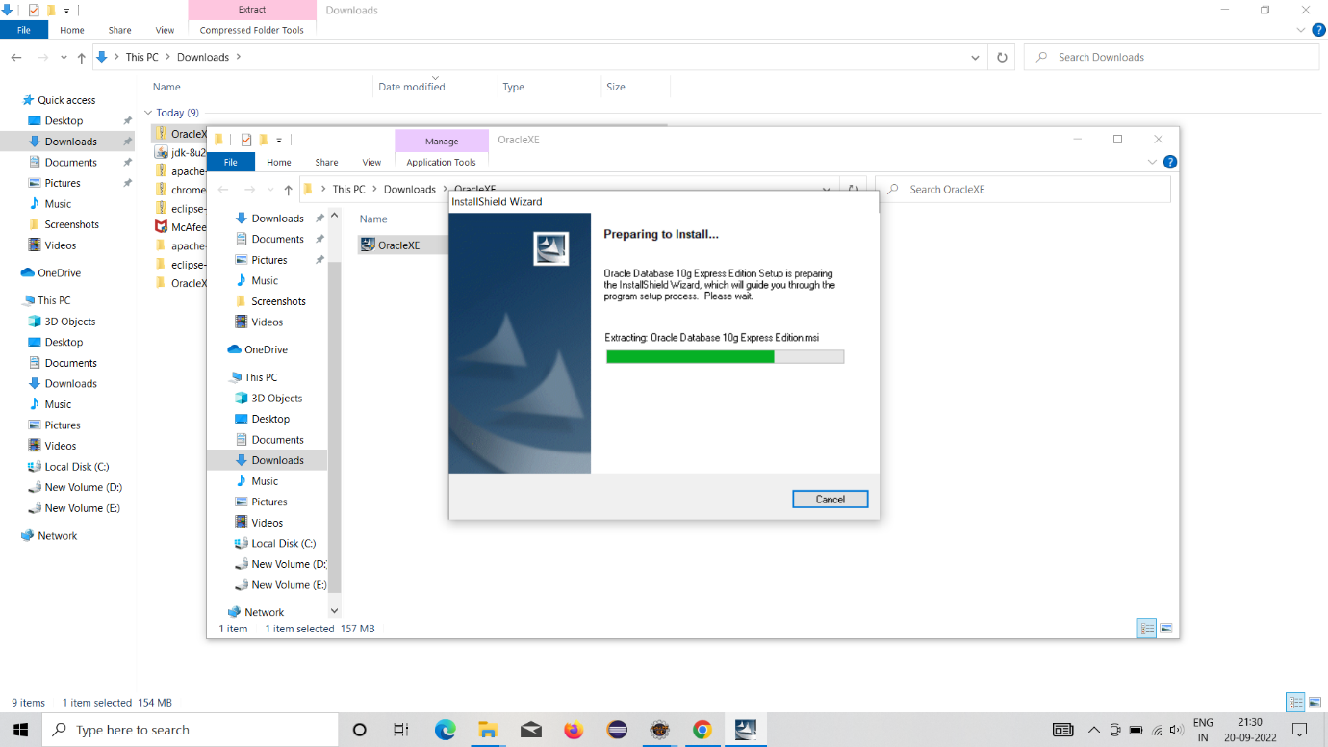

Git clone from Eclipse:

1.Clone a git repository select

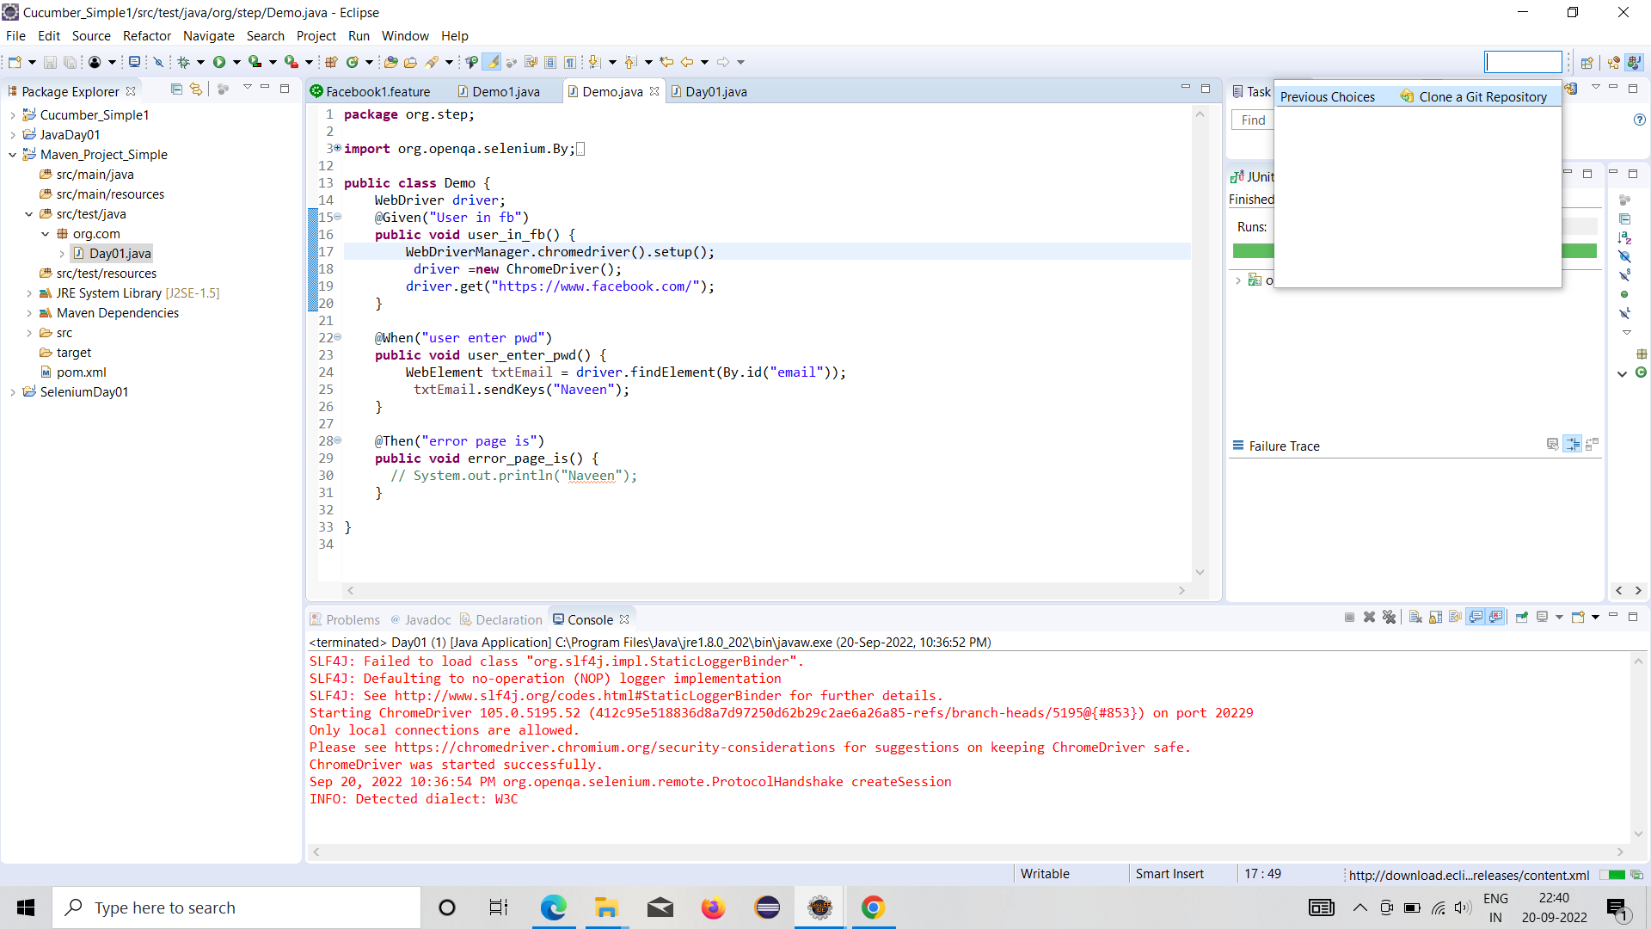



2.Enter the github uri and username ,password---🡪pwd---some time new token generate

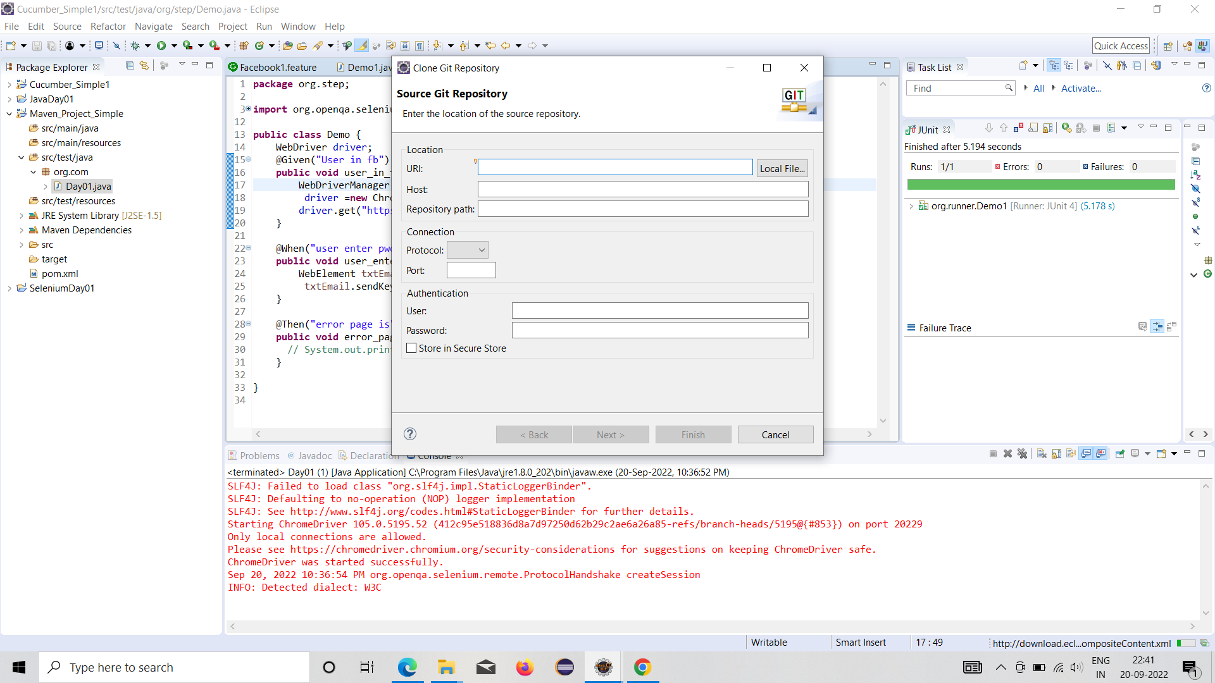

pwd---some time new token generate

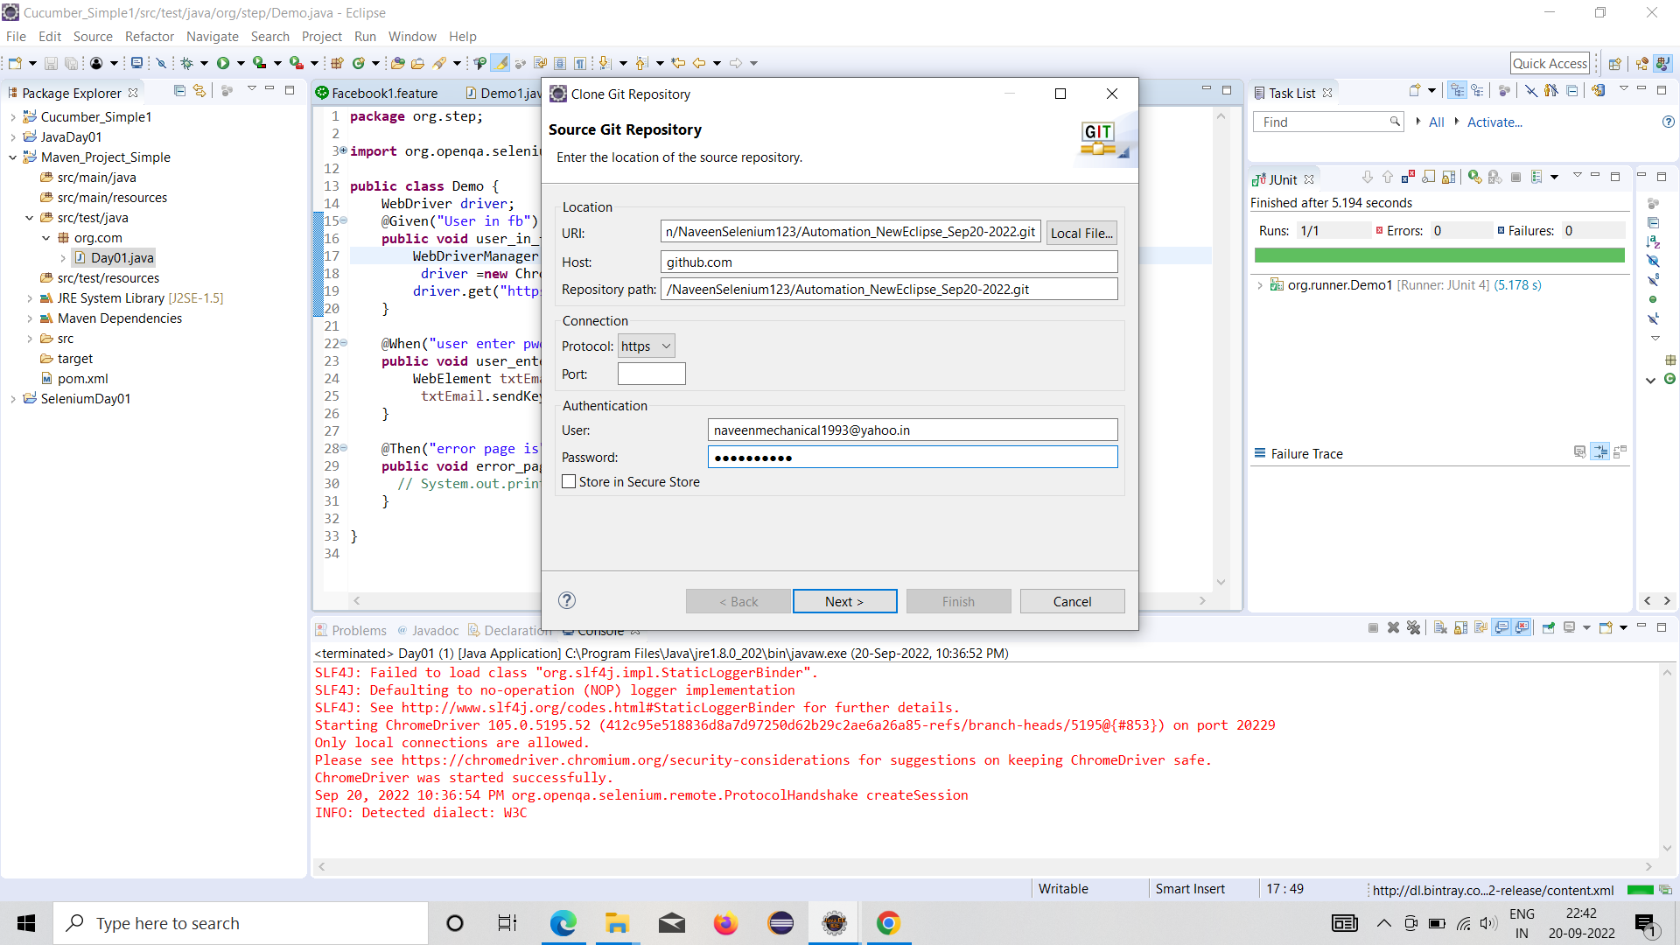

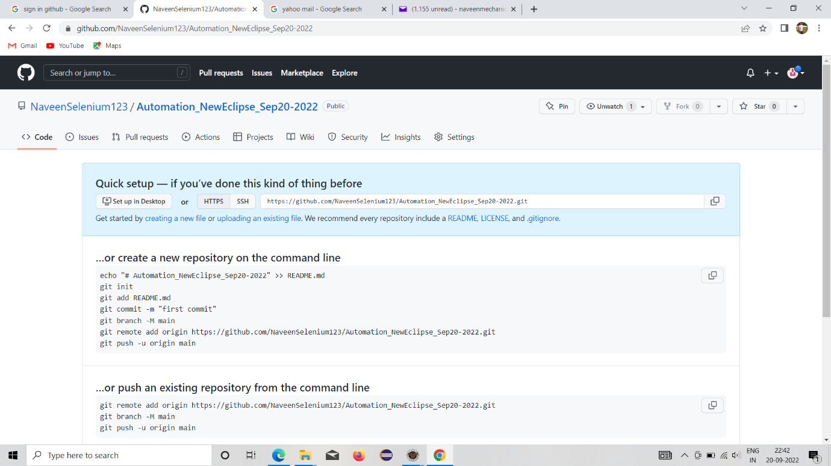



3.Git files storage in local system:

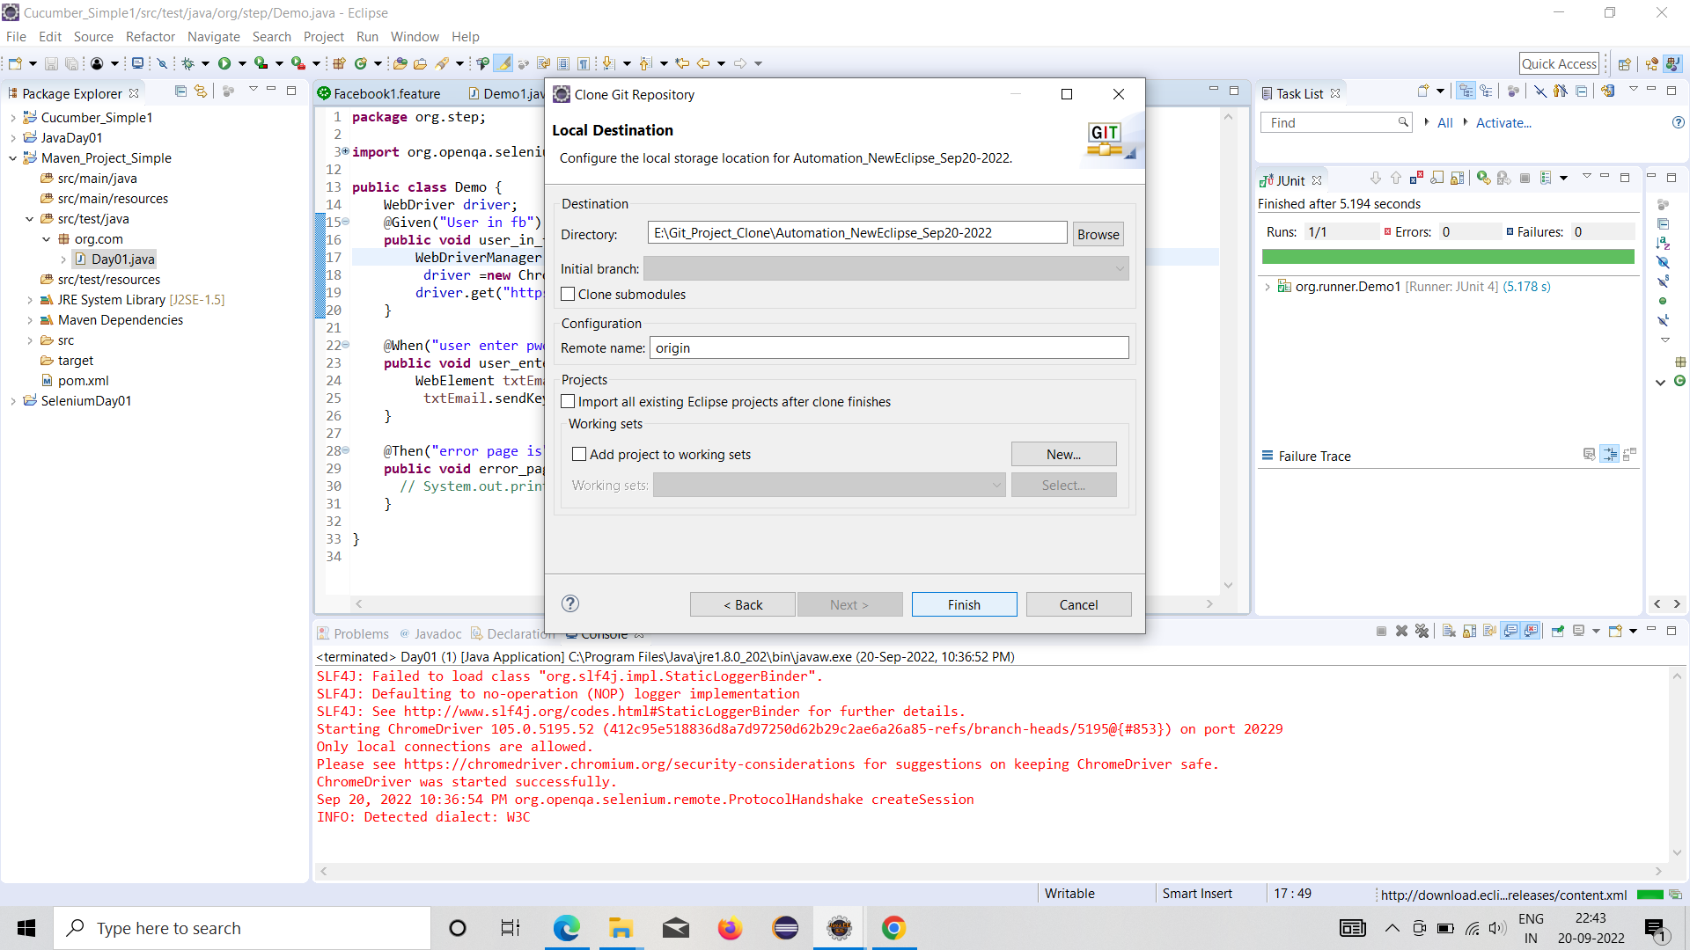



4.Share the our project

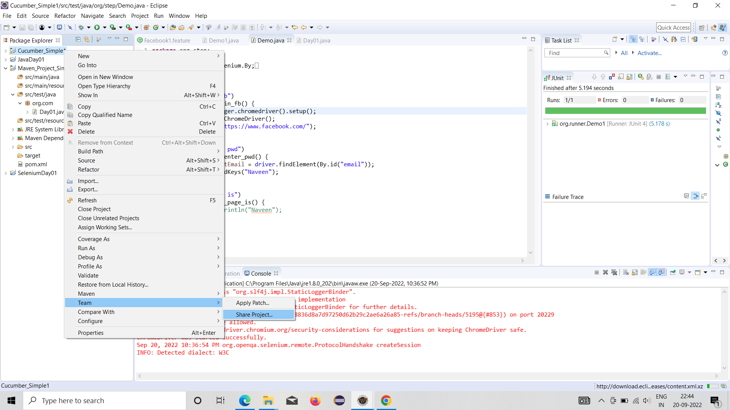



5.Repository selection

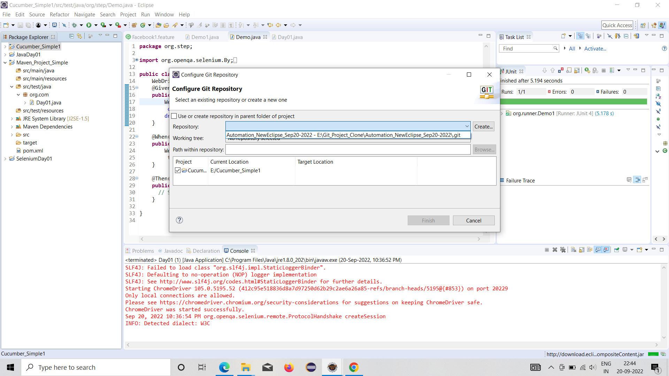



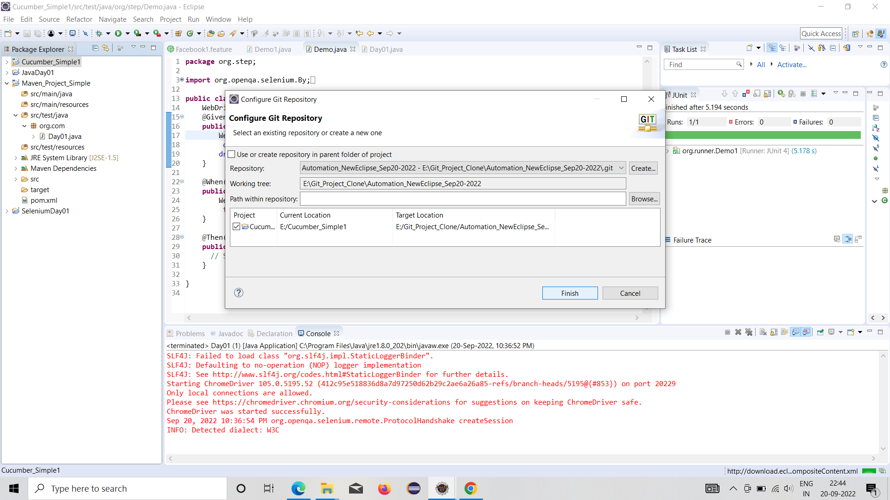



6.Commit our project

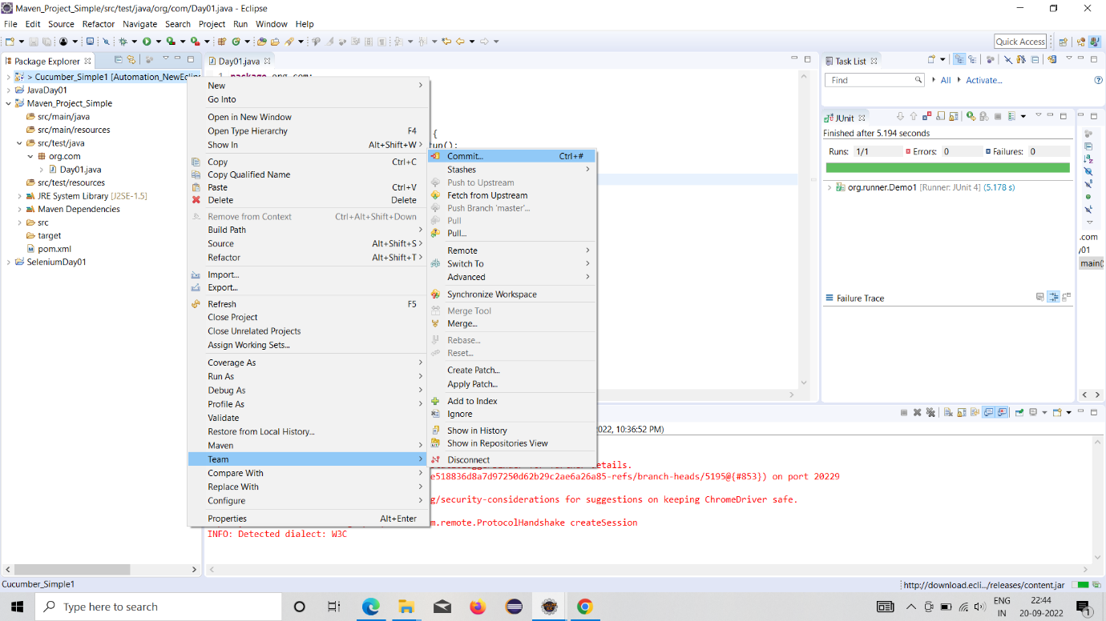



7.Select commit and push

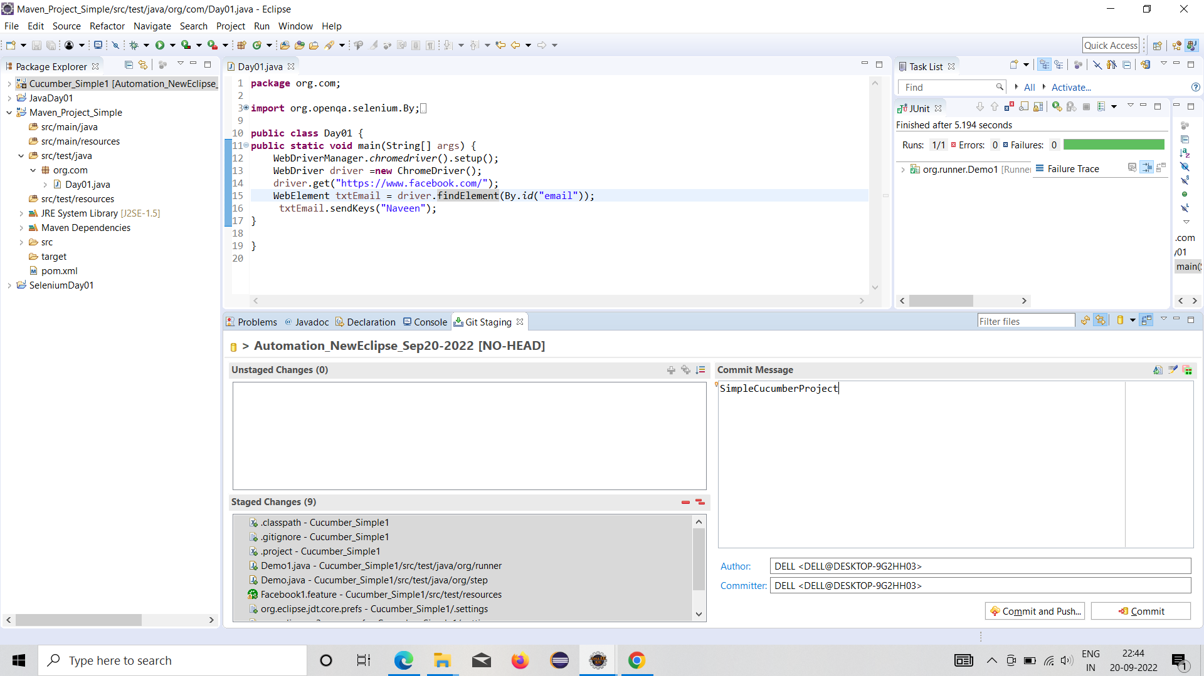



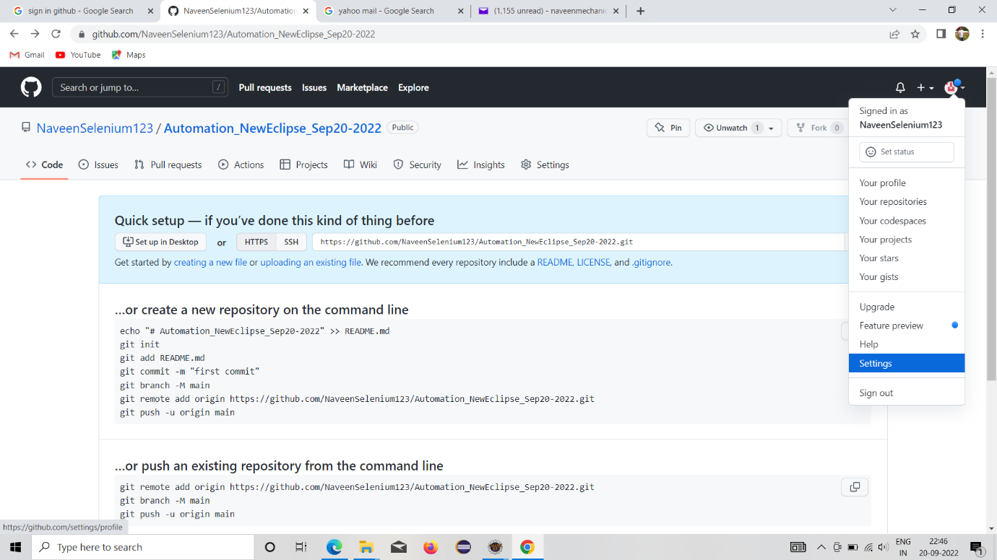



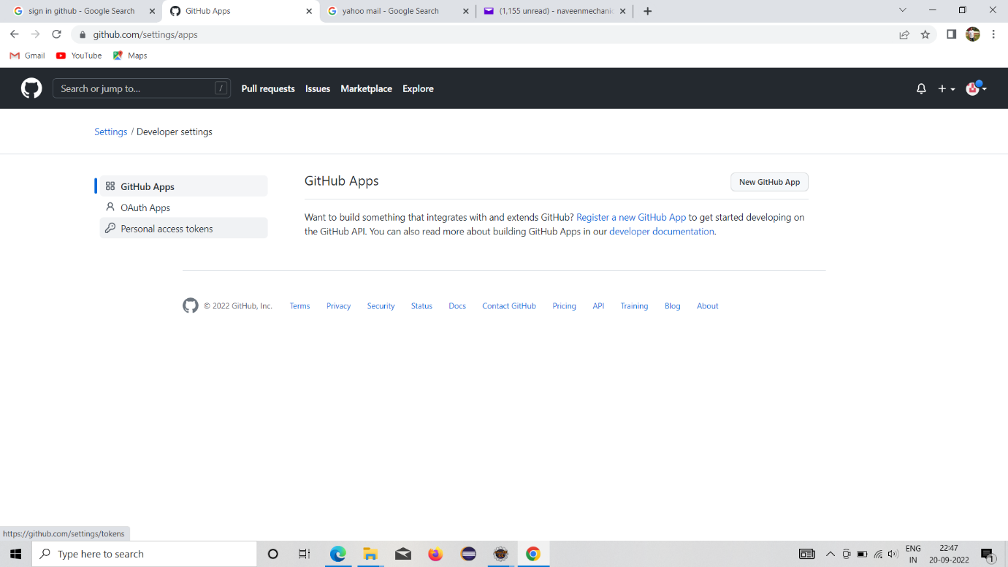



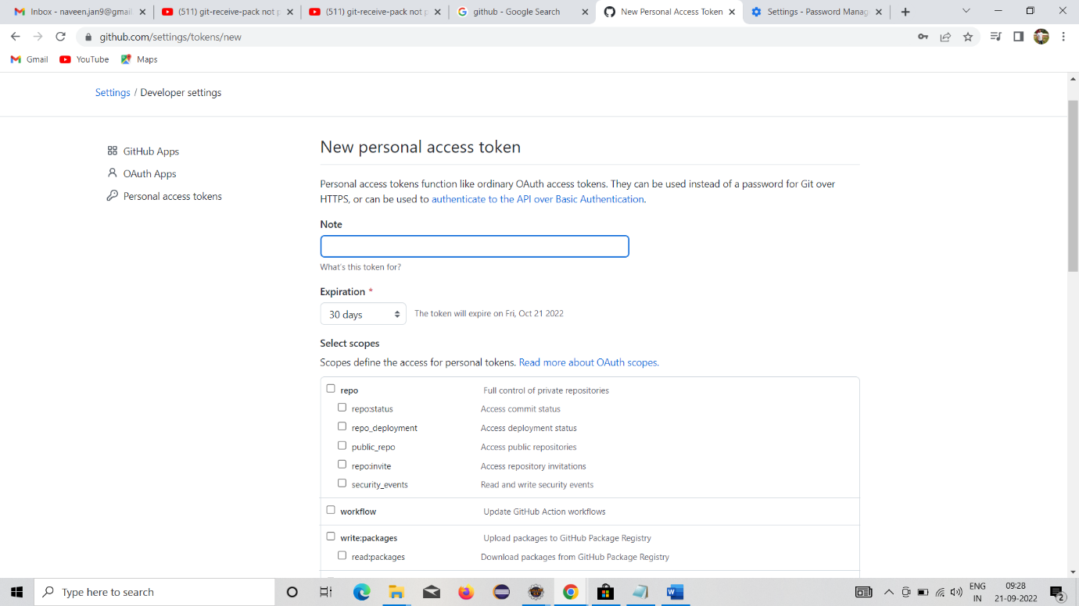



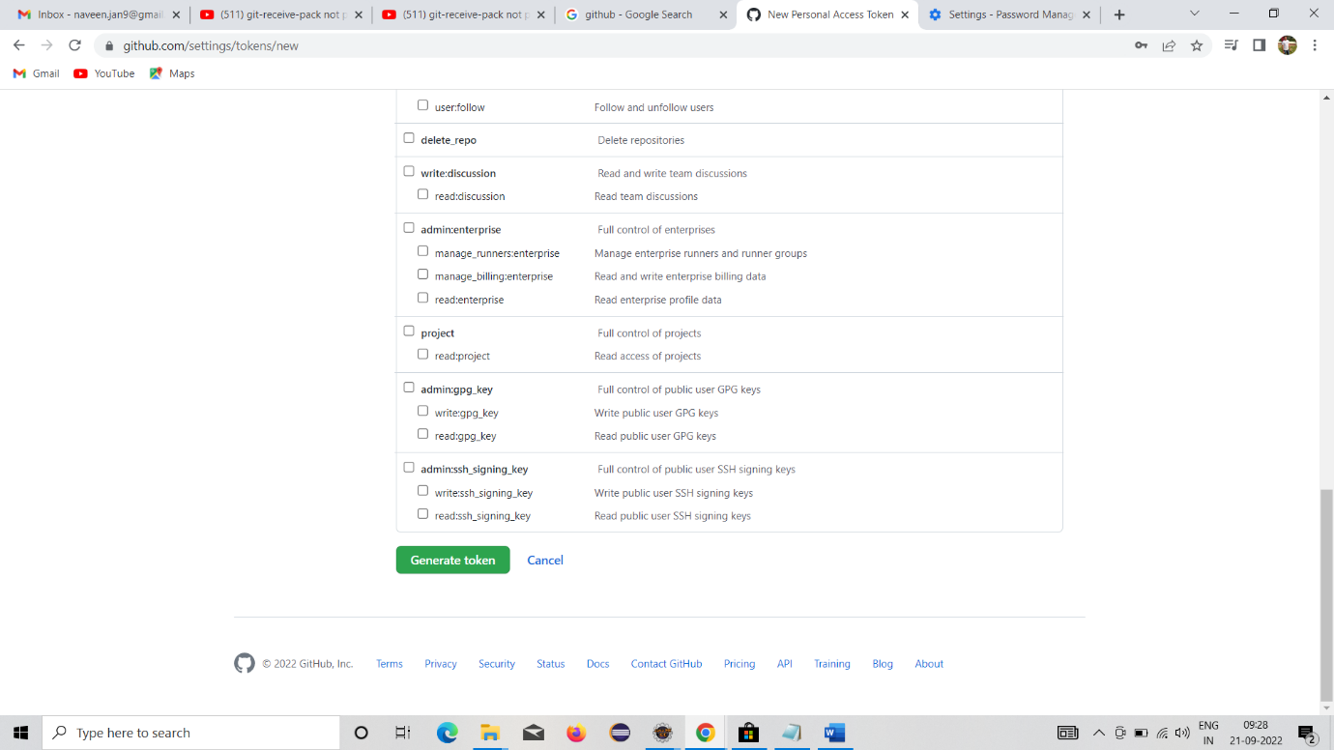



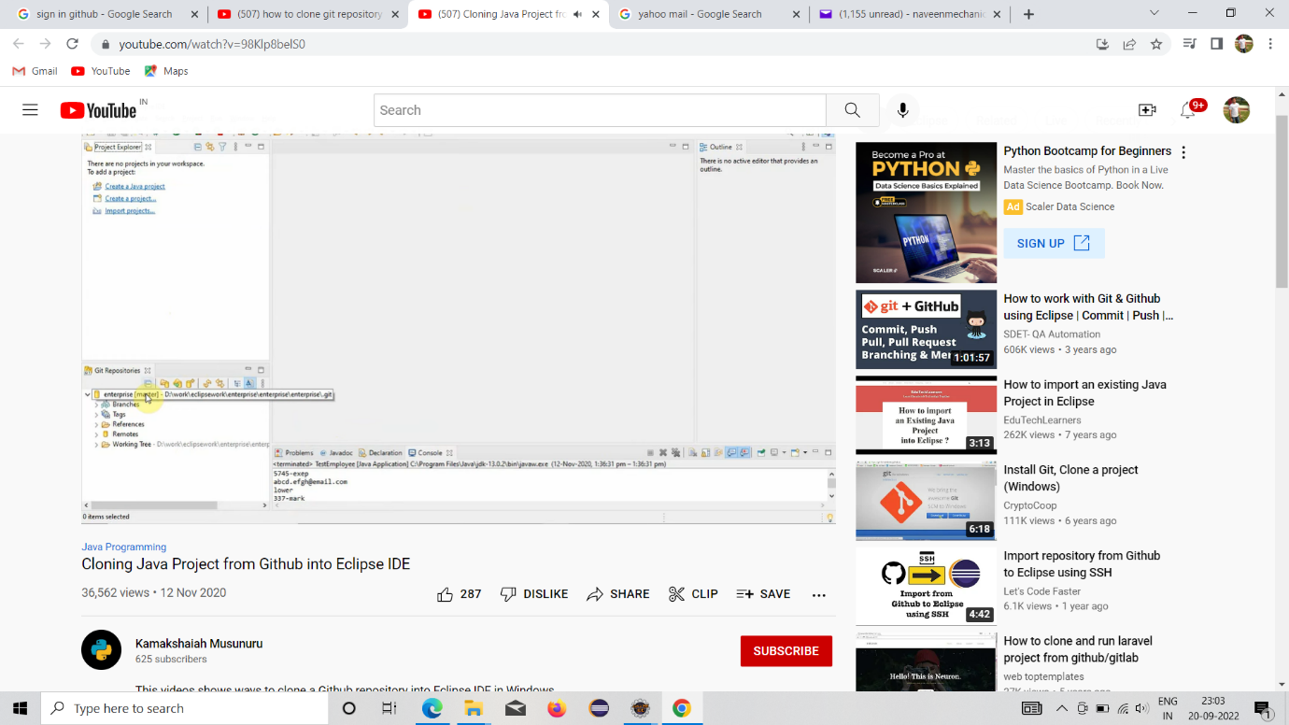

Git Clone:

Issue facing this:

Soln: Generate new token

(github----setting----right side developer setting---personal access token---generate new token---note-name given—repo selection—Generate new token)

<https://www.youtube.com/watch?v=8x0ywtCOzxo&t=338s>

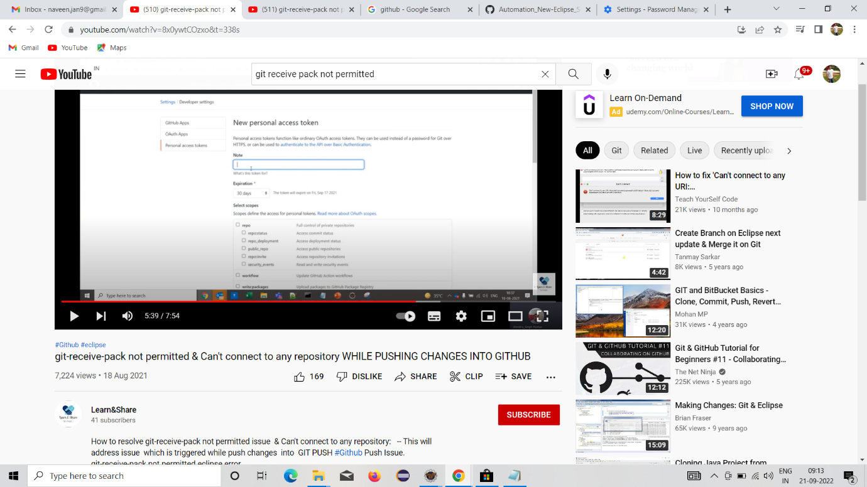

8.SQL Installation

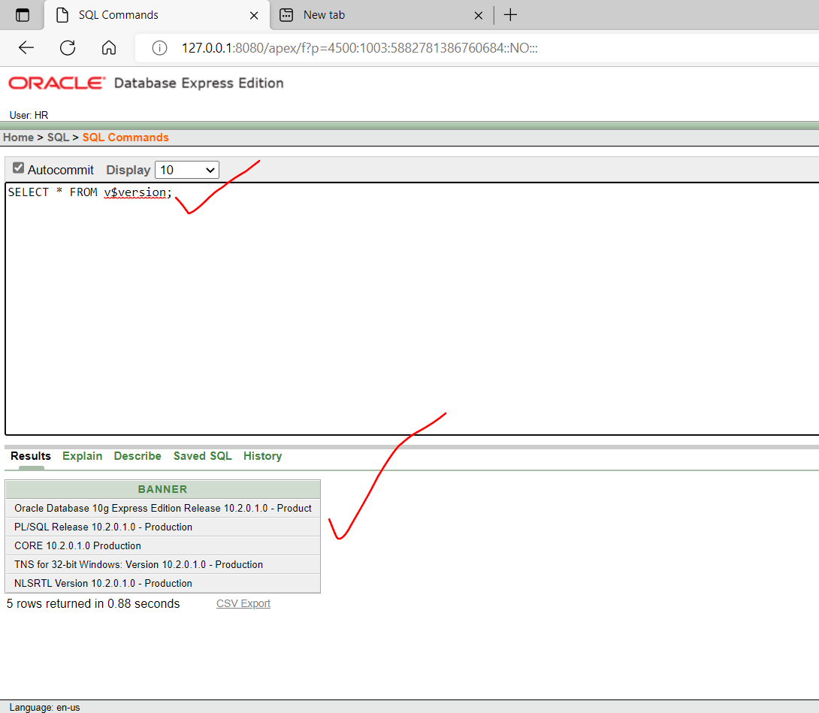

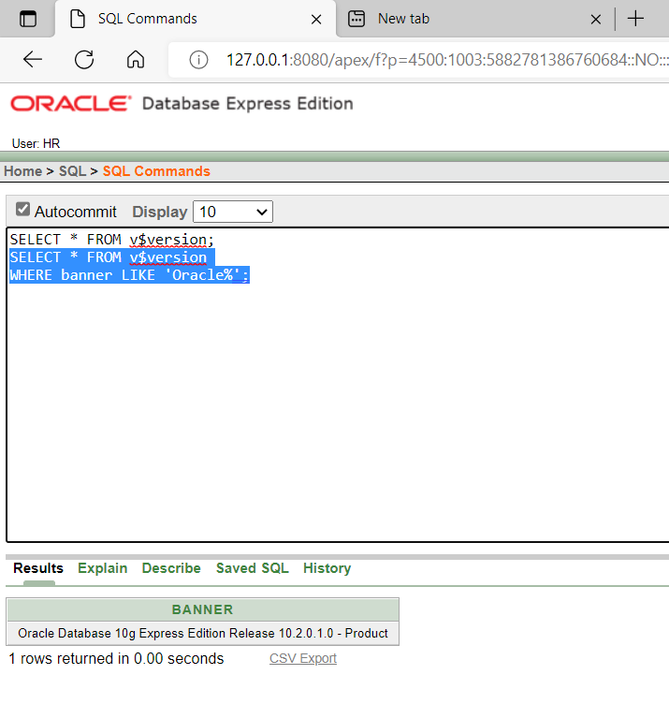

<https://drive.google.com/file/d/1GZZC2mUXykw-sCO5ST4pOK8FX6UXhYev/view>

SQL local host no: http://127.0.0.1:8080/apex/f?p=4500:1003:555509665335221::NO:

Error facing while create the maven project in eclipse

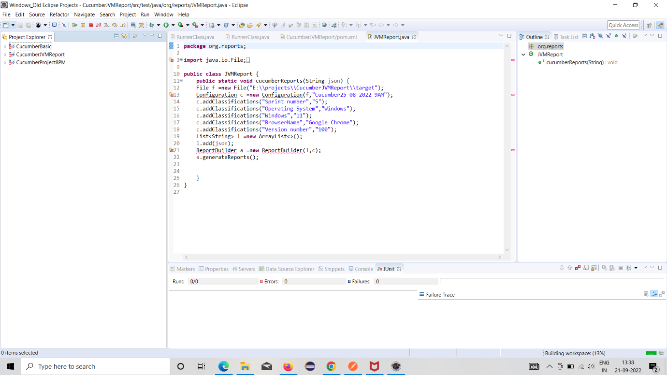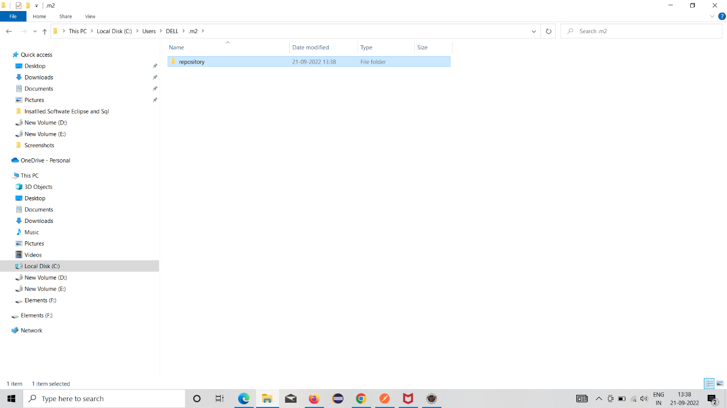



How to resolve:

Error:In eclipse maven project red colour dot came

Soln:(go to c drive—user folder--.m2 folder---repository)----------delete the repository

Eclipse Old installation procedure:

INSTALLATION

DATE:04-03-2022

1.JAVA

2.SELENIUM

3.ECLIPSE

4.MAVEN

5.JUNIT

6.DATA DRIVEN FRAMEWORK

7.JAVA (ENCAPSULATION-getters and setters;File handling—file reading---common io 2.4 jar download)

8.SELENIUM(screenshot topic-- common io 2.4 jar download)

9.Cucumber installation

10.SQL -JDBC CONNECTION

11.GIT

12.JENKINS

13.CUCUMBER

(This word involve java to junit fw date:04-03-2022)

JAVA INSTALLATION:

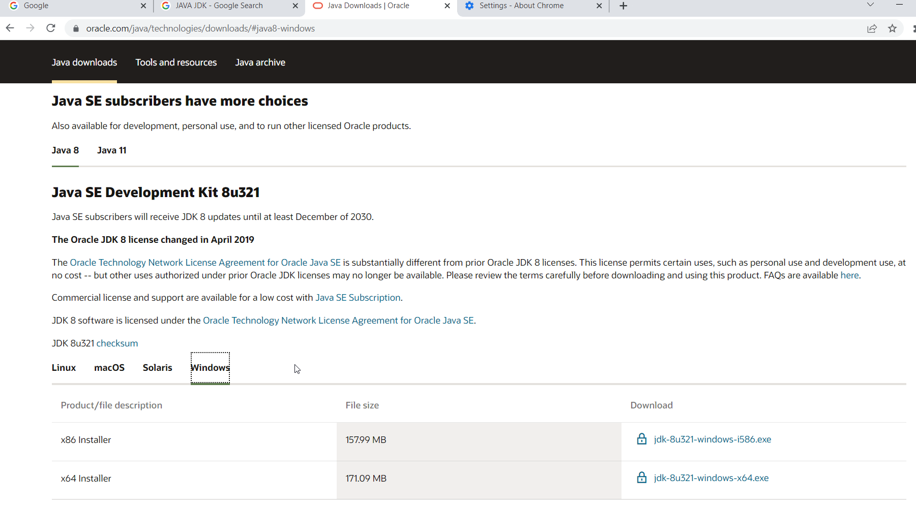

JDK1.8 –INSTALL—64 BIT--

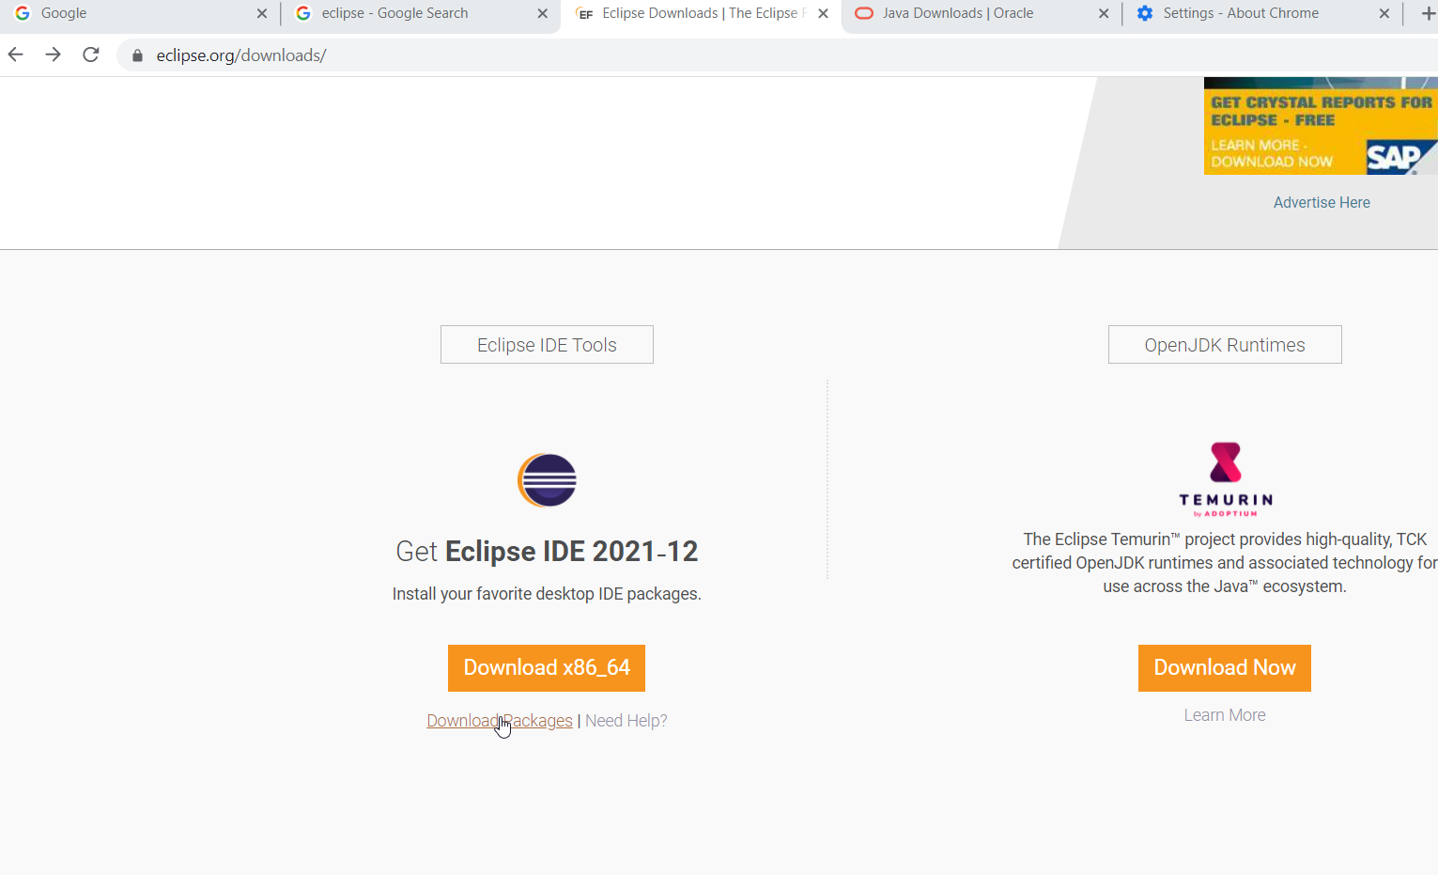

ECLIPSE OXYGEN 3A DOWNLOAD:

EXTRACT ALL—PIN TO TASK BAR

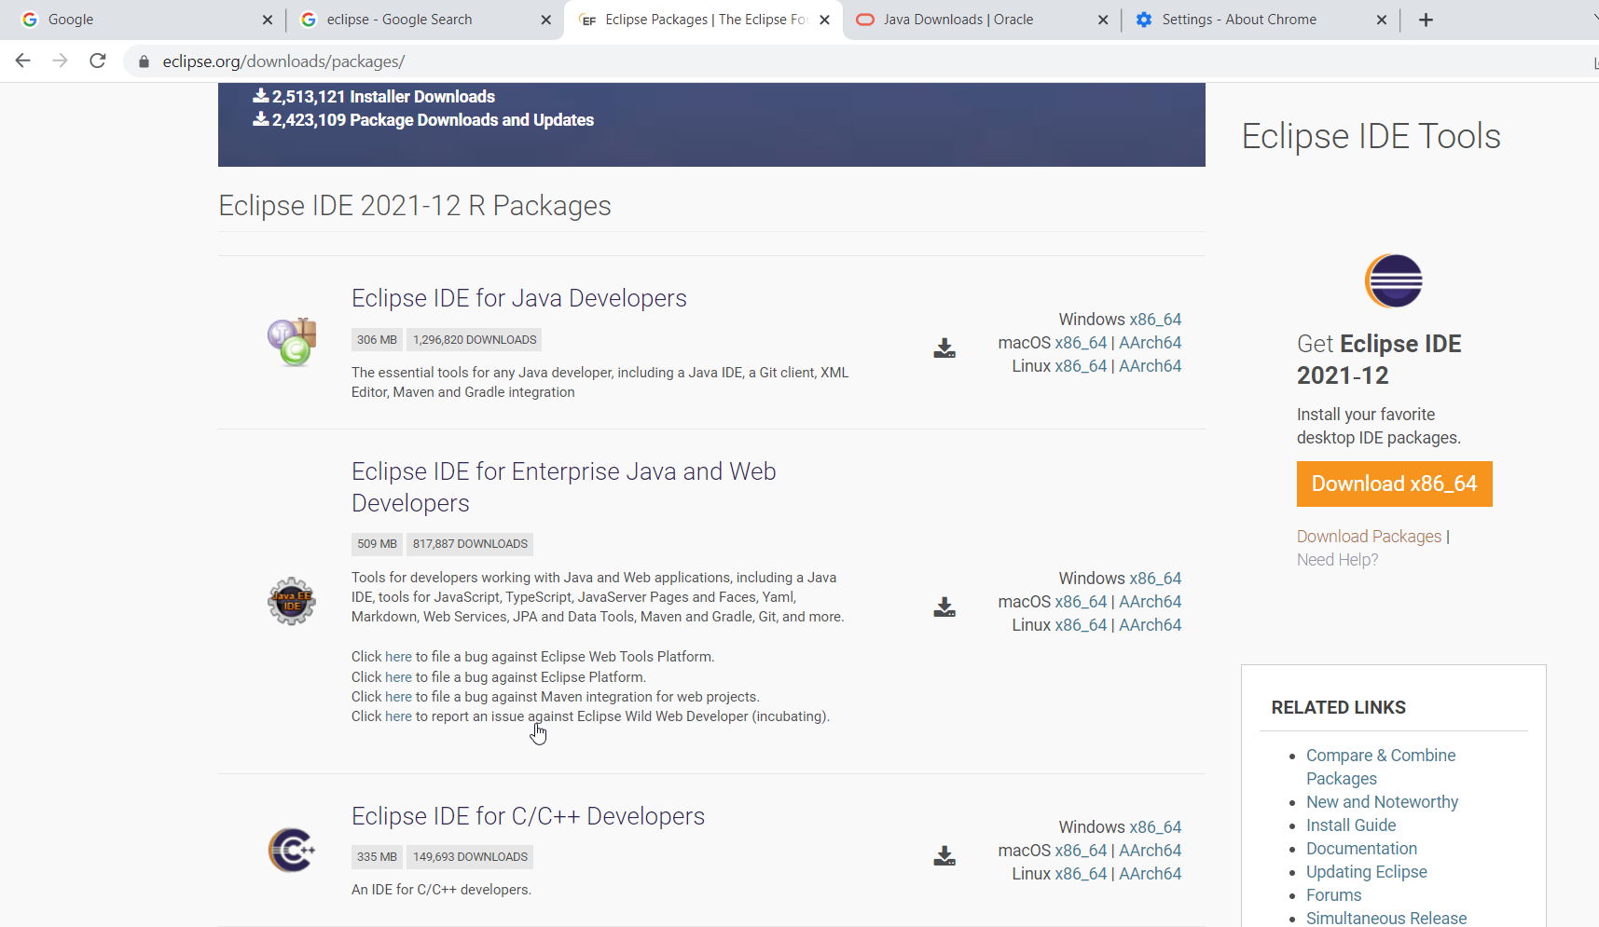

FILE HANDLING:

DOWNLOAD-common io 2.4 jar ---extract—copy in your project—add to build path

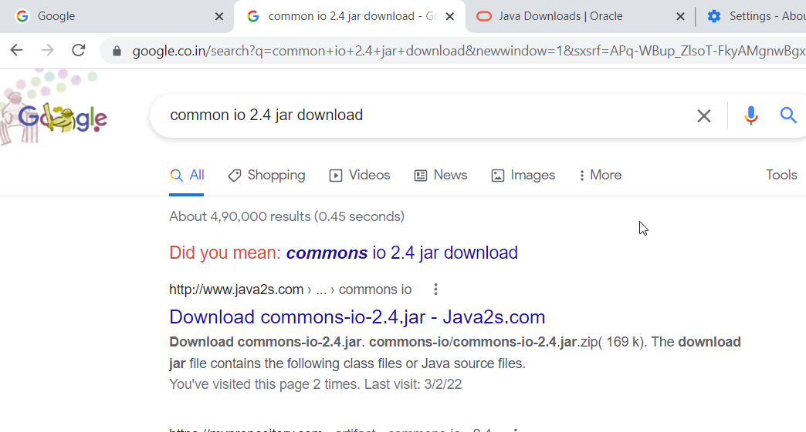

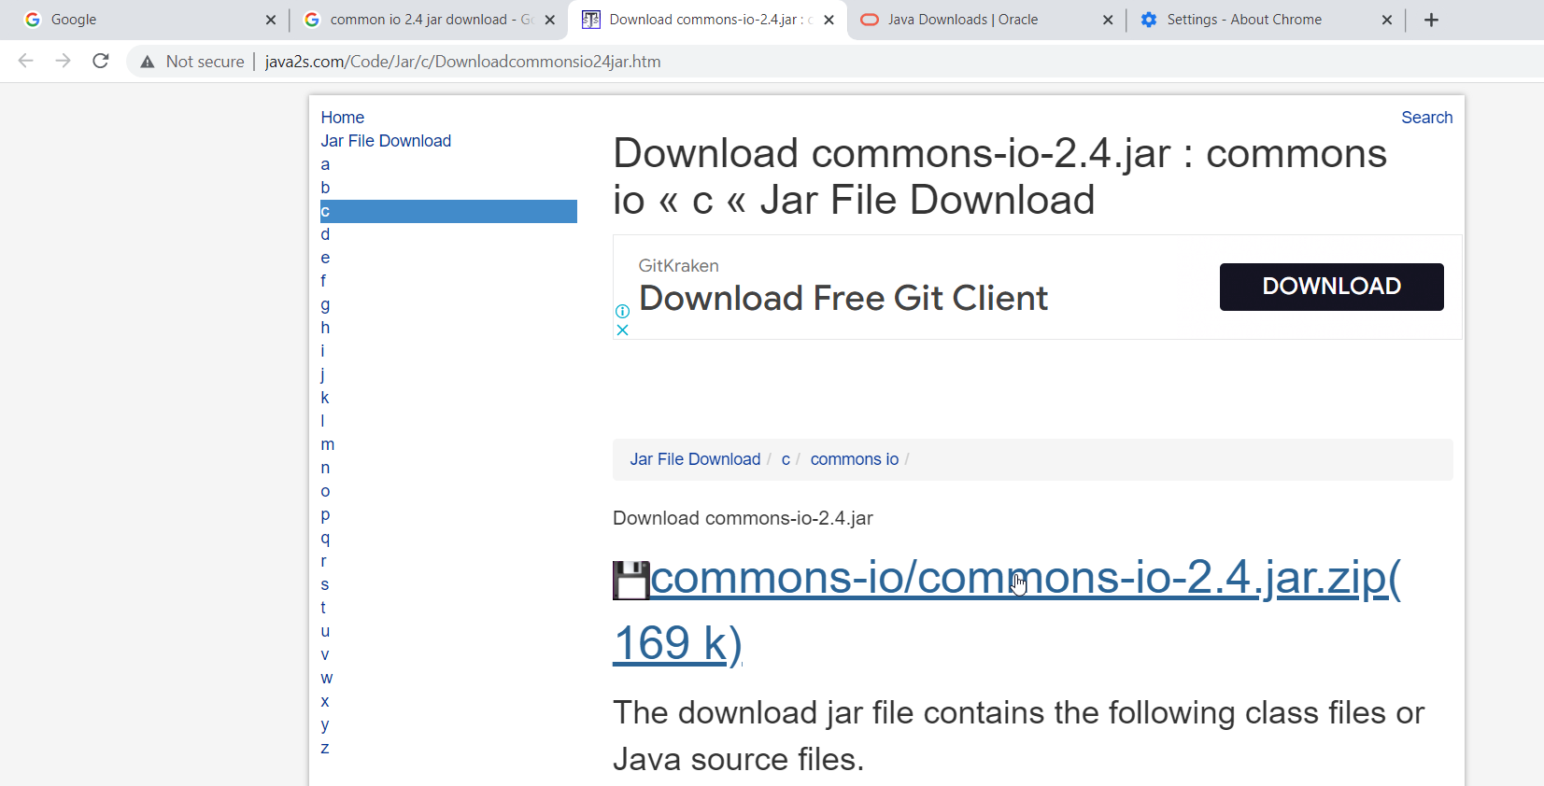

SELENIUM INSTALLATION:

Driver version <= browser version (eg:97< 99)

1.create java project

----right click—project---new –folder—lib

----right click—project---new –folder—driver

2.copy and paste the jar in lib folder

3. copy and paste the driver.exe in driver folder

4.right click jar—build path—Add to build path(shoud not to the driver.exe)

5.select the path of driver from the project

Driver—right click –properties—copy the path –paste the path value in system.setproperty

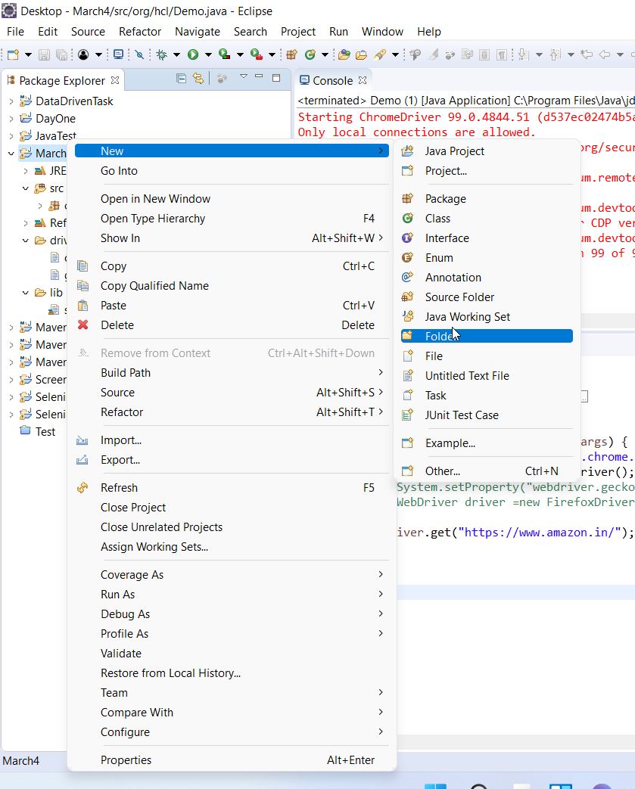

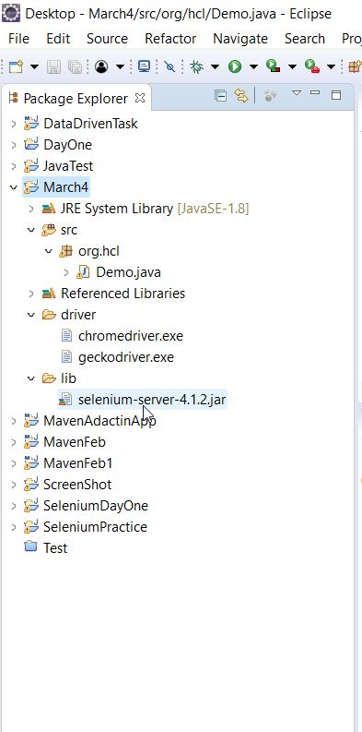

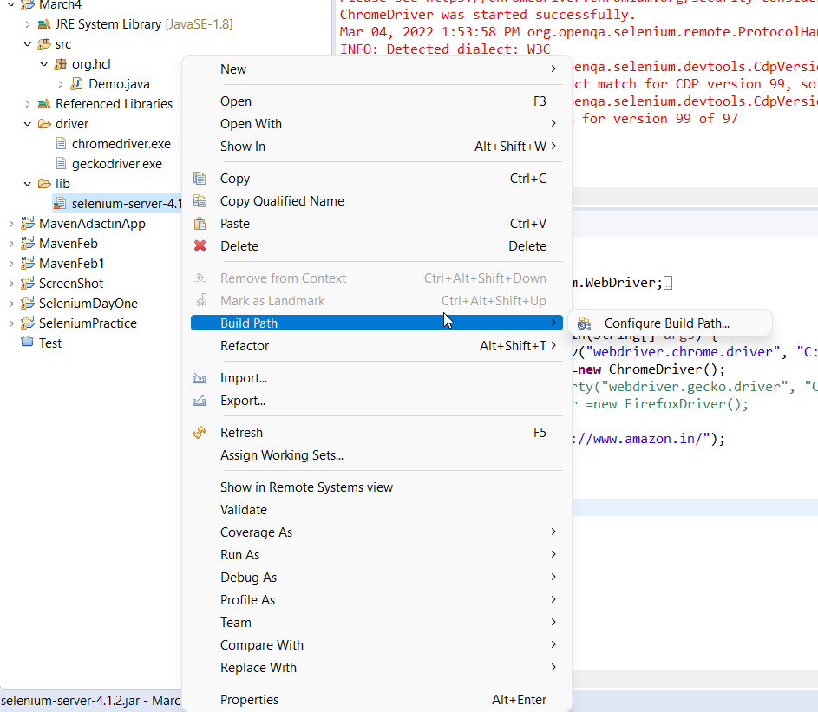

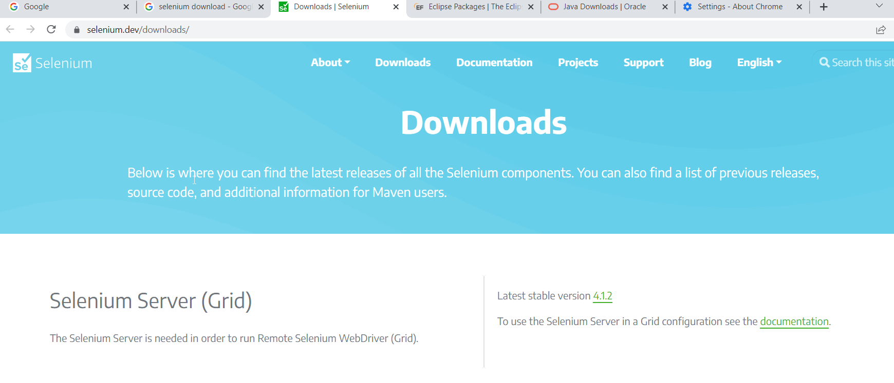

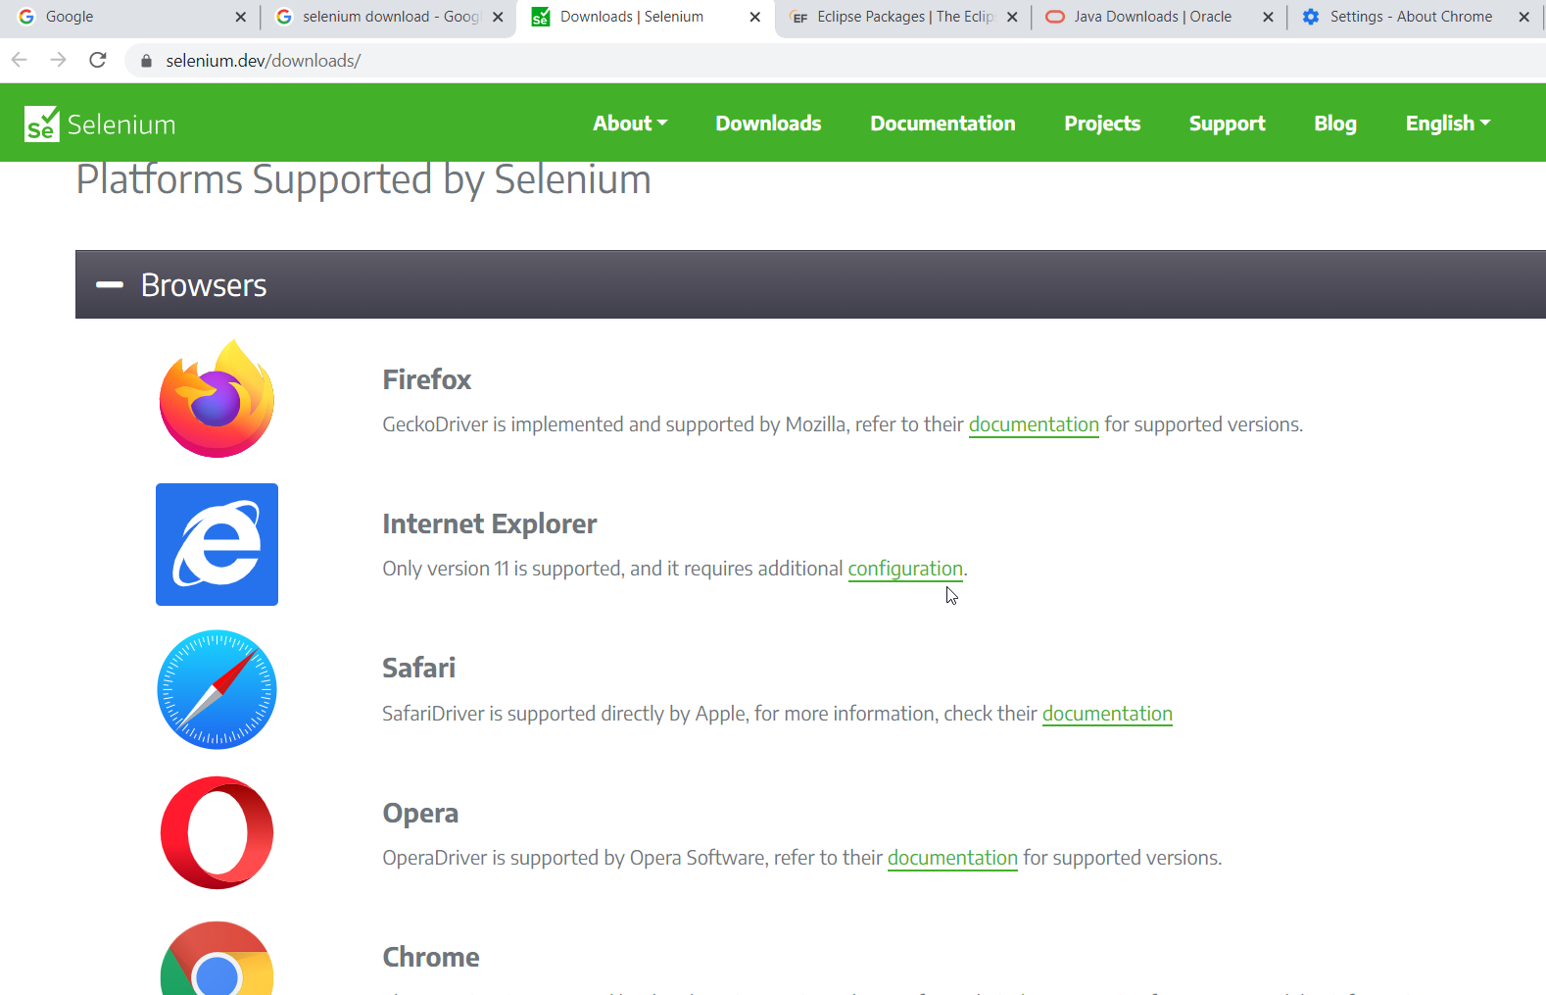

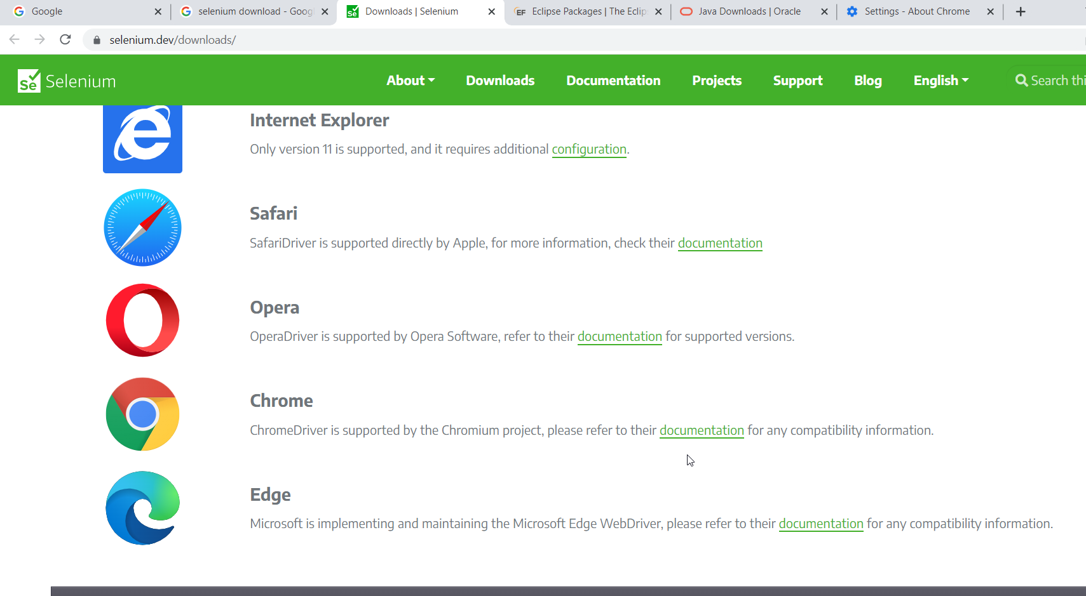

CHROME DRIVER:

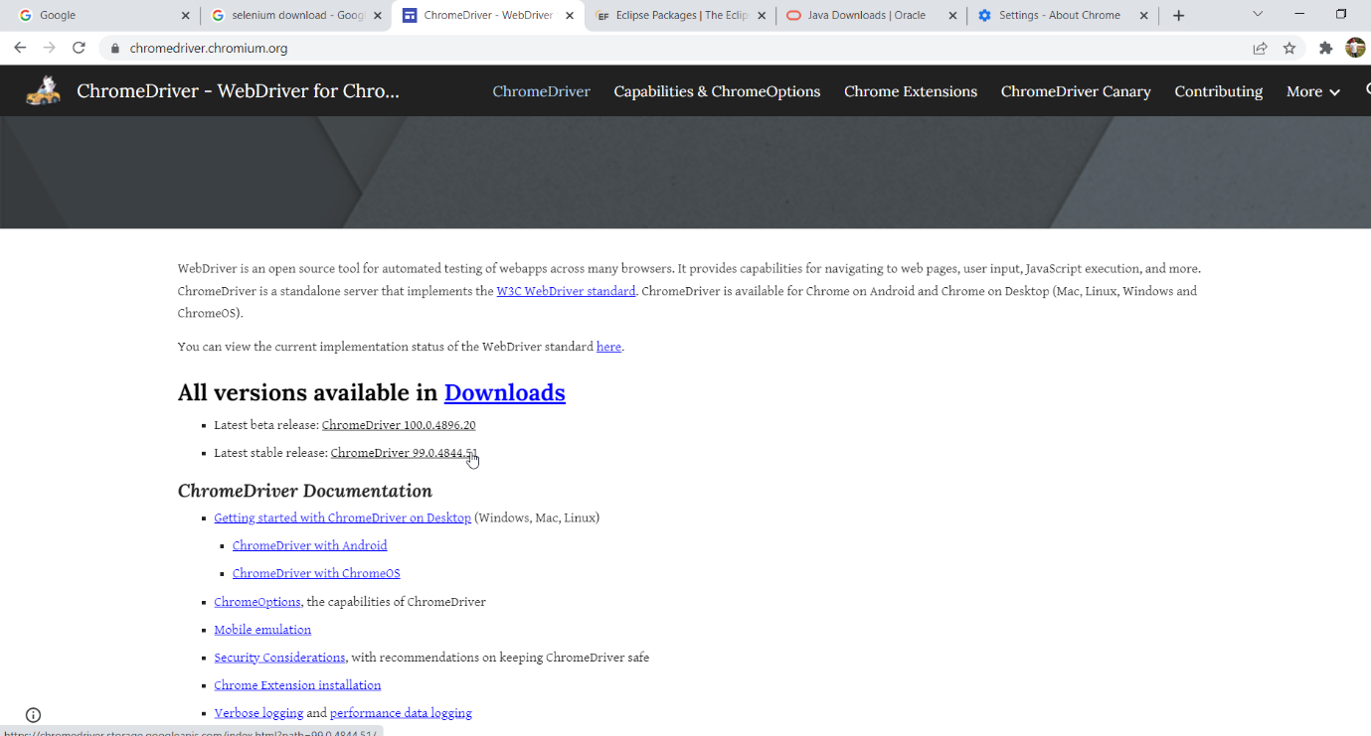

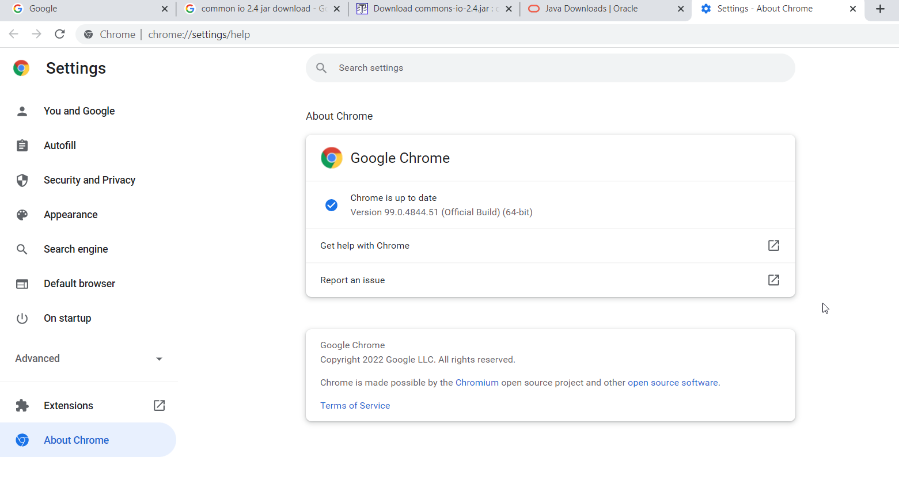

Firefox driver:

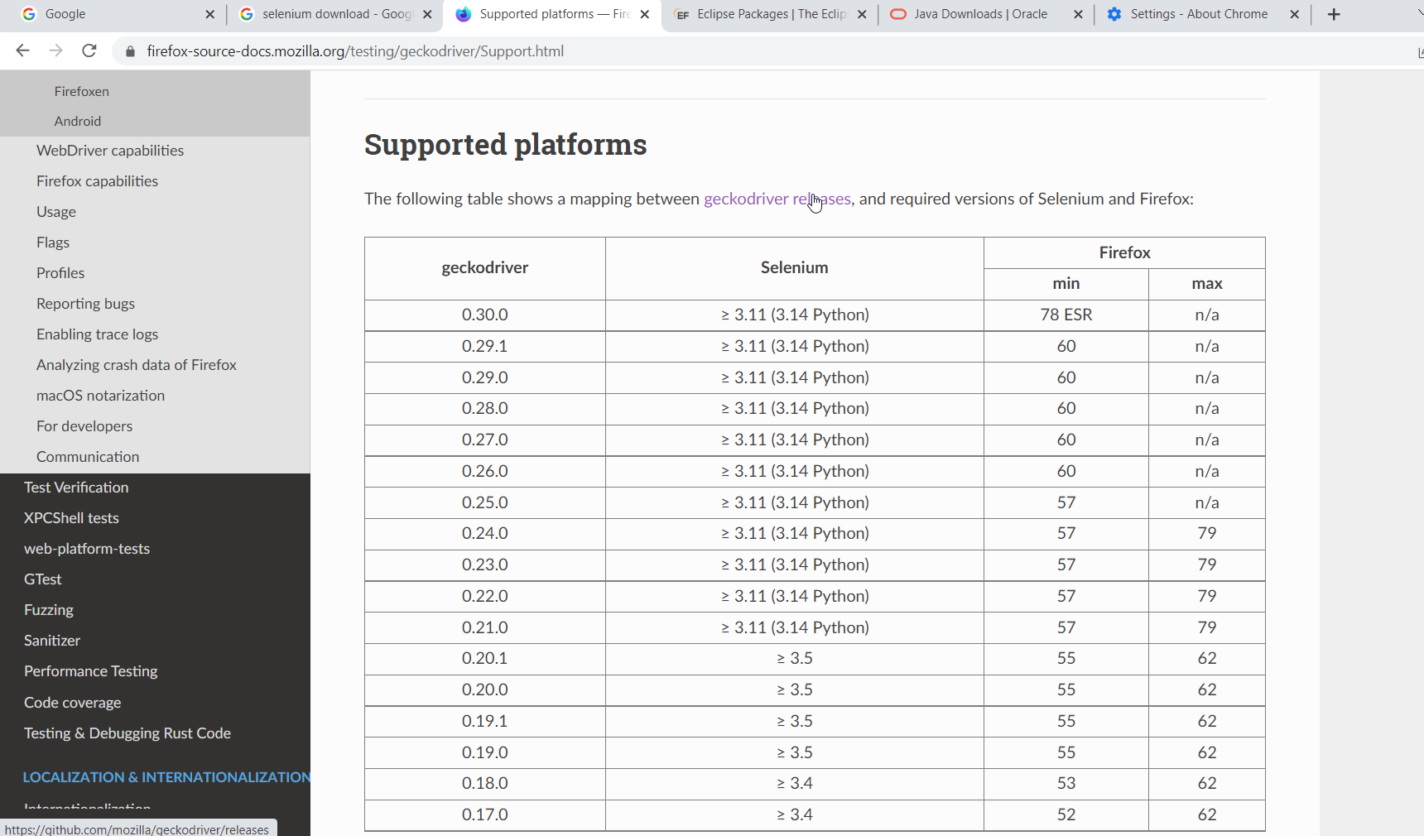

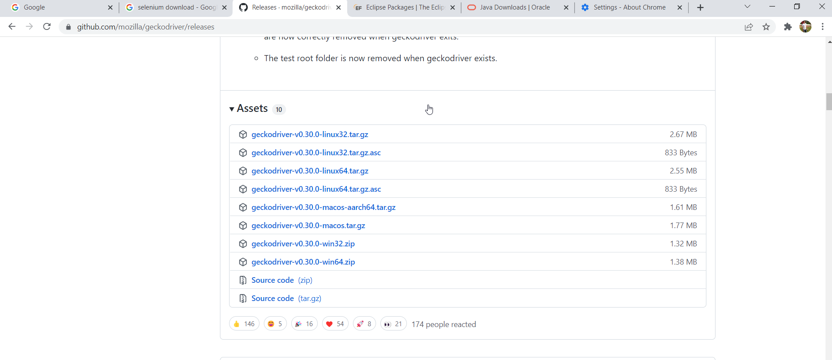

SELENIUM SCREENSHOT:

DOWNLOAD-common io 2.4 jar ---extract—copy in your project—add to build path





MAVEN PROJECT:

1.Apache maven download –search in google

2.binary zip file –3.8.4 bin zip—cliclk

3.download and extract

4.set the environment variables:

User variable:

CLICK NEW

C drive –inside java folder--

JAVA_HOME---set the jdk path with bin

MAVEN_HOME-set the maven path with bin

System variables:

JAVA_HOME---set the jdk path inside bin

MAVEN_HOME-set the maven path inside bin

To check java and maven installed in command prompt:

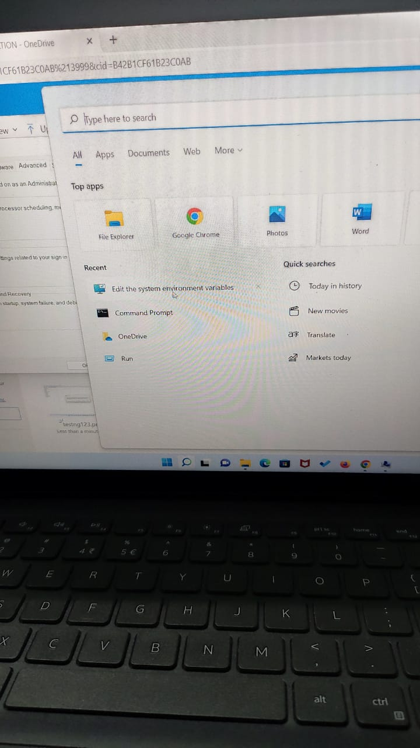



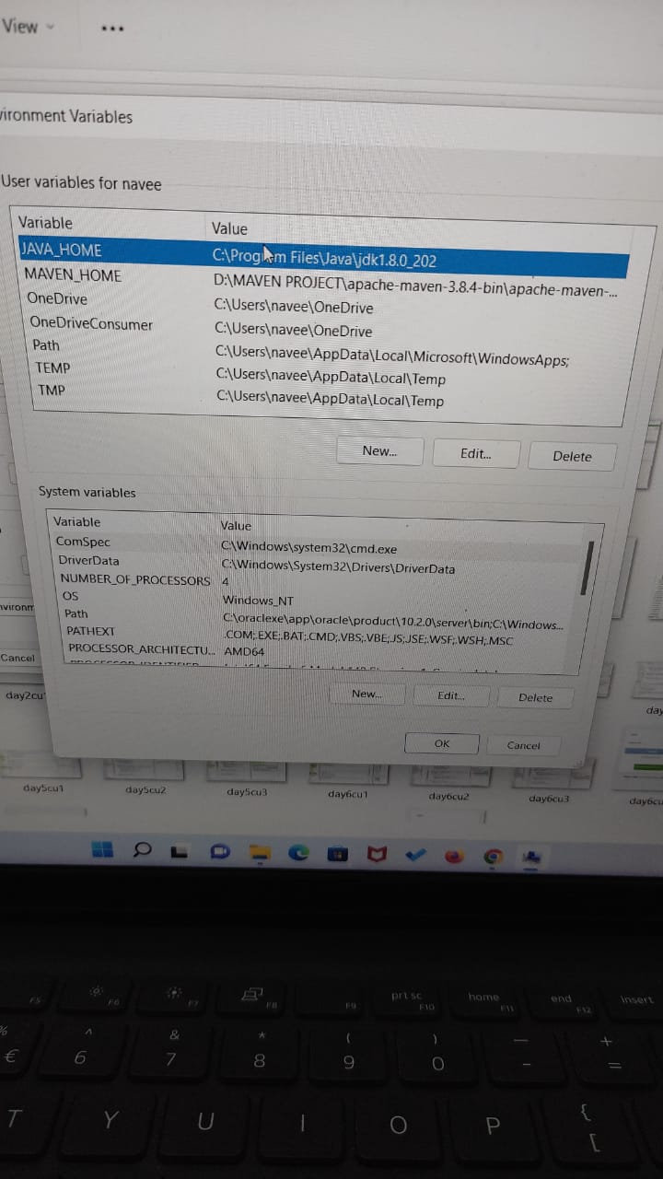



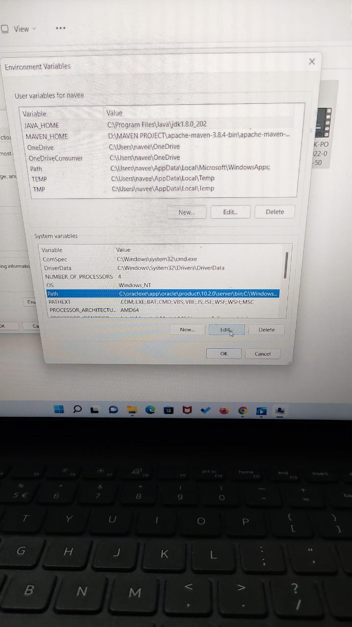



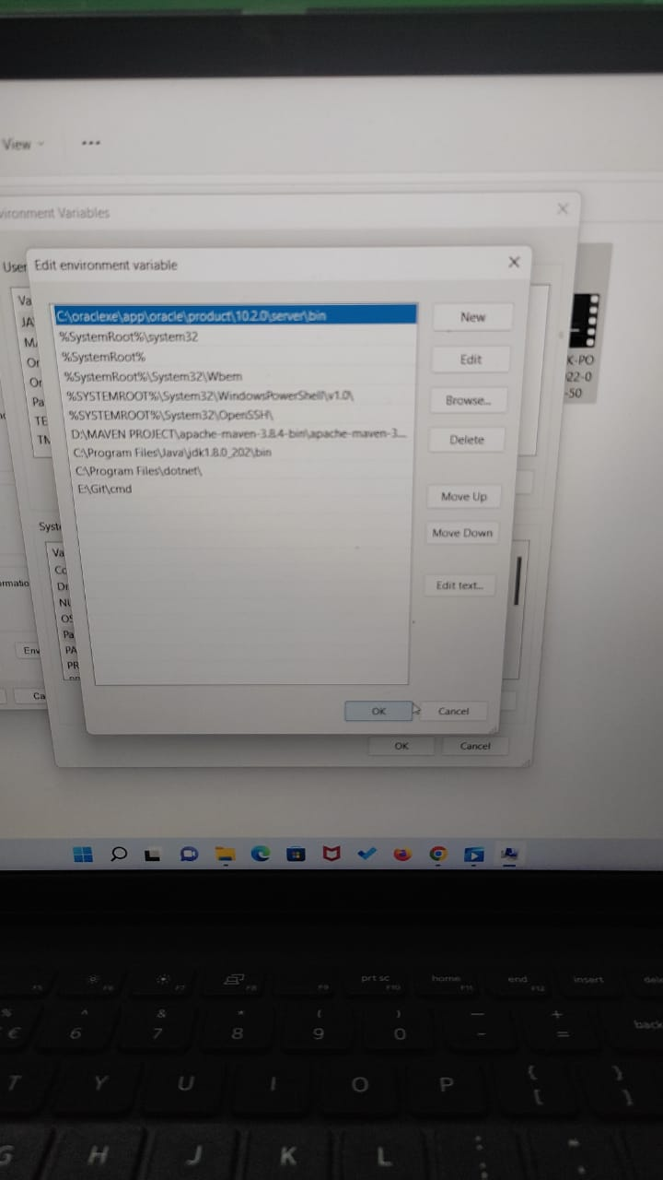



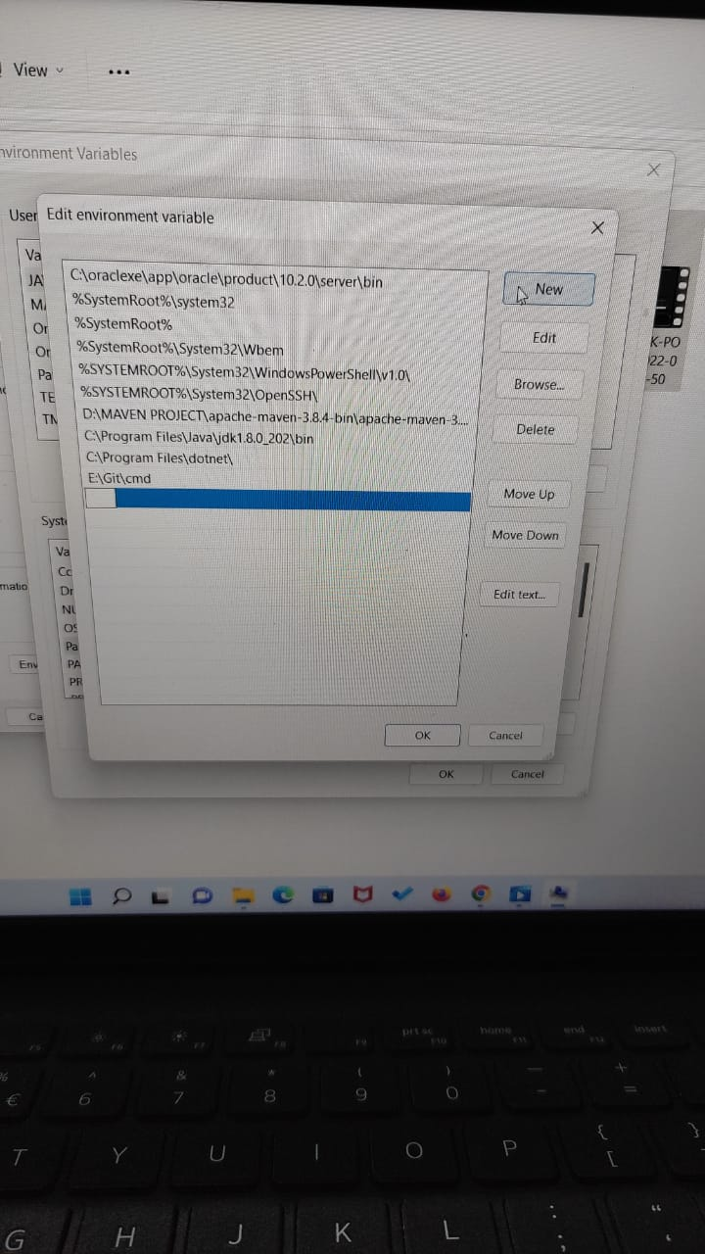



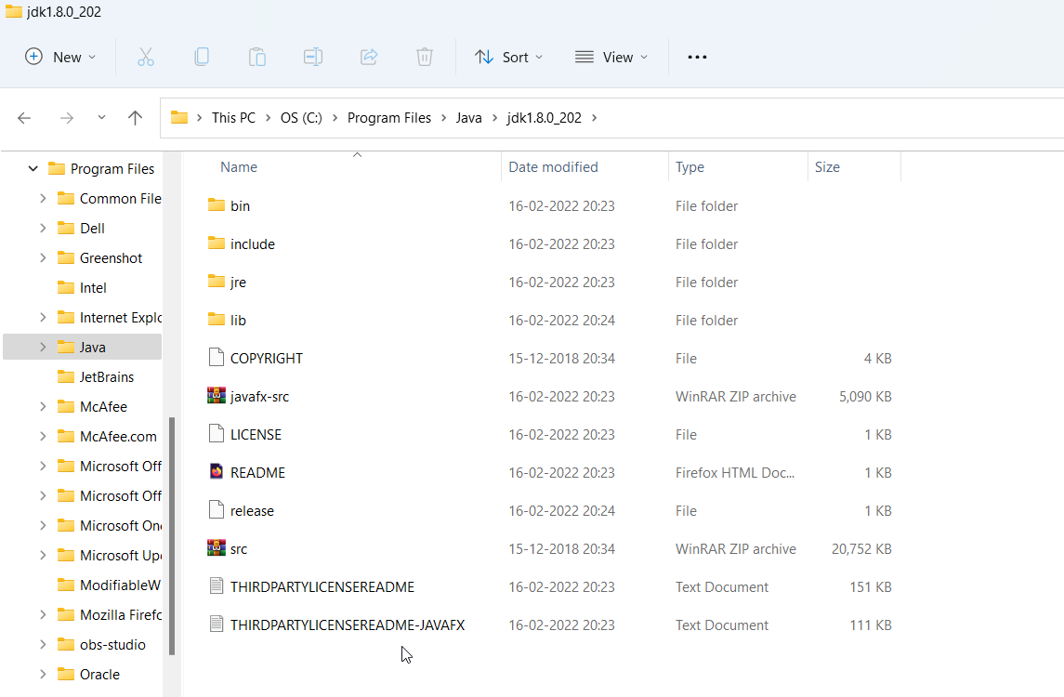

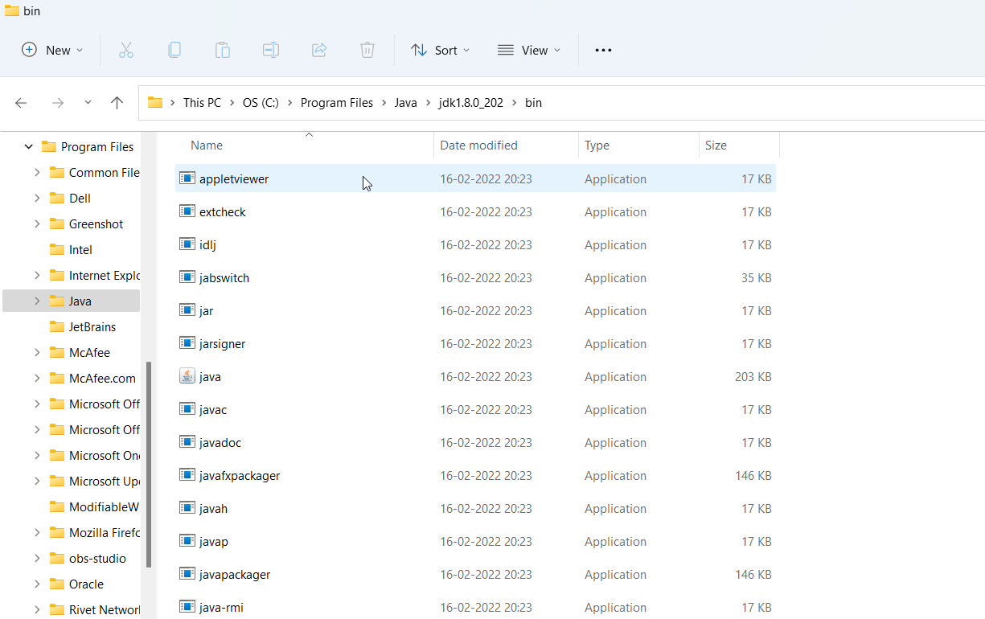

Maven path:

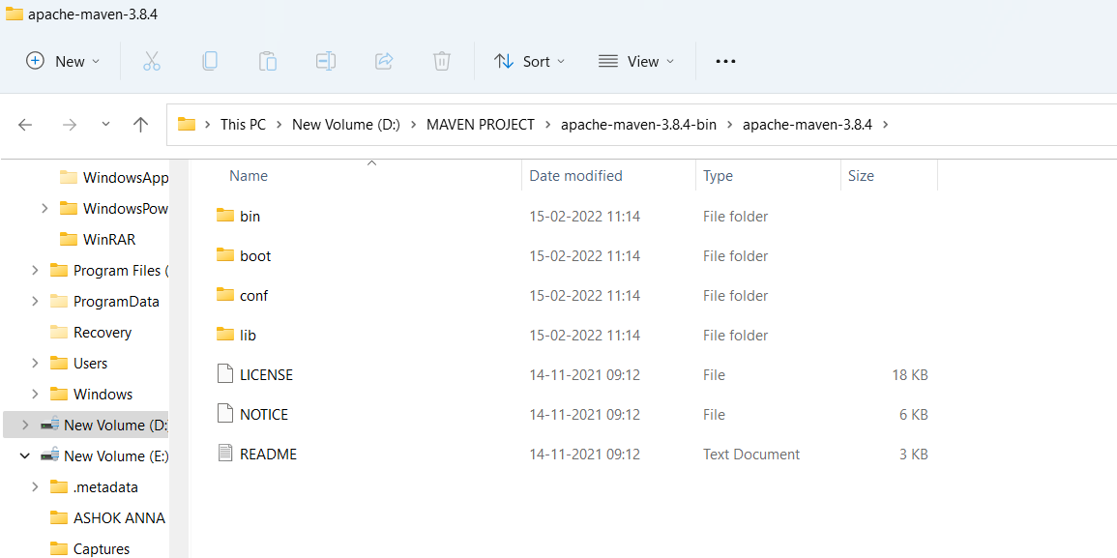

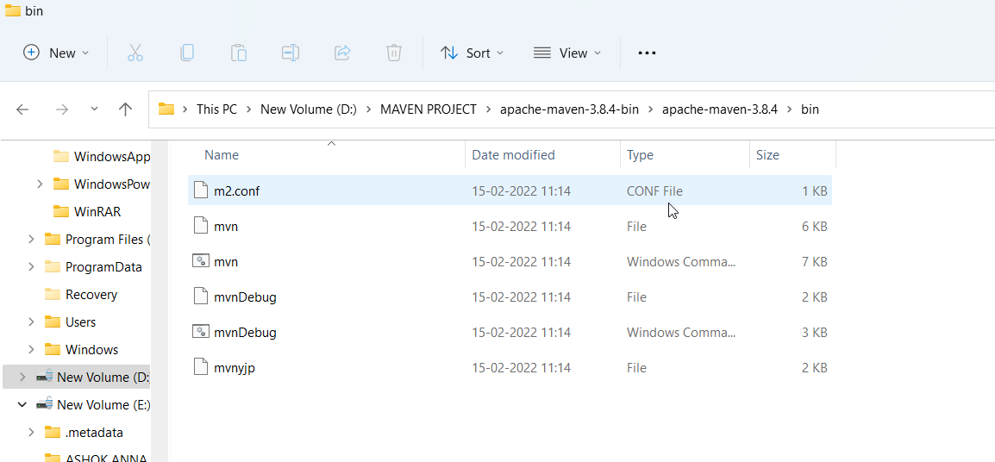

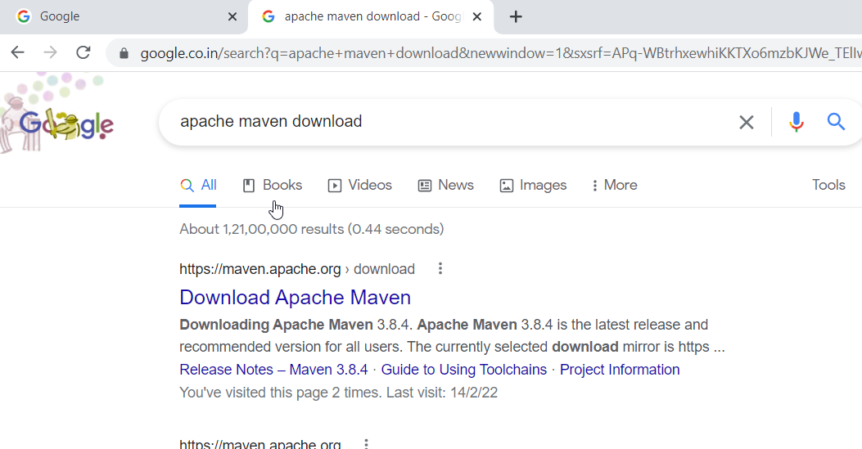

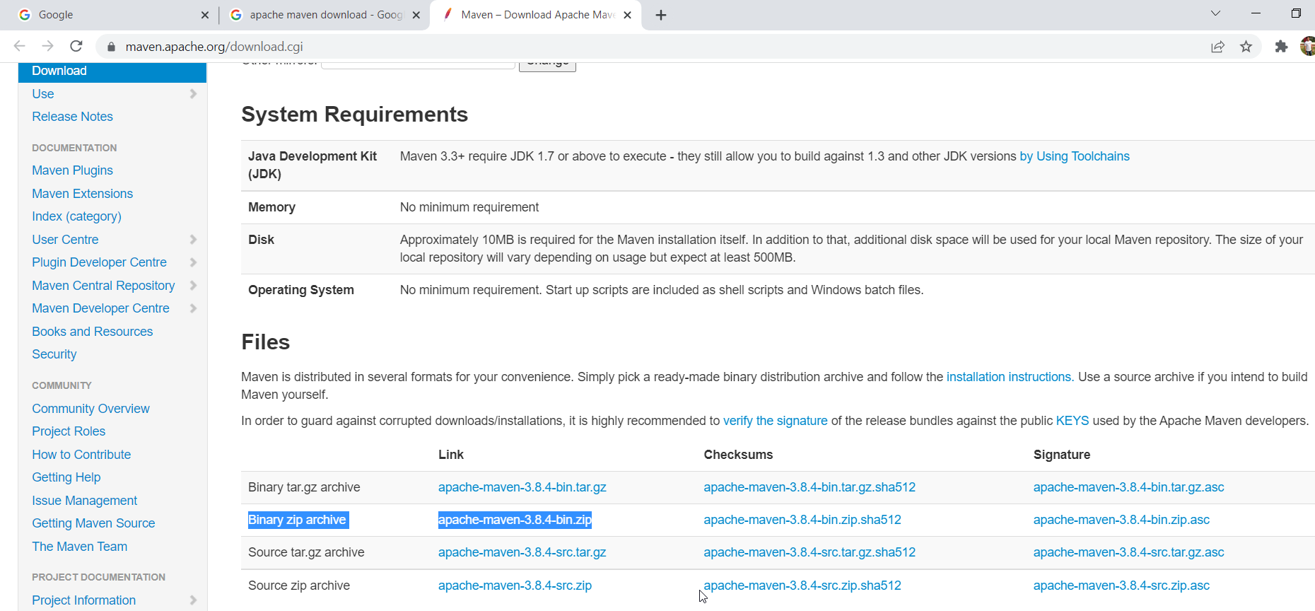

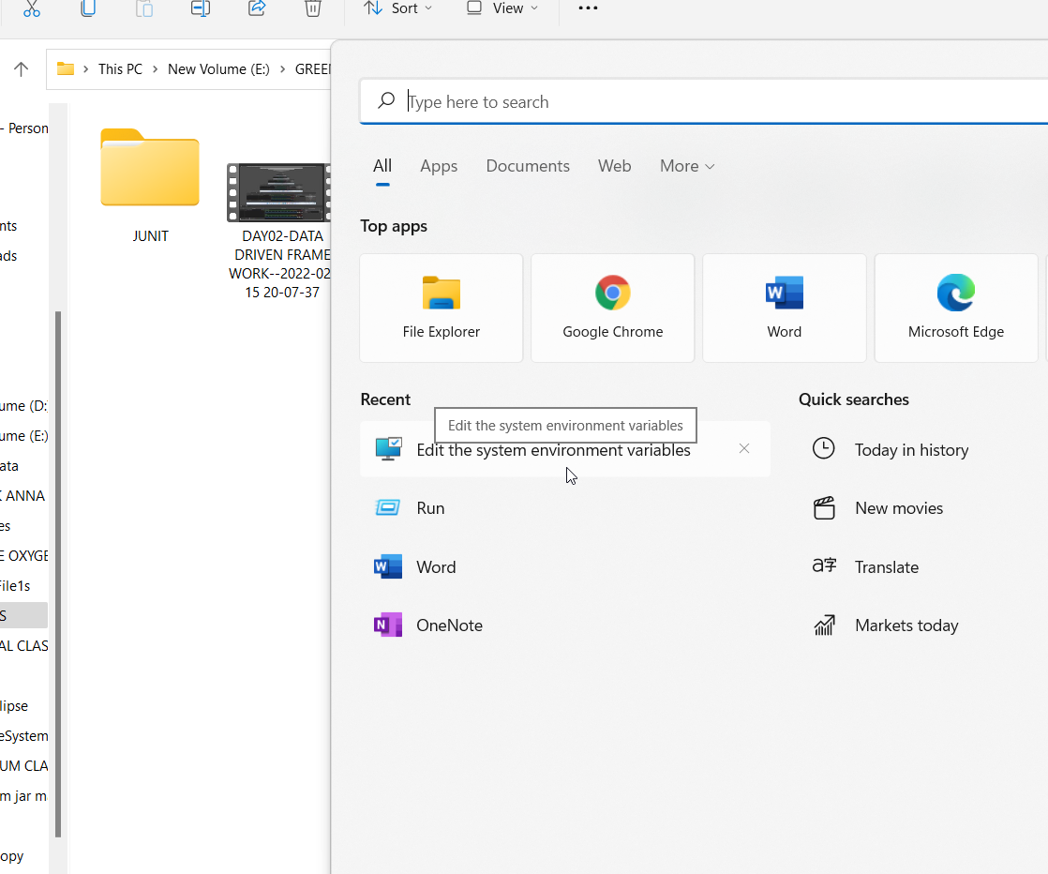

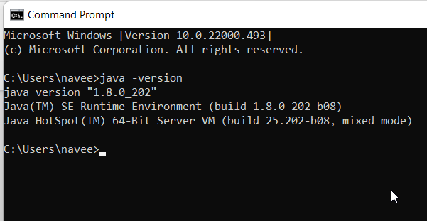

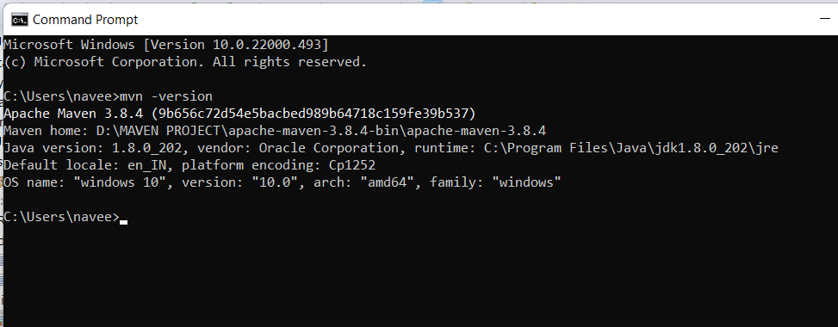

To import the web driver in maven project:

Src/test/java—right click—class and package create

Step:1----3.141.59 maven dependency—search in google –copy dependency—paste pox in project –inside the project paste it.

To import the web driver manager in maven project:

Step:2----webdrivermanager maven dependcency—in google search---5.0.3—click—copy and paste in pox.xml

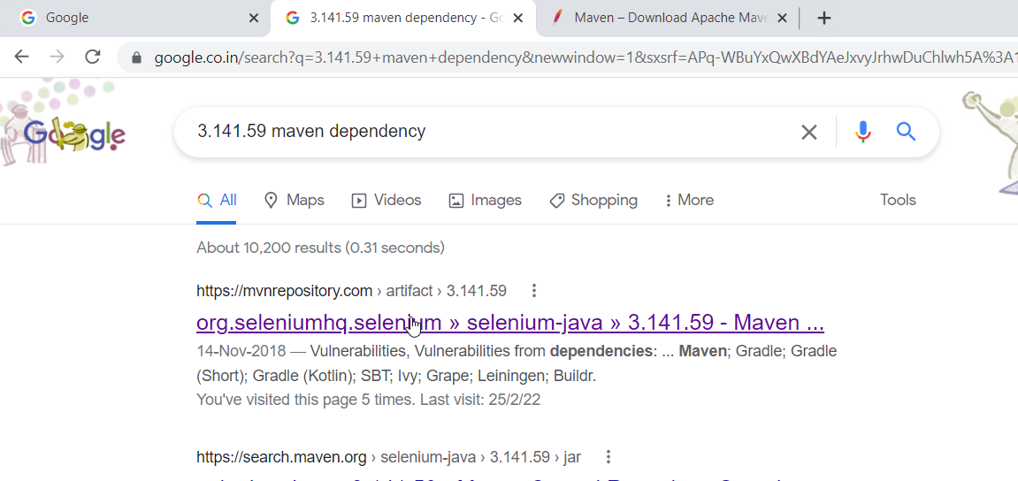

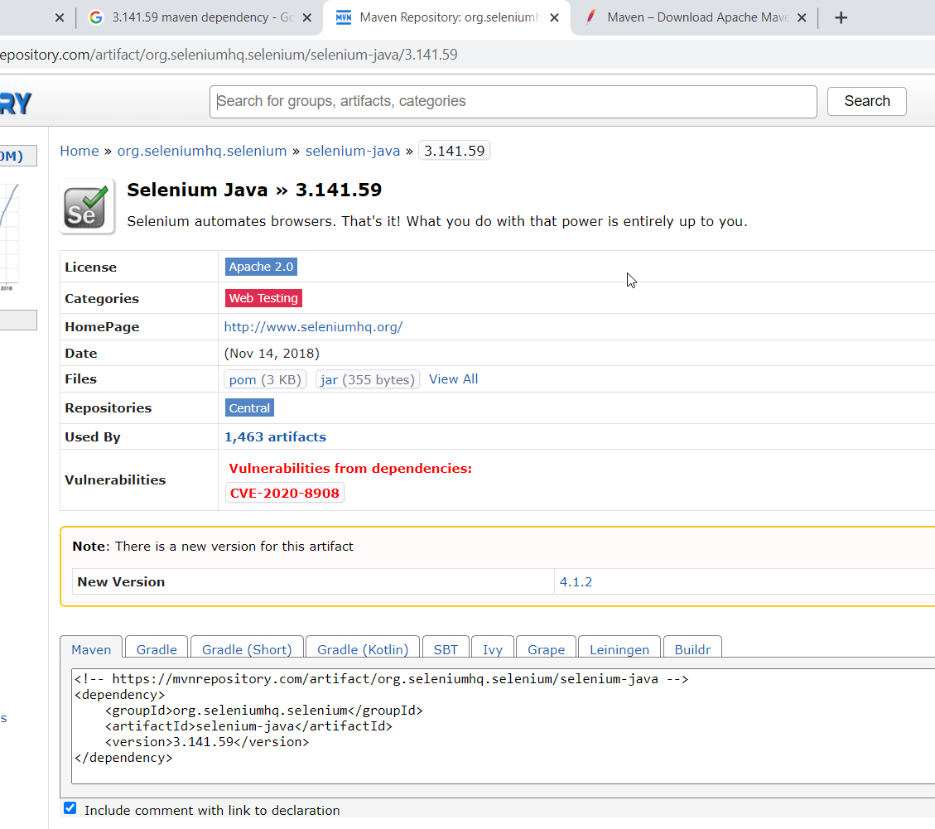

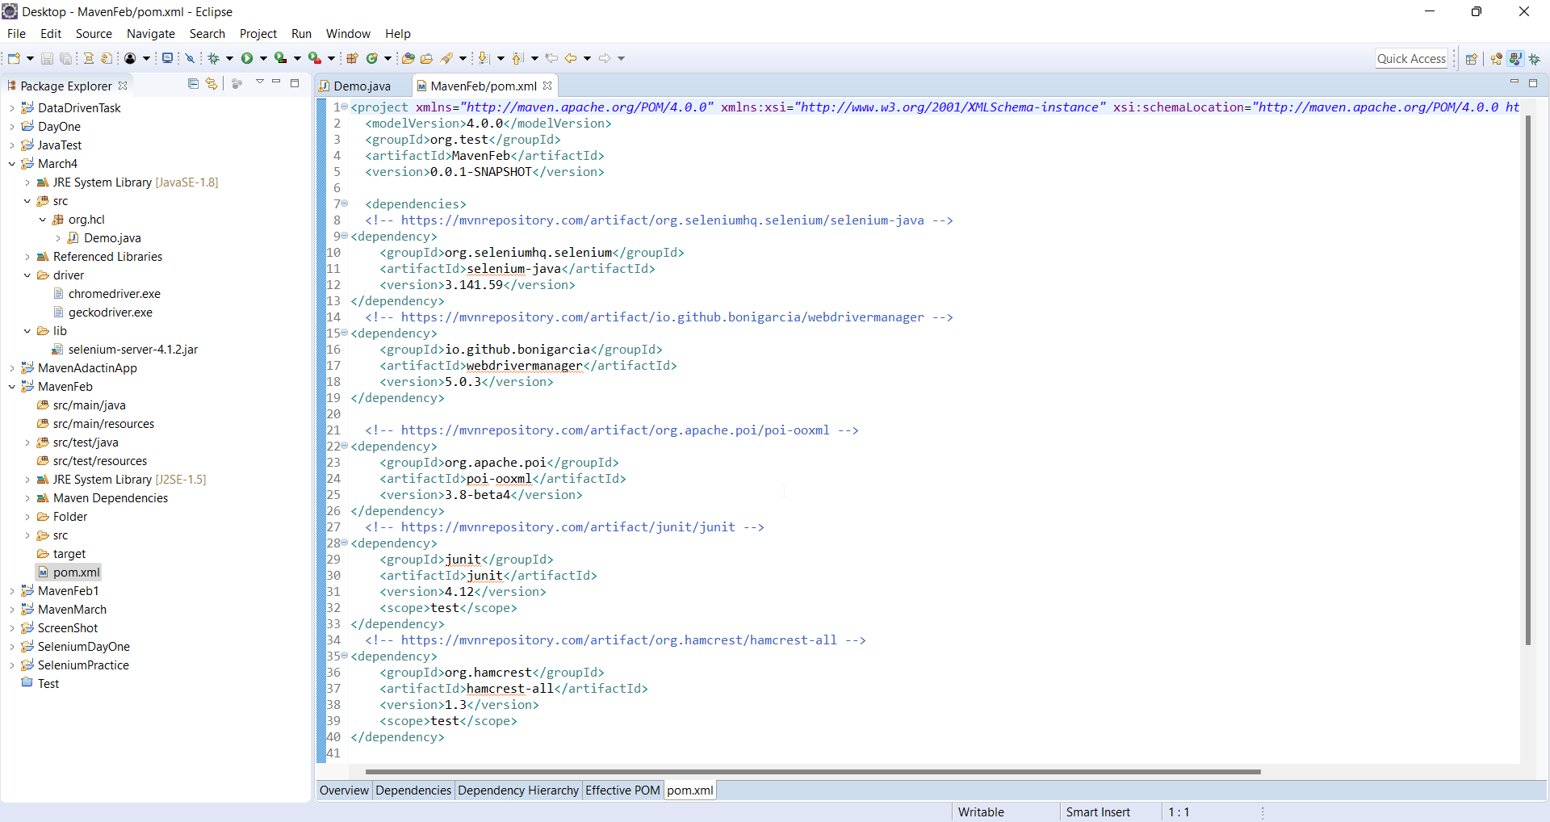

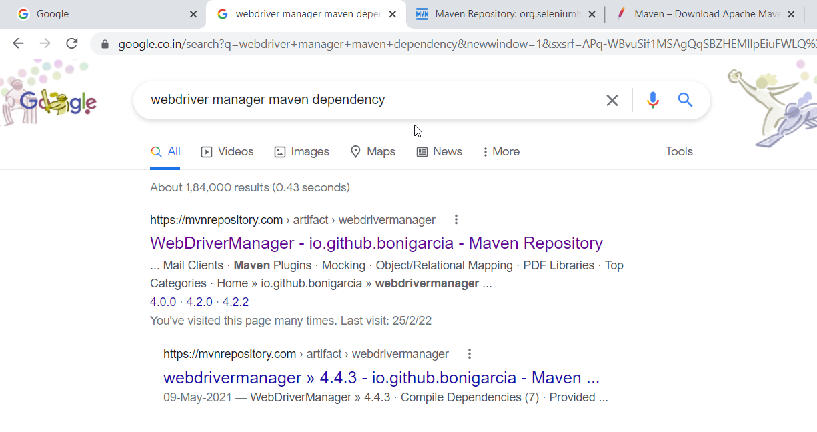

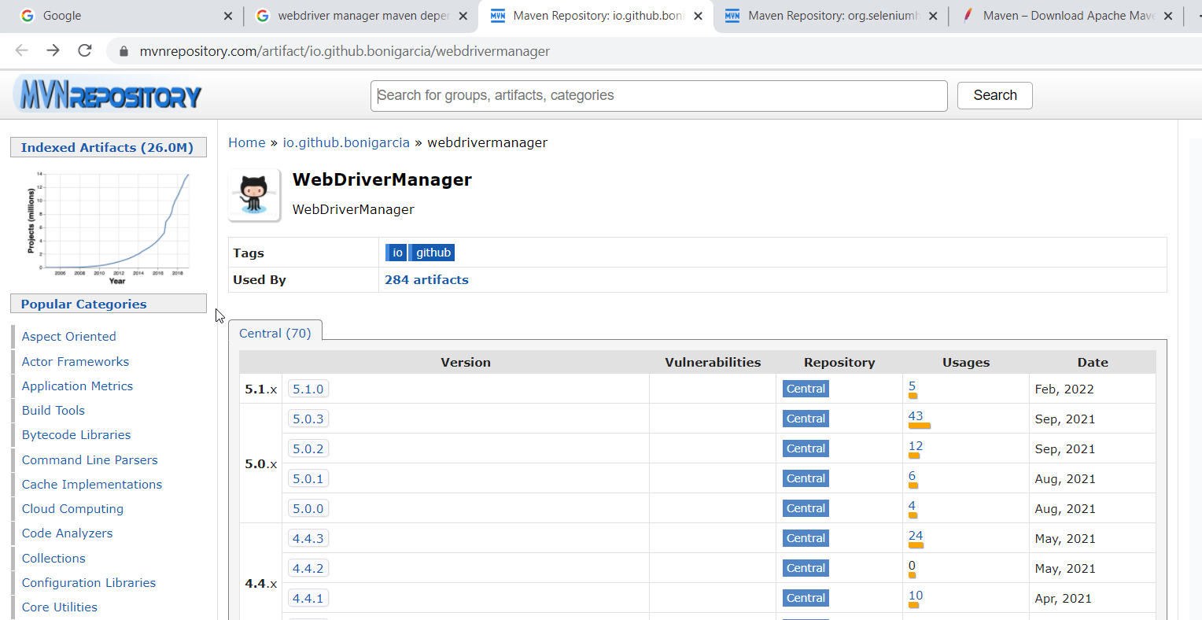

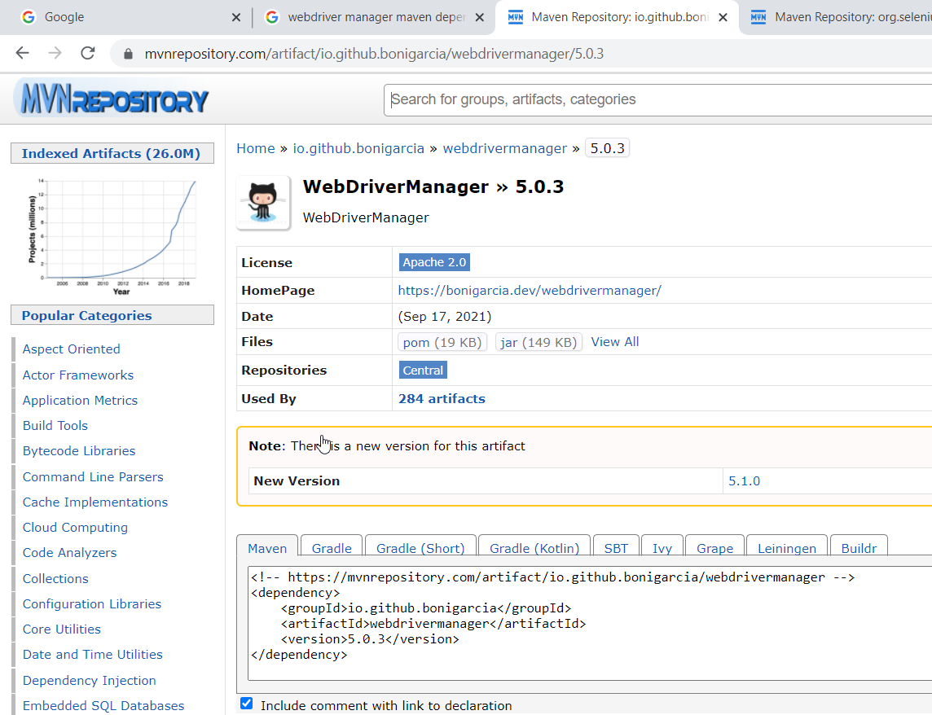

To get the work book in maven project:(data driven framework)

1.Apache poi-ooxml 3.8 beta 4 maven dependency—google search—paste in dependency

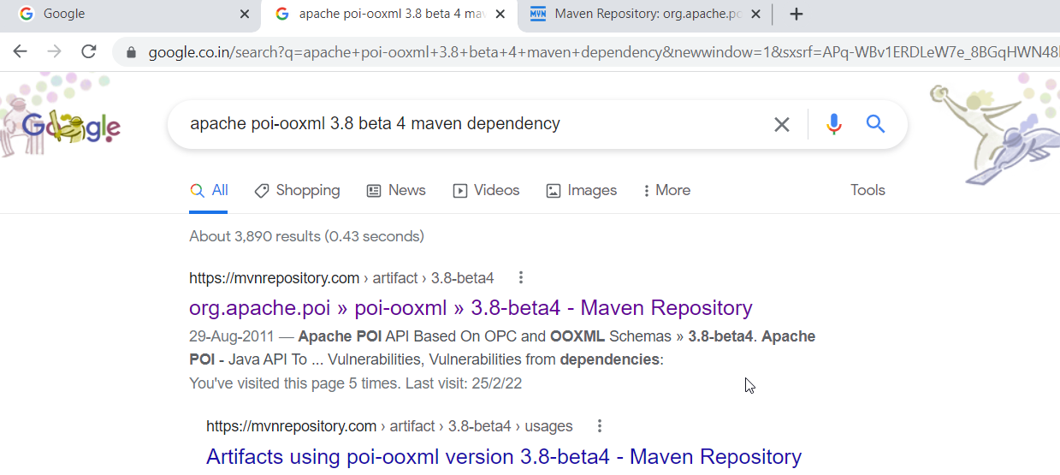

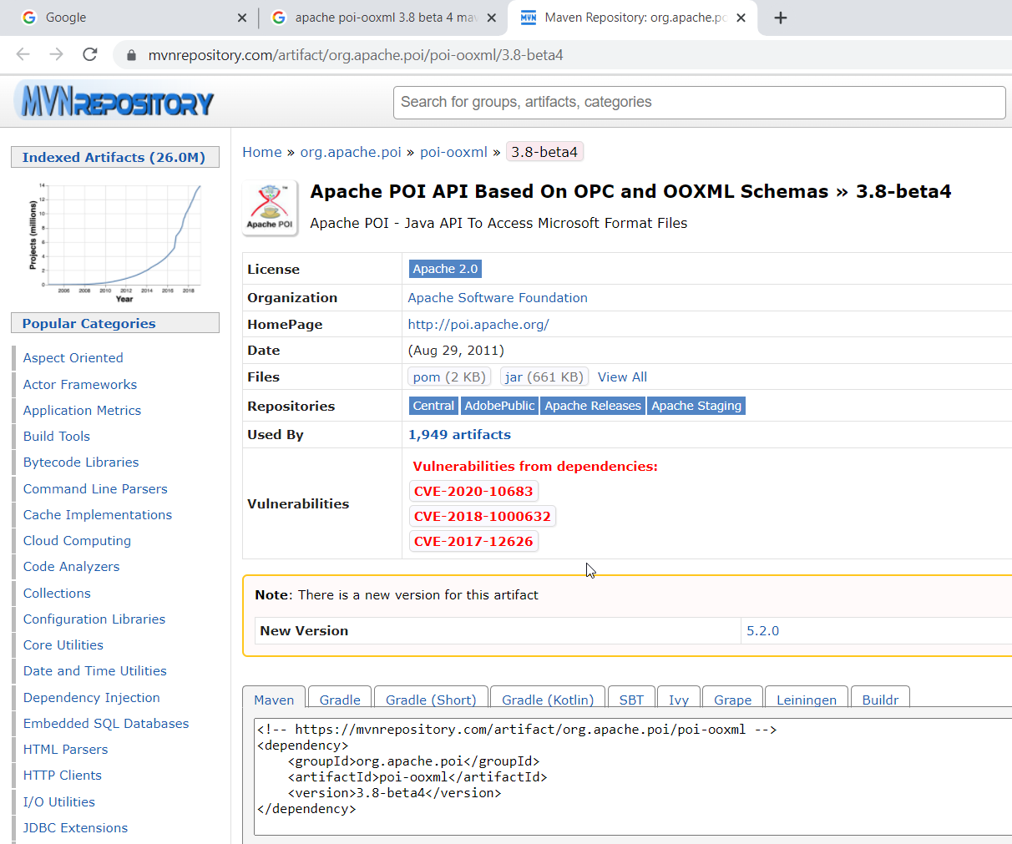

JUNIT FRAMEWORK:

Dependencies:

1.junit—4.12

2.hamcrest all -1.3

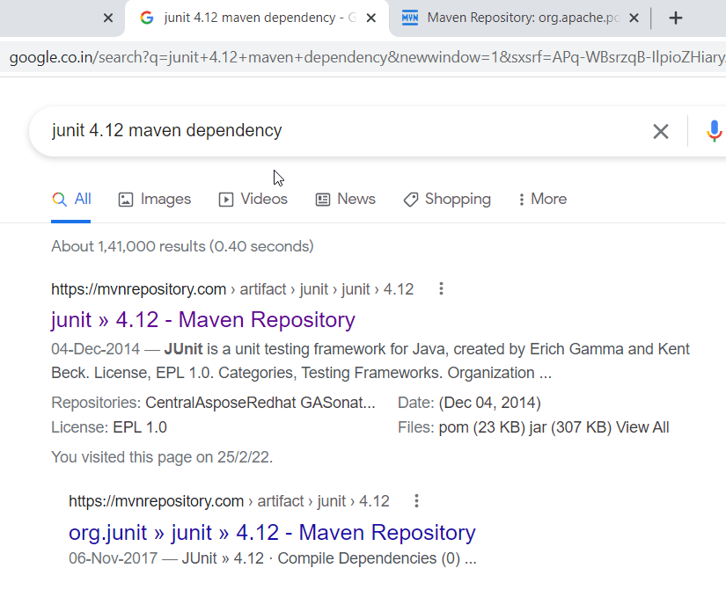

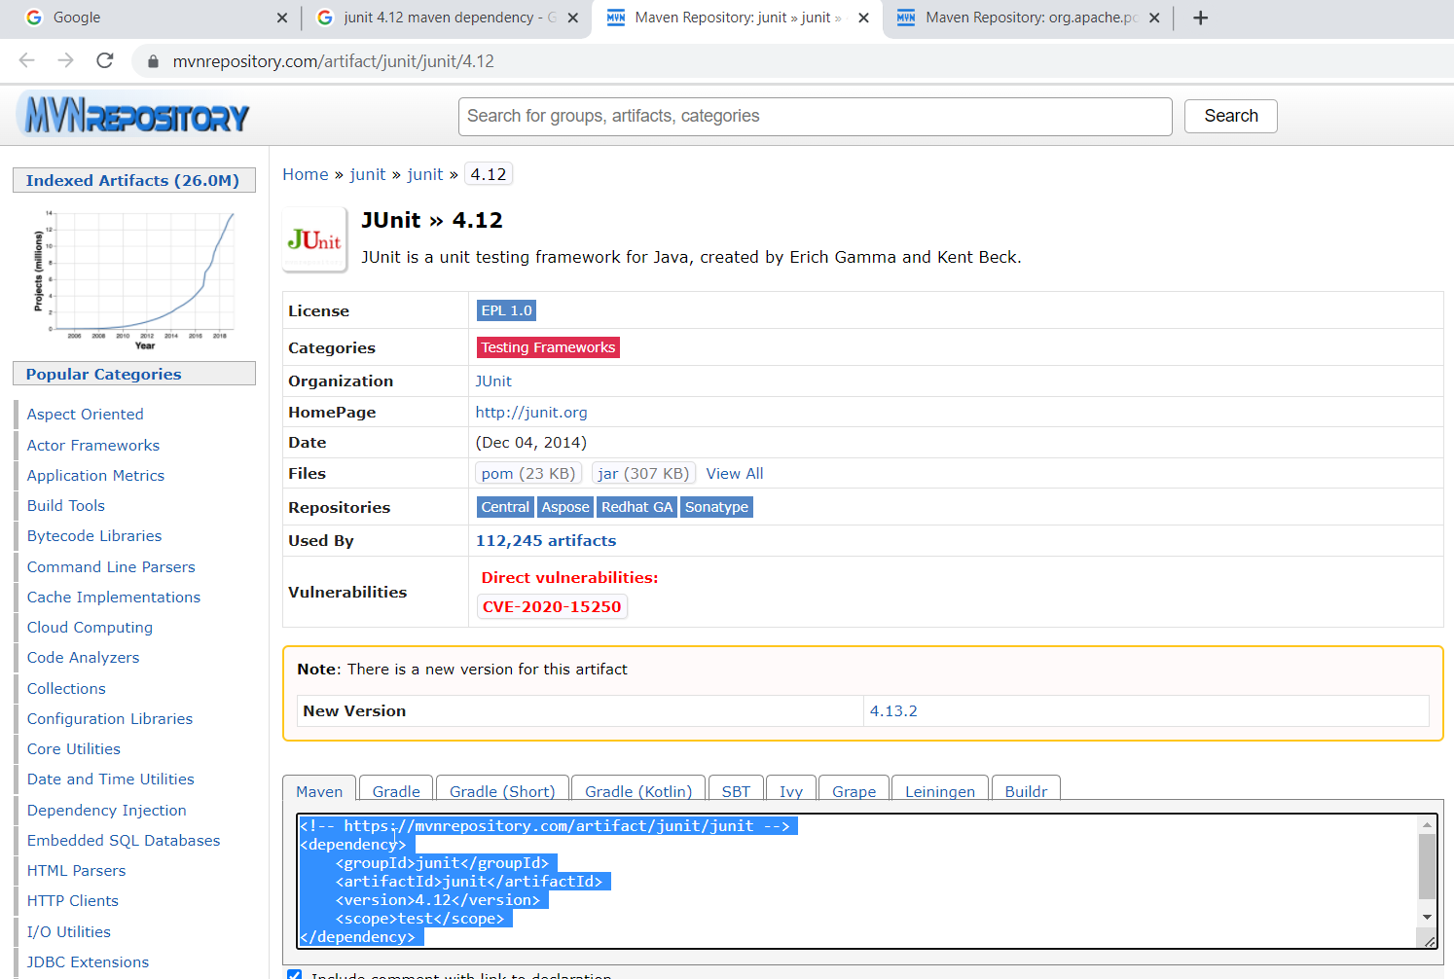

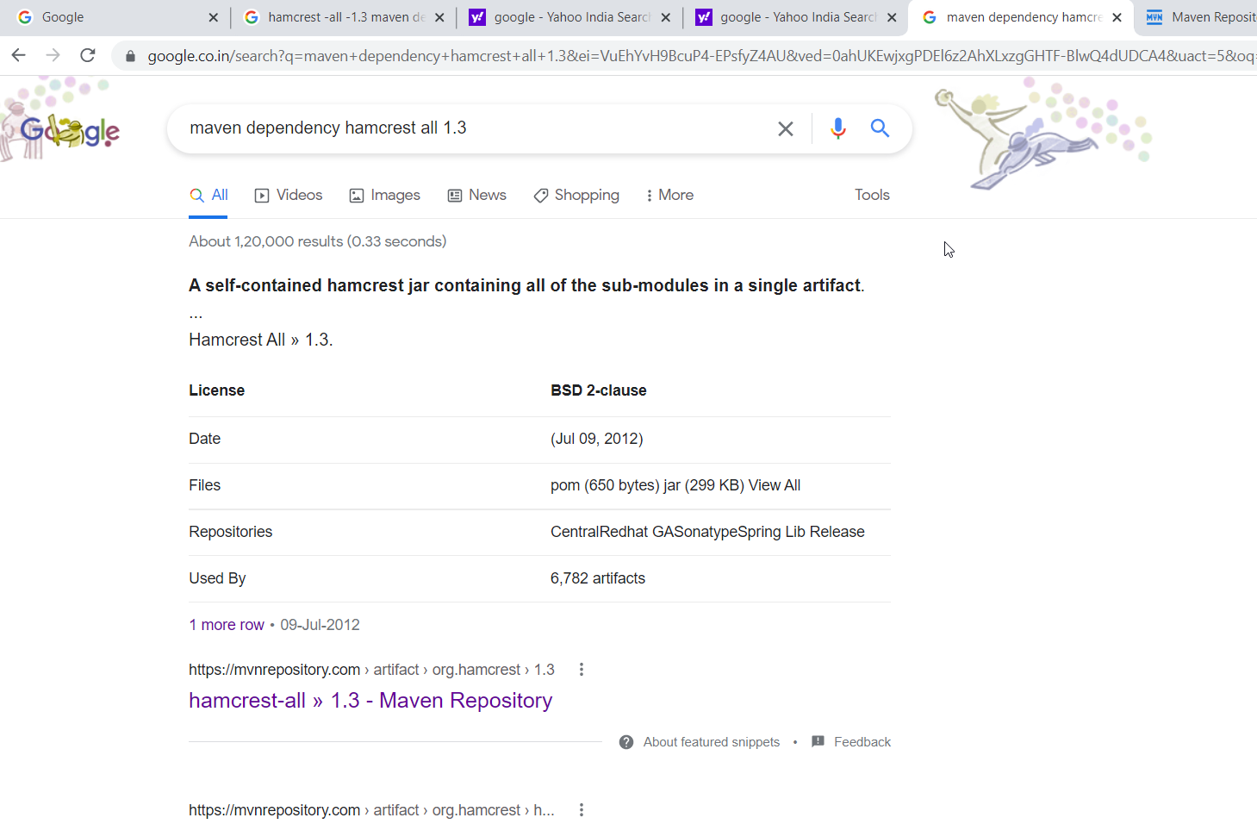

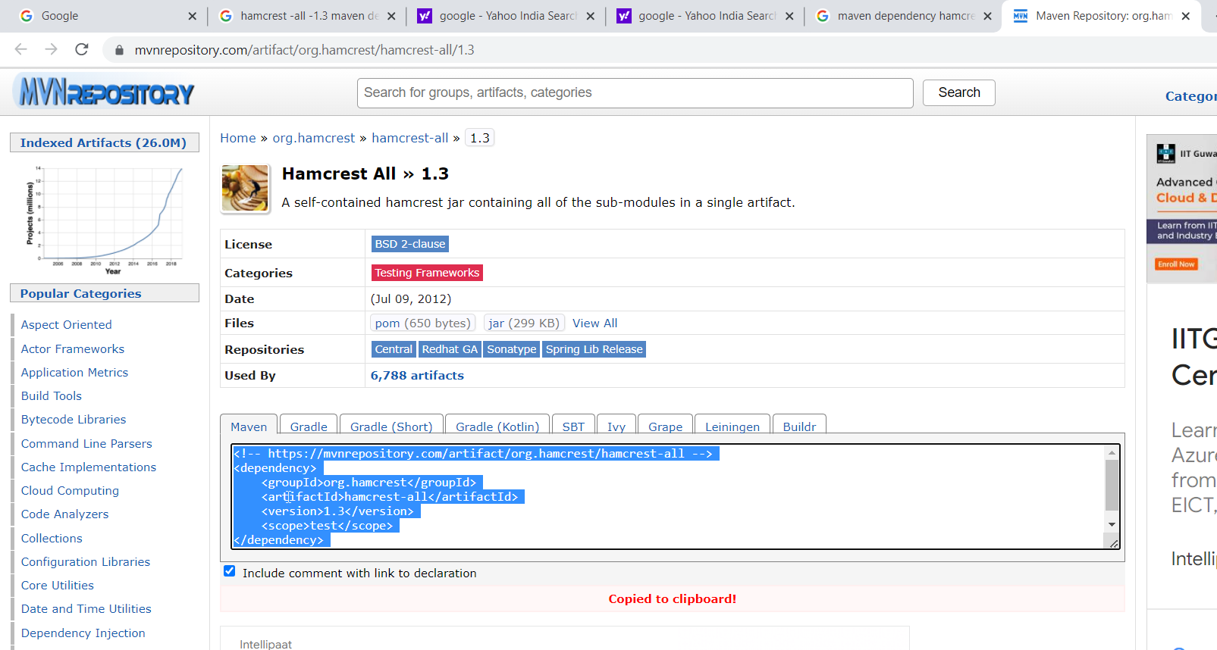

+++++++++++++++++++++++++++++++++++++++++++++++++++++++++++++++++++++

TestNG installation:

Date:08-03-2022

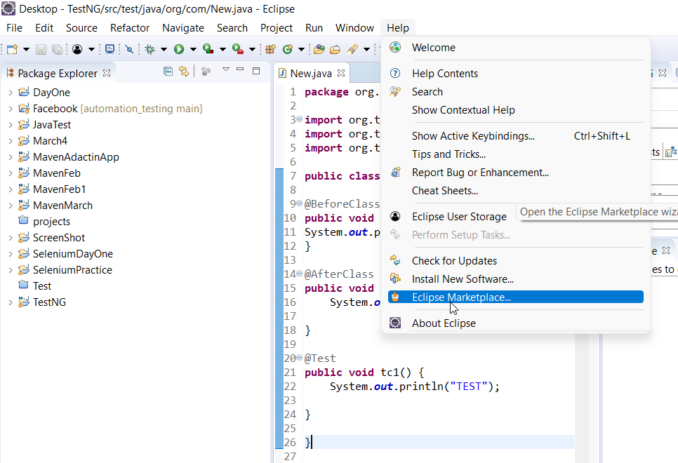

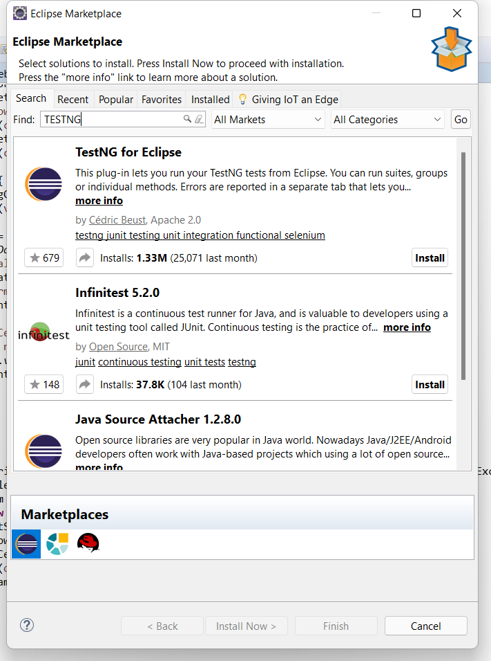

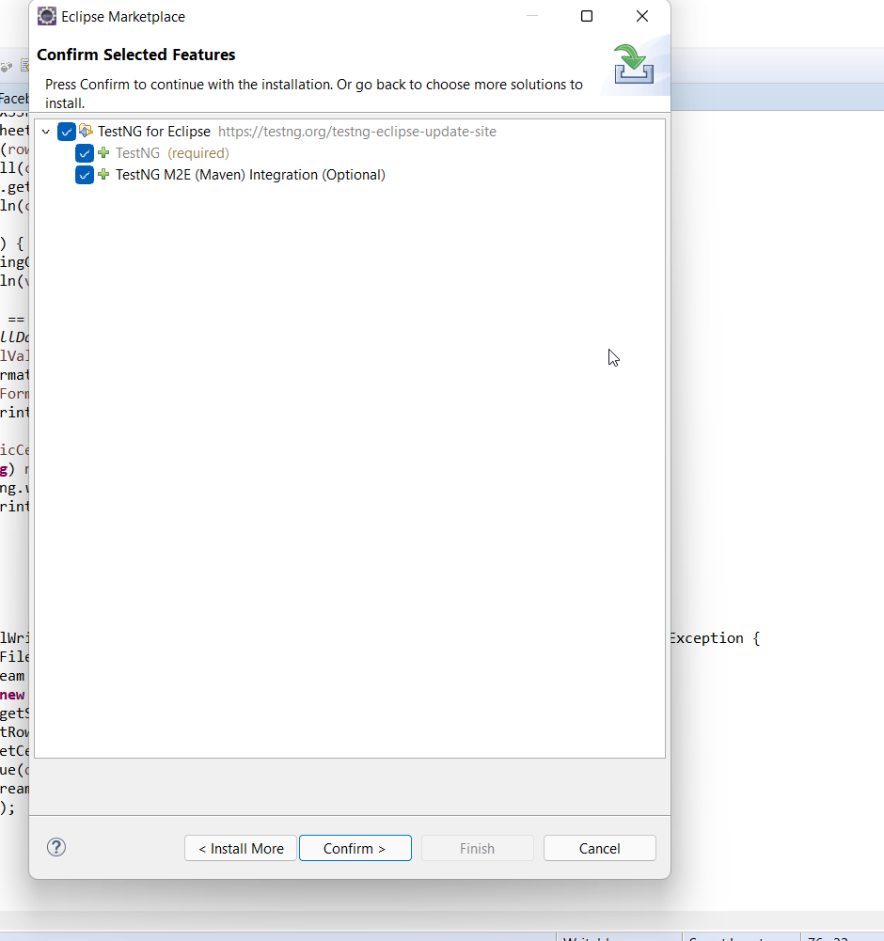

(it consume more time to install approimately ---5hrs)

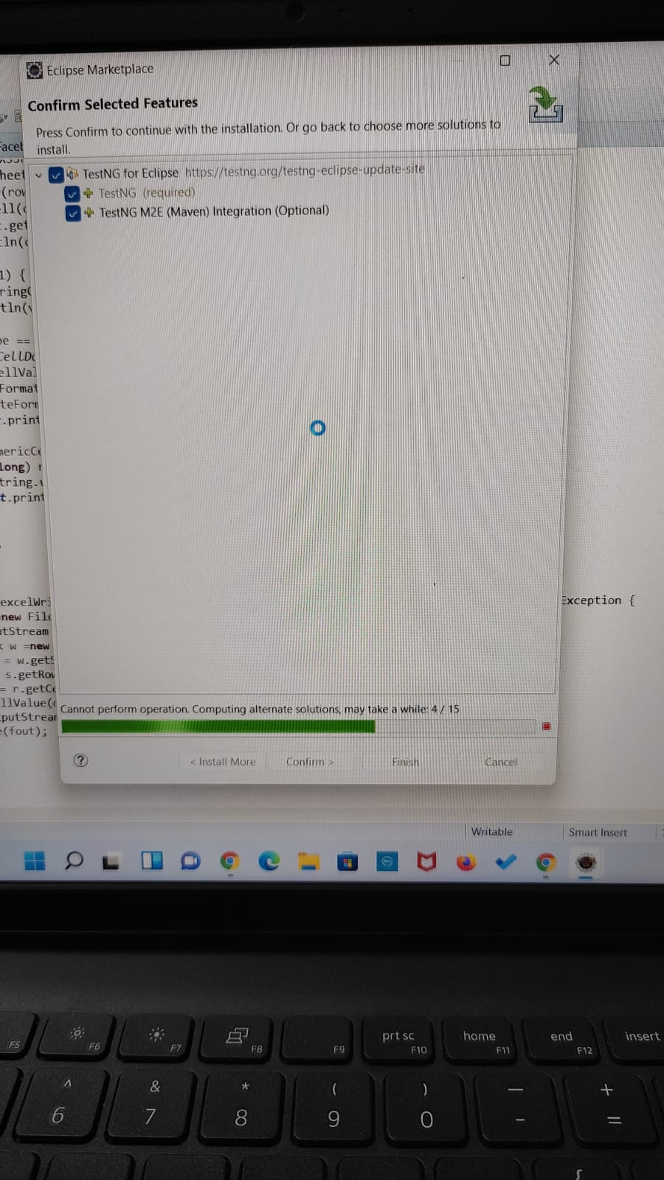

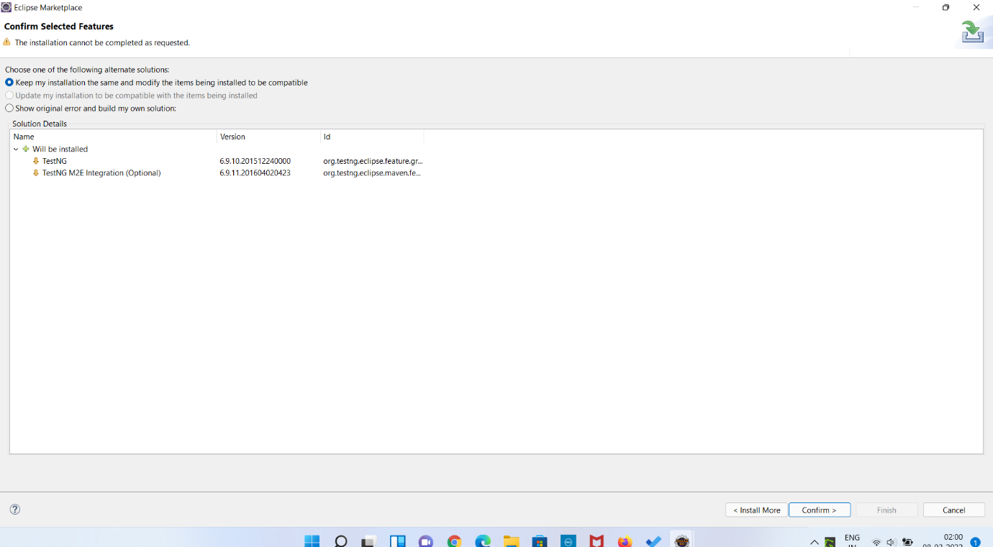

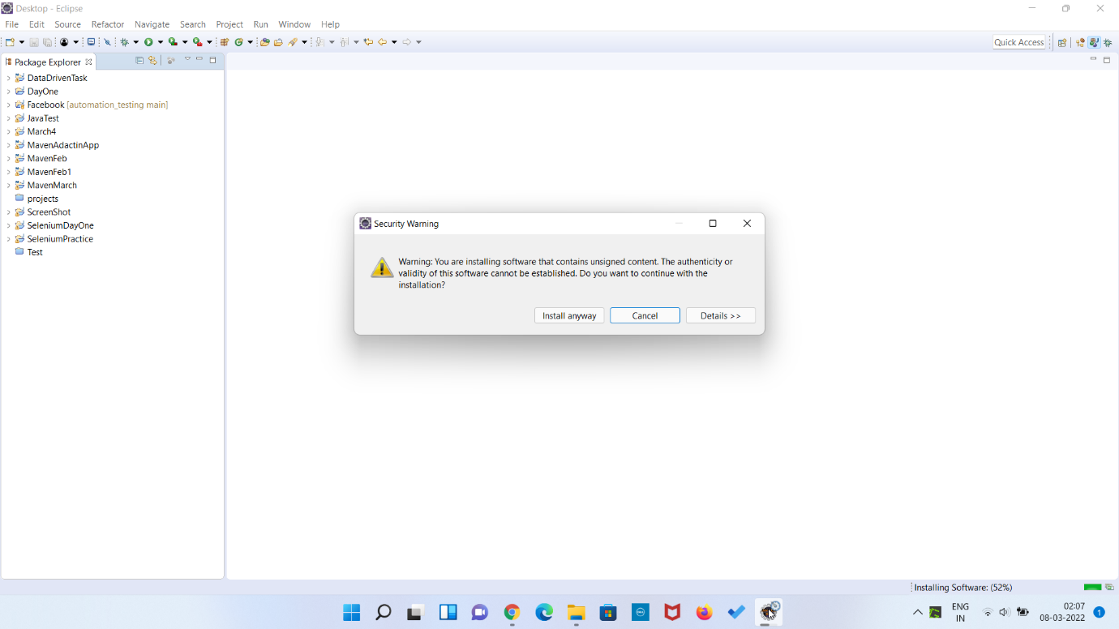

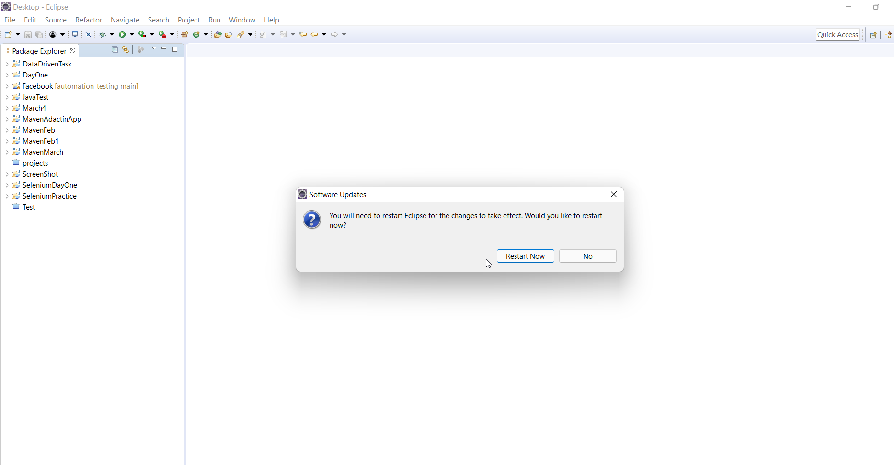

DEPENDENCIES:

Higher Version:

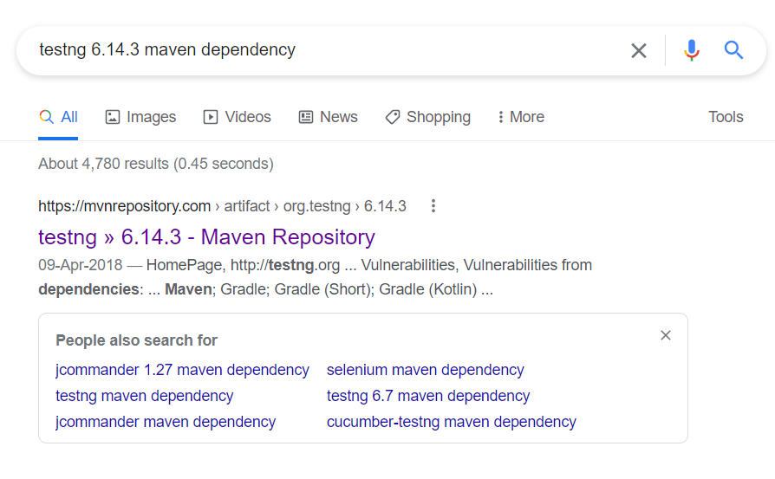

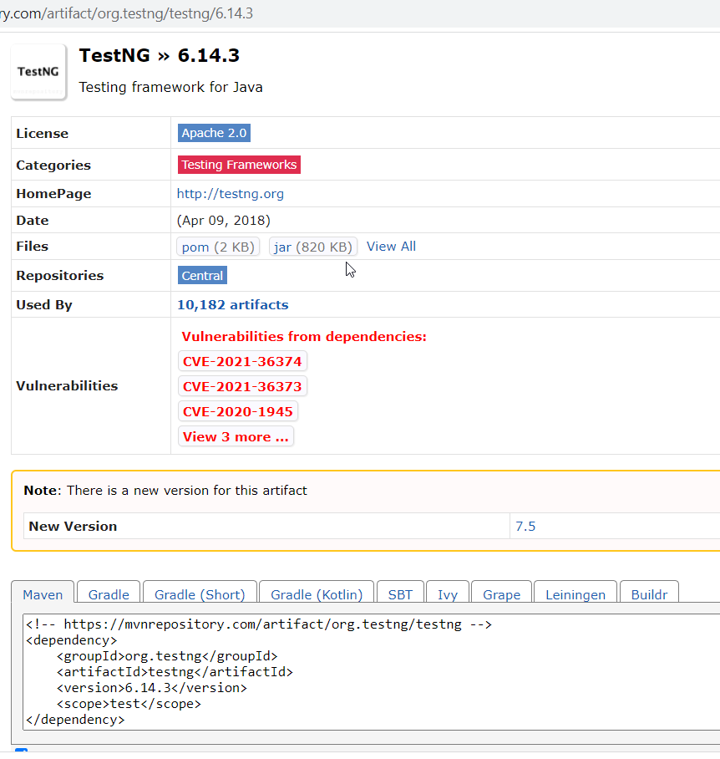

+++++++++++++++++++++++++++

Lower version(If not supported above one ,use this one)

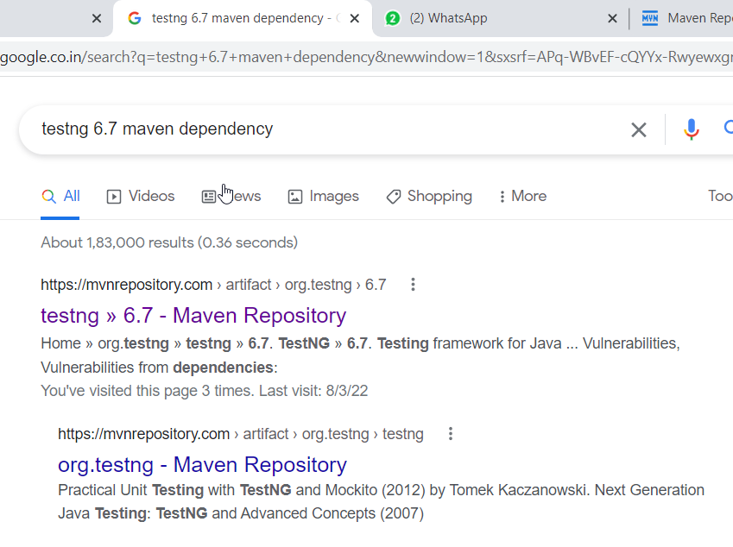

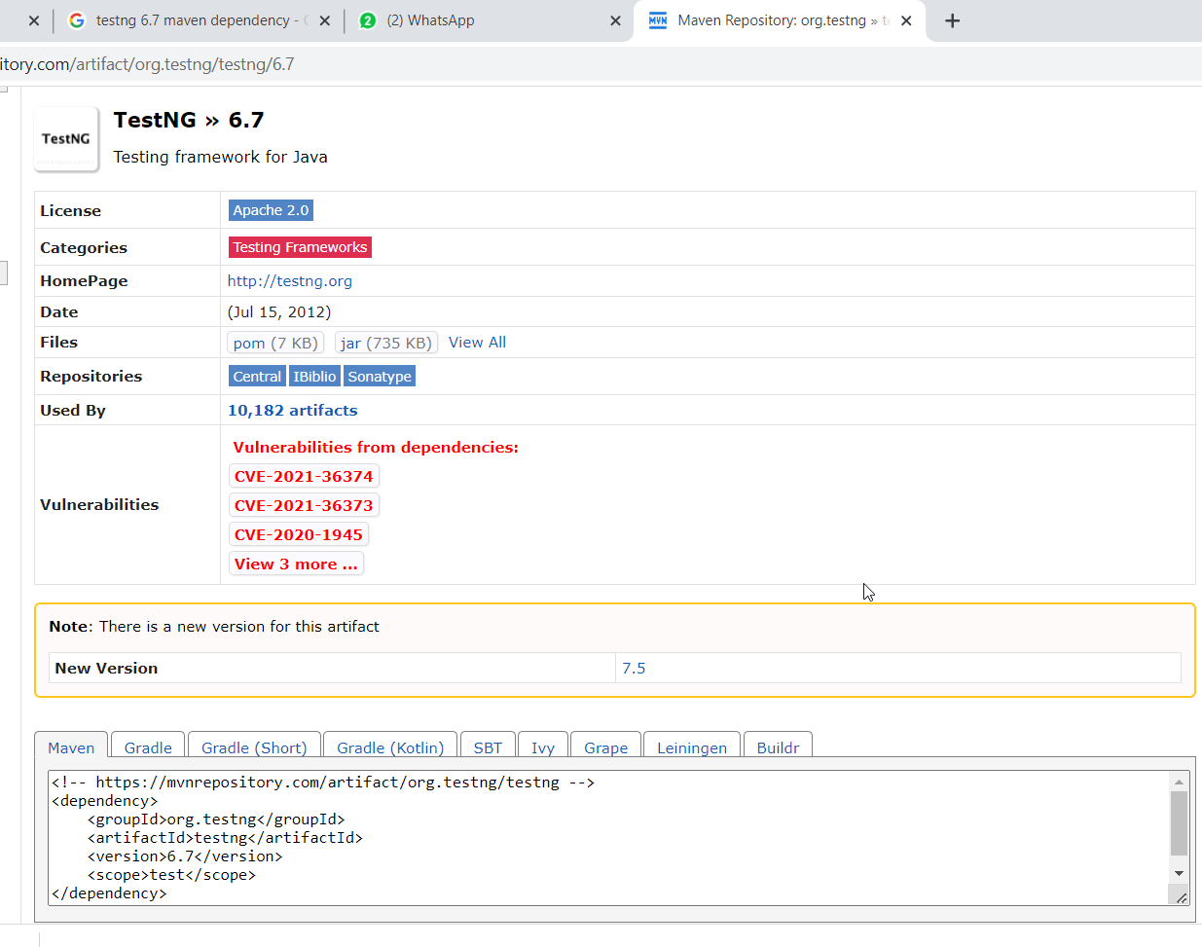

+++++++++++++++++++++++++++++++++++++++++++++++++++++++++++++++++++++++++++

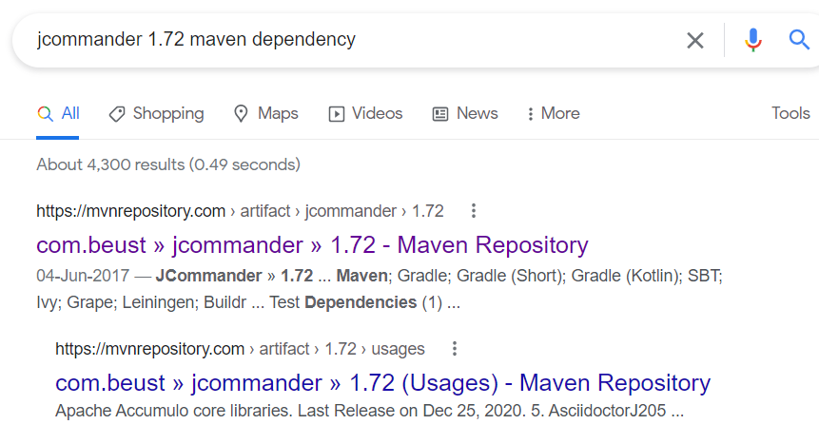

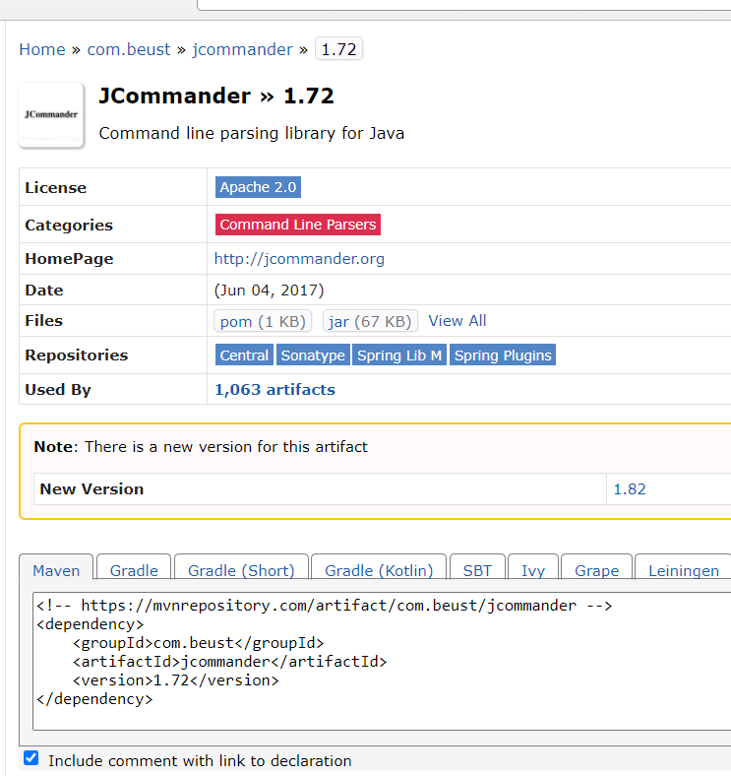

+++++++++++++++++++++++++++++++++++++++++

Cucumber Installation:

Date:08-04-2022

CUCUMBER CLASS NOTES:

DATE:08-04-2022

INSTALLATION PROCEDURE:

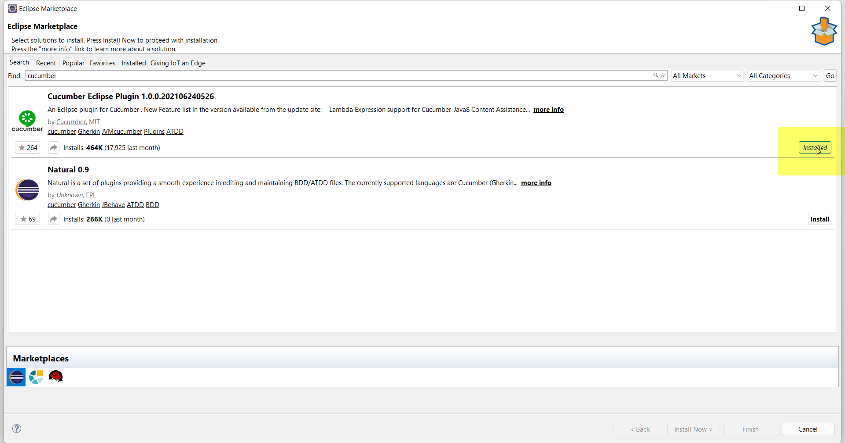

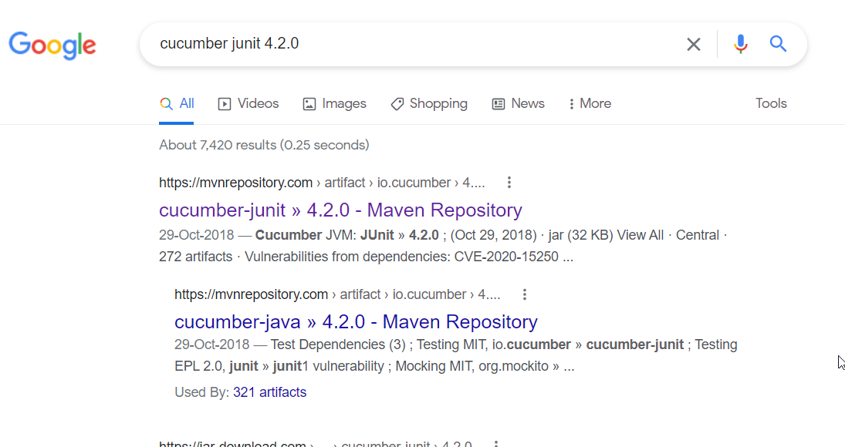

CUCUMBER JUNIT AND CUCUMBER JAVA -🡪BOTH DEPENDENCY SAME VERSION:

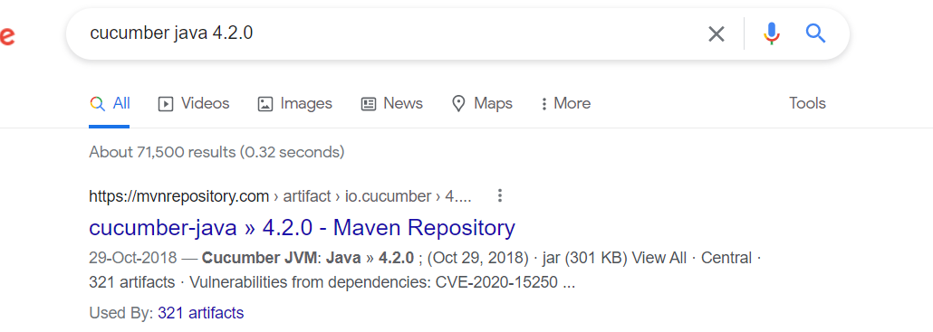

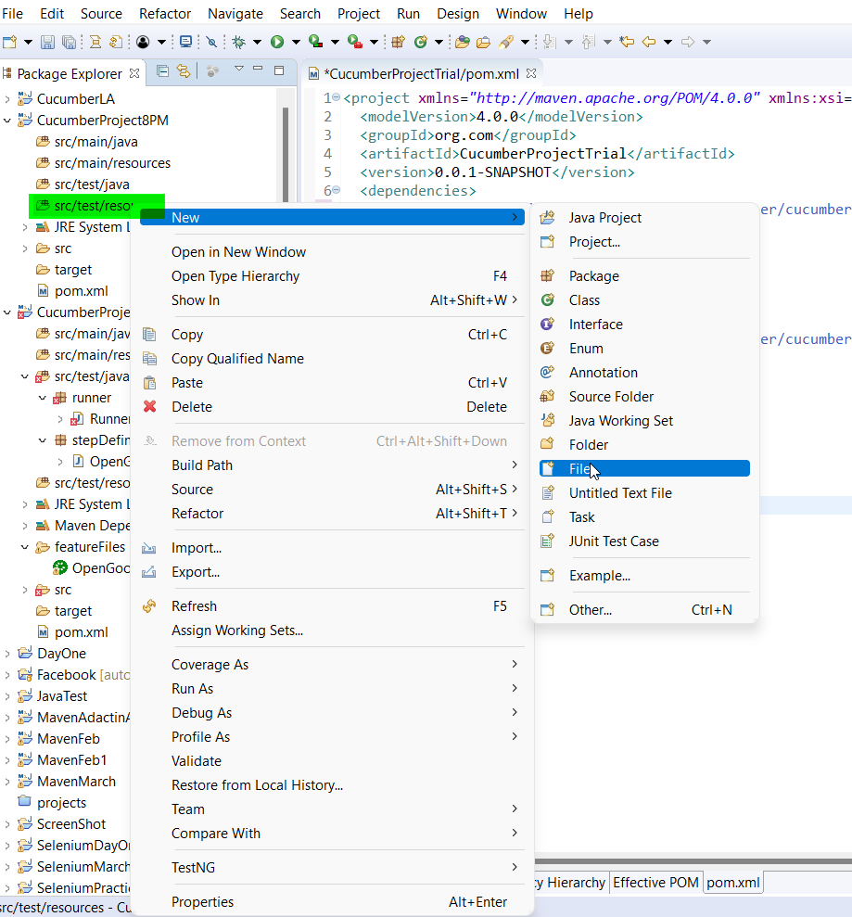

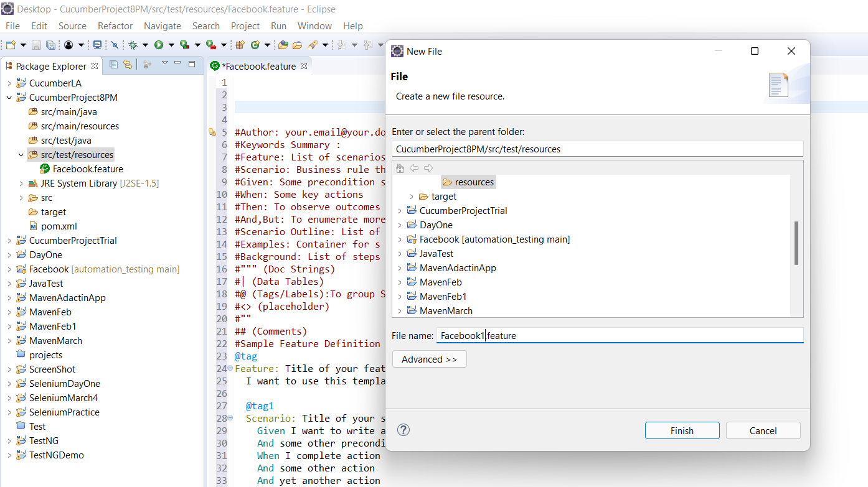

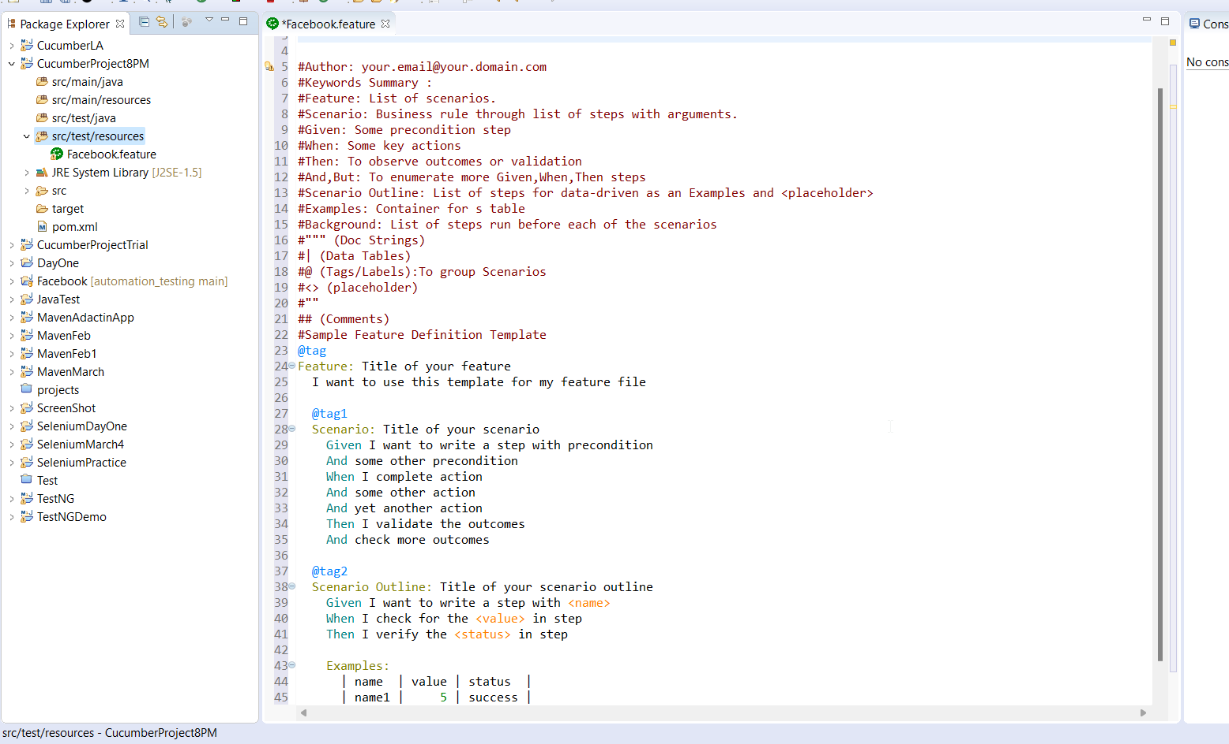

+++++++++++++++++++++++++++++++++++++++++

Feature:Verify login fuctionality in Facebook application

Scenario:Verify login functionality for valid username and invalid password

Given User is on Facebook login page

When User enters valid username and invalid password

When user clicks on login button

Then Error page is dispalyed

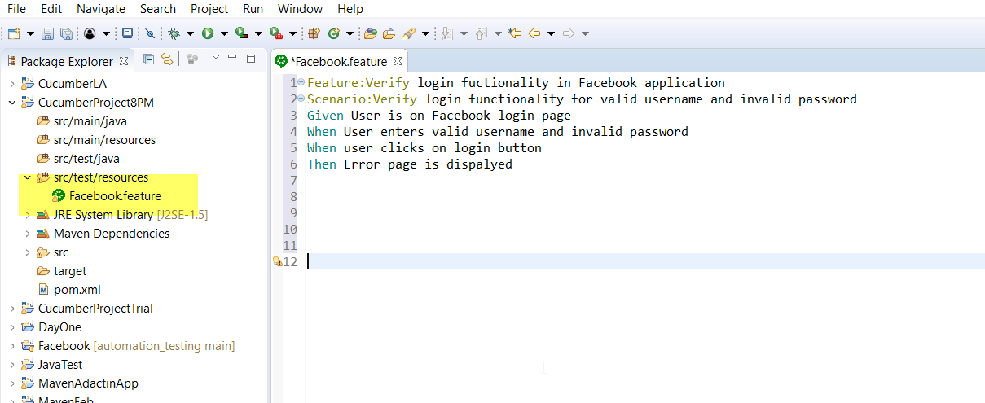

++++++++++++++++++++++++++++++++++++++++++++++++++++++++++++++++++++++

JDBC CONNECTION:

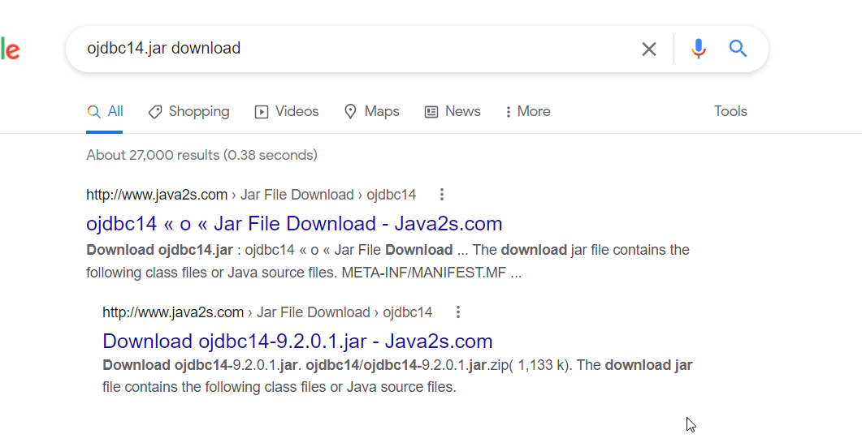

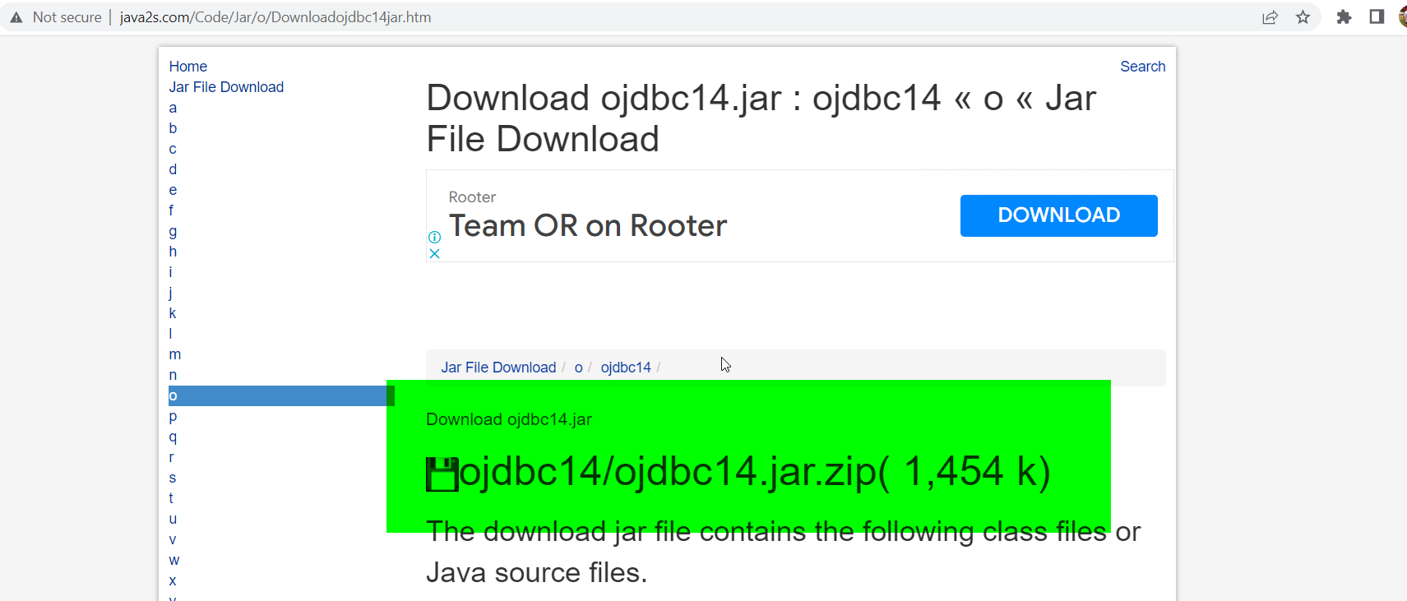

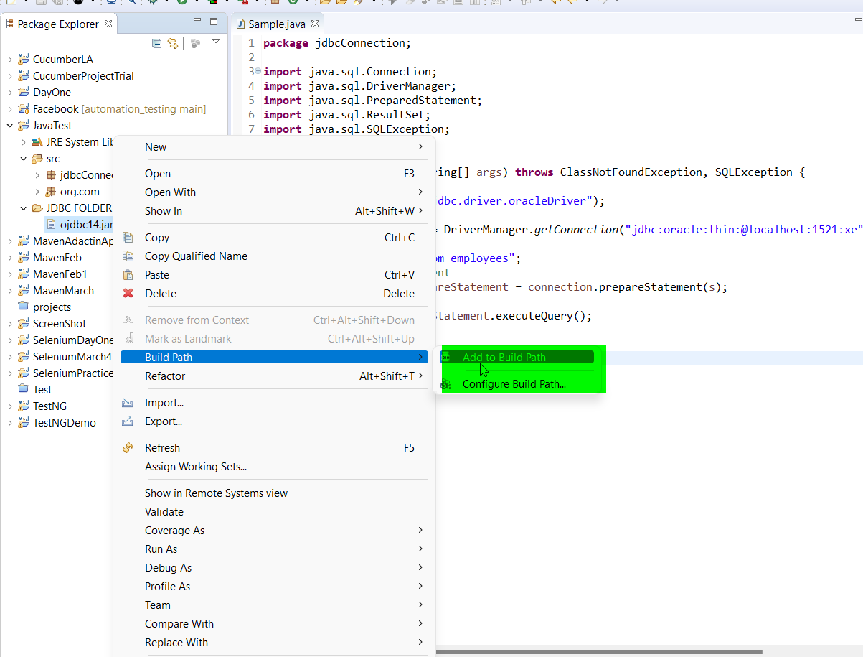

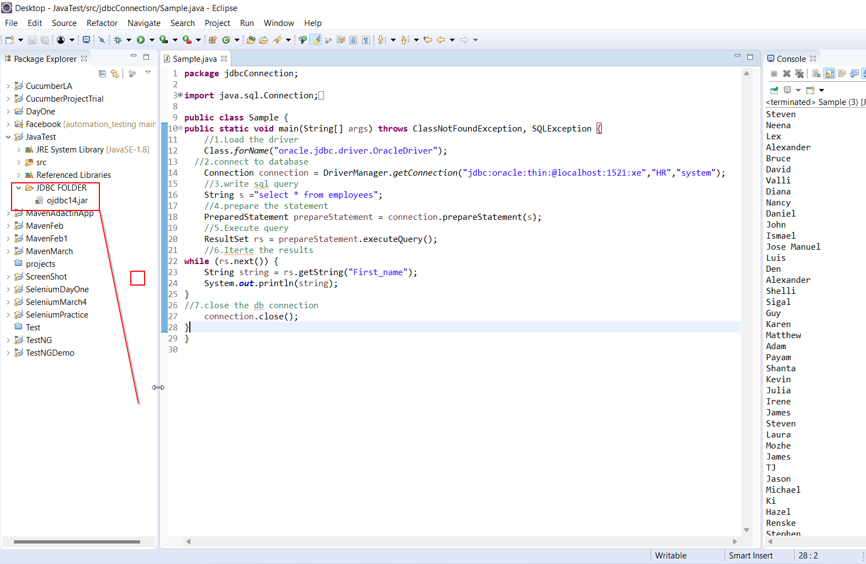

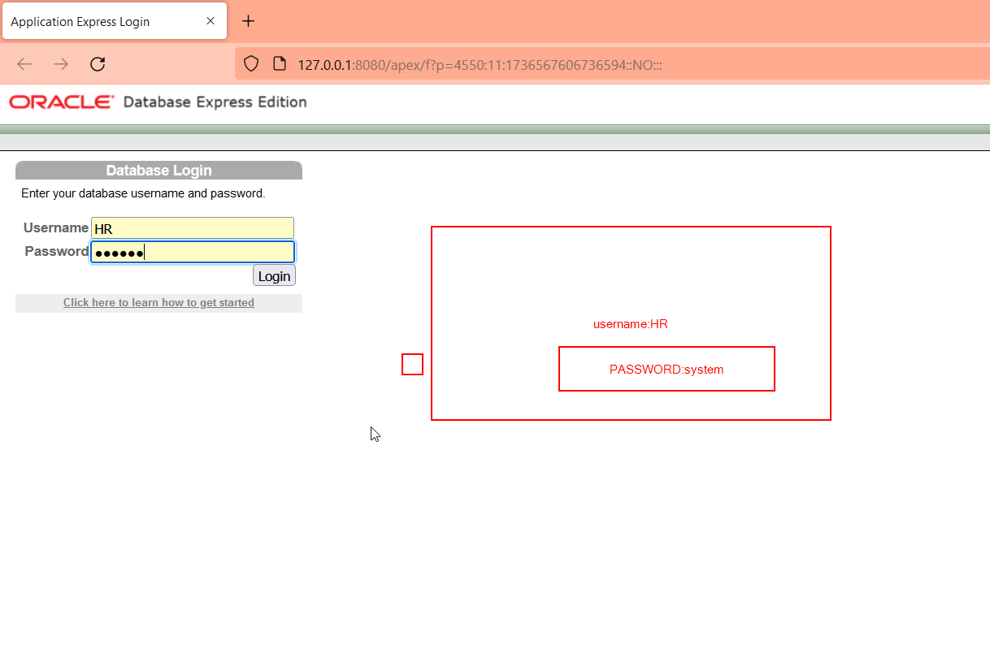

CUCUMBER:

CUCUMBER CLASS NOTES:

DATE:08-04-2022

INSTALLATION PROCEDURE:

1.Install the plugin

2.Dependencies add in pom.xml

a.cucumber junit-4.2.0

b.cucumber -java -4.2.0

c.WebDriver manager maven dependency –5.1.1

d.Selenium maven dependency-4.1.3







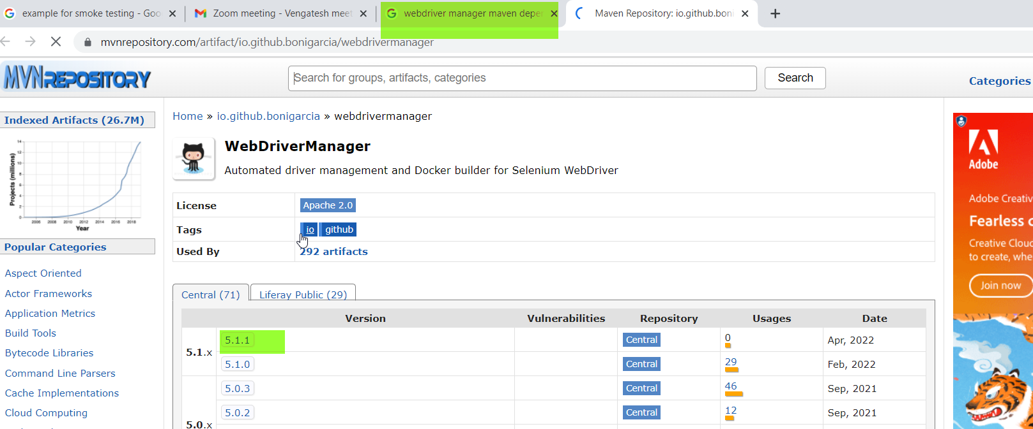

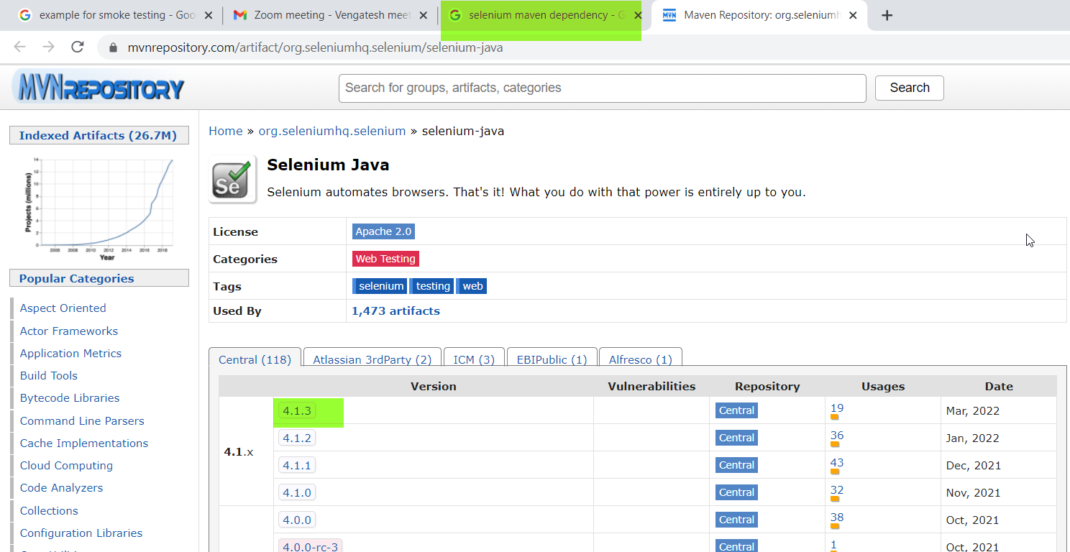







+++++++++++++++++++++++++++++++++++++++++

JENKINS:

Jenkins:

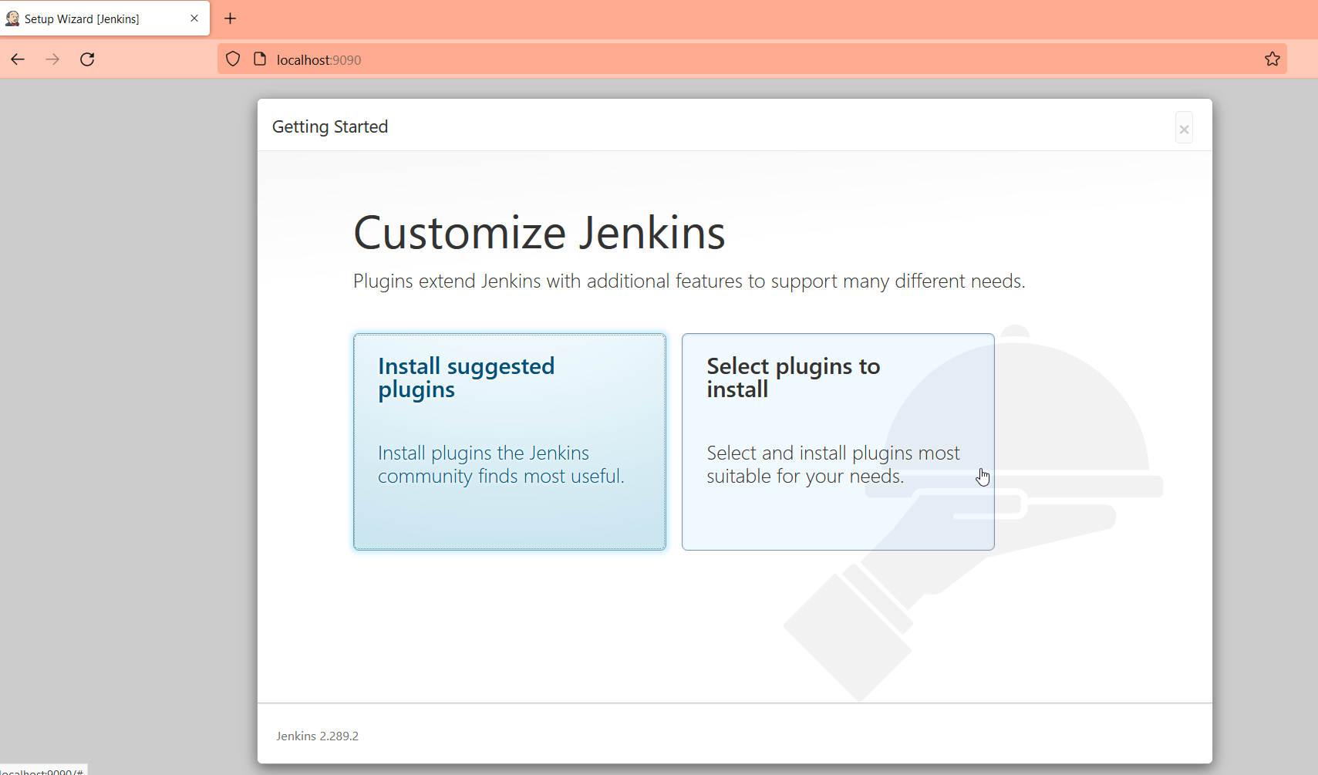

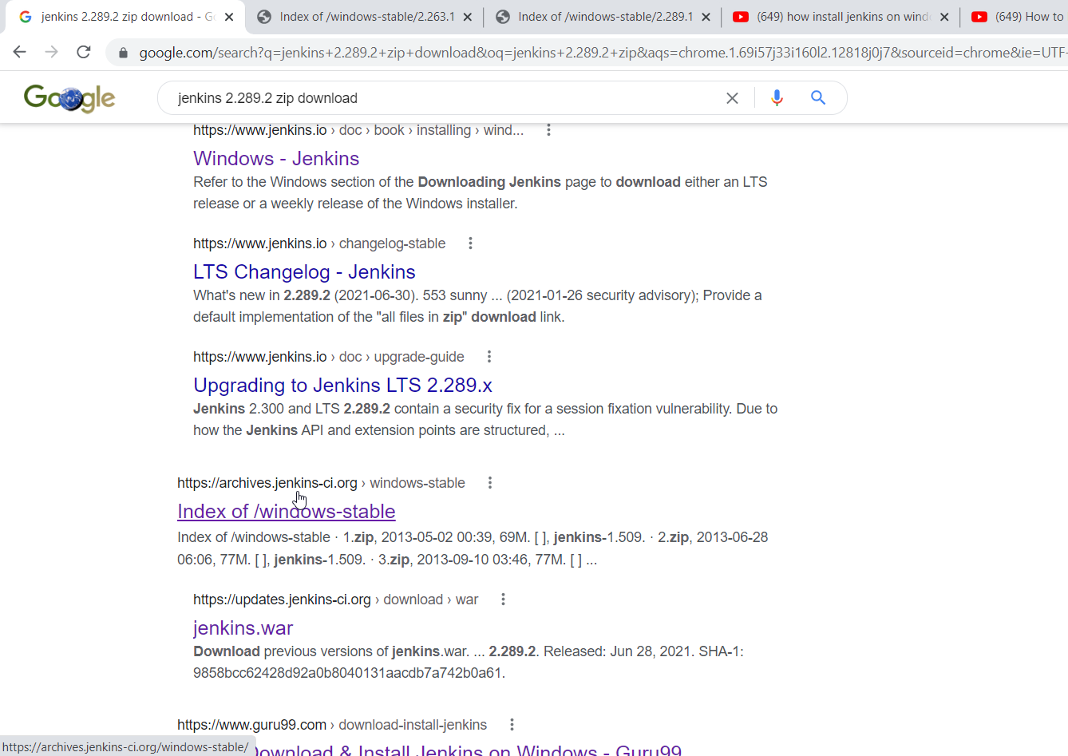

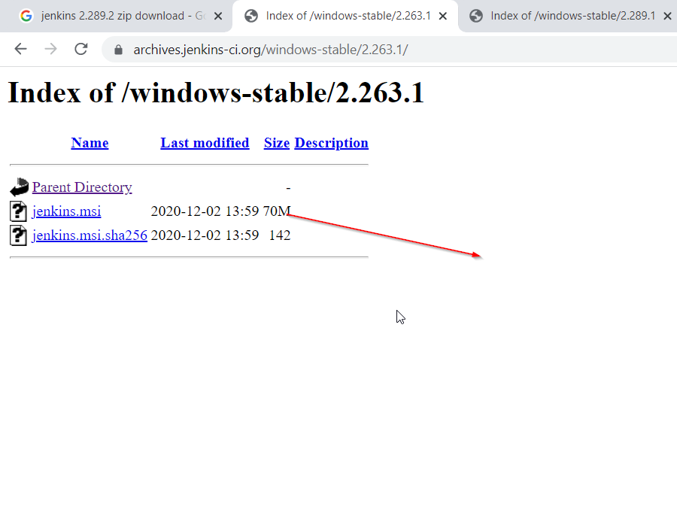

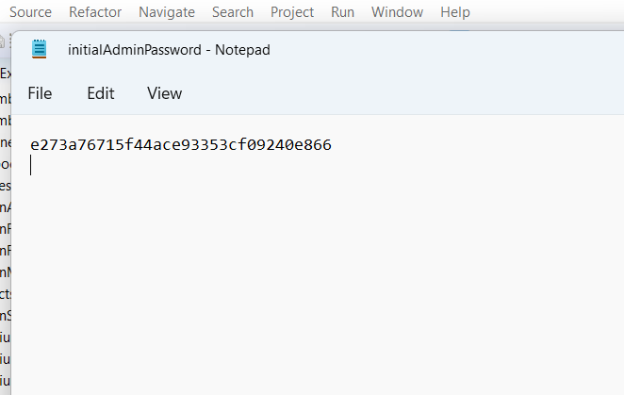

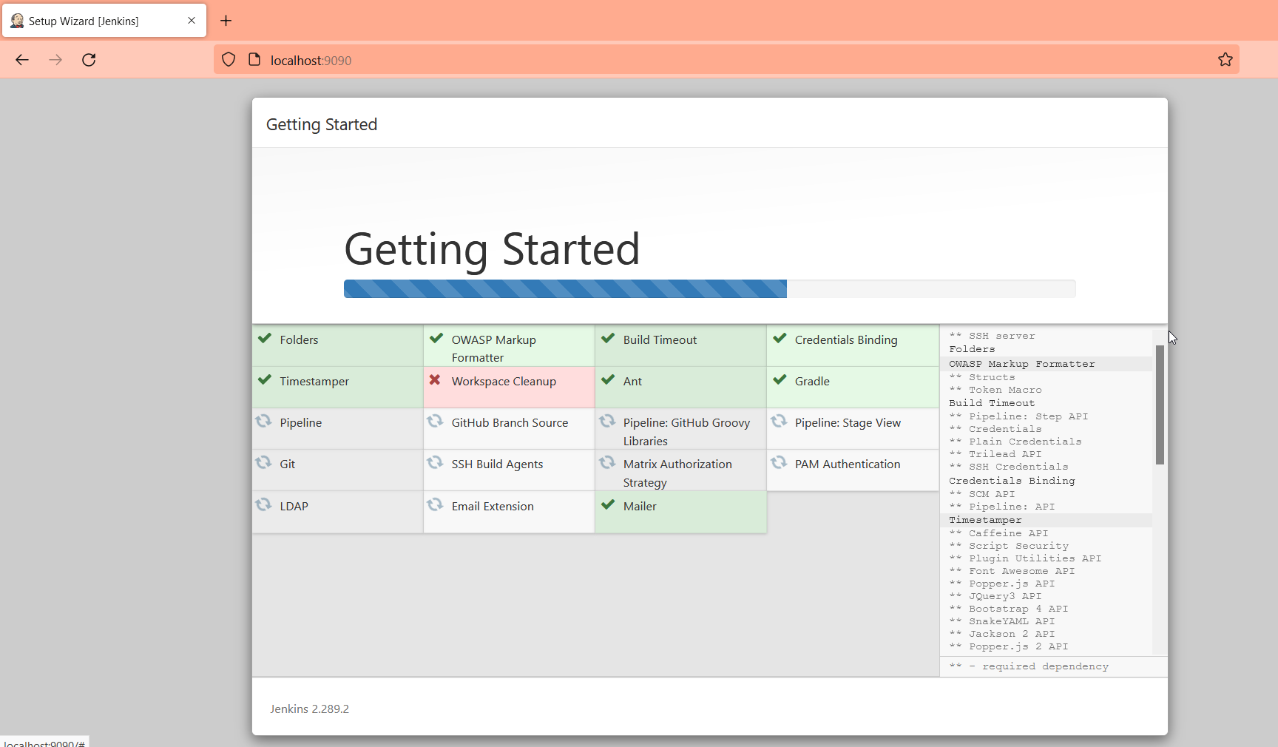

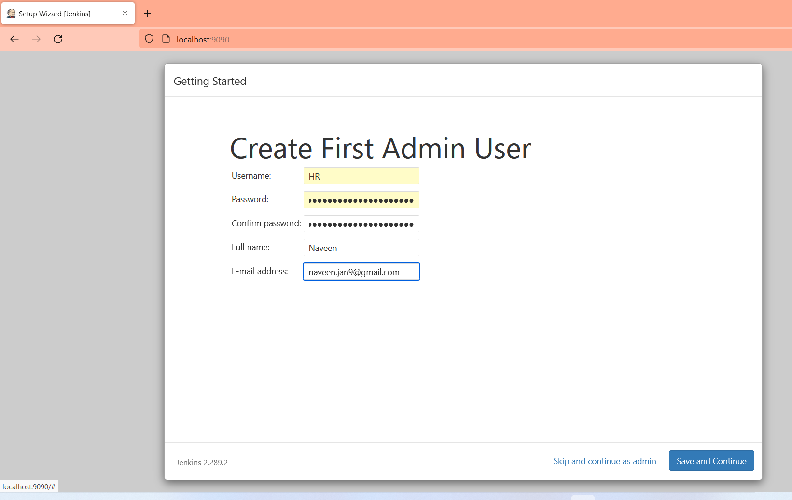

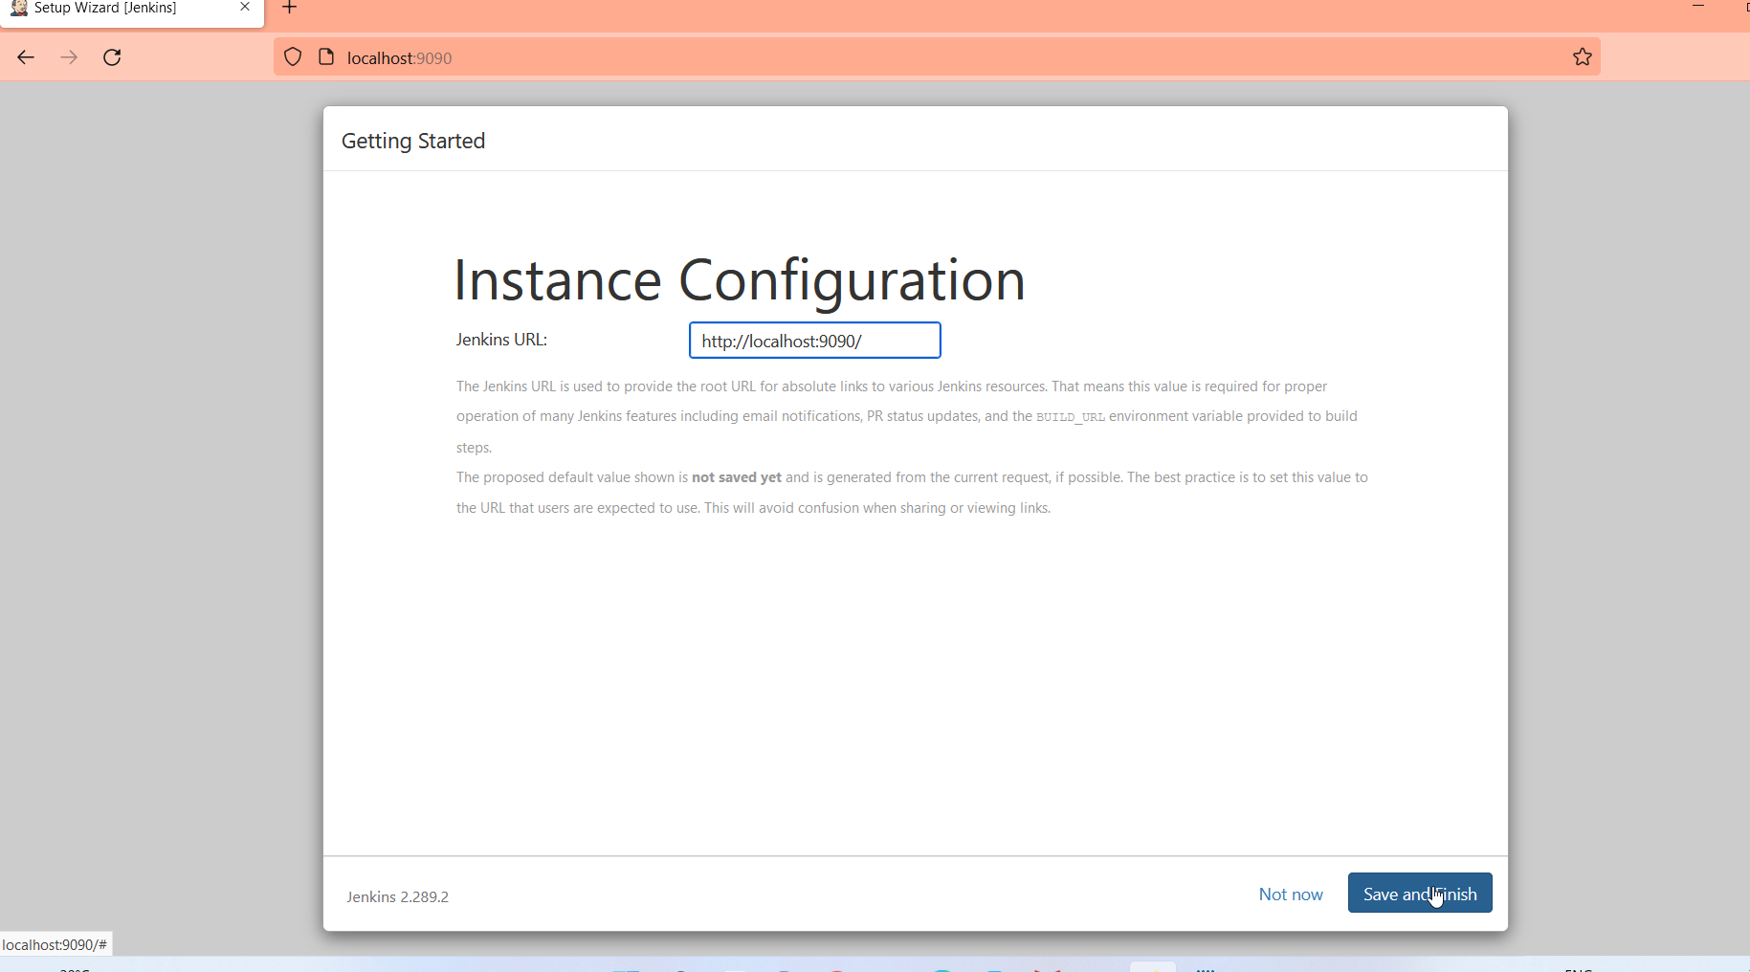

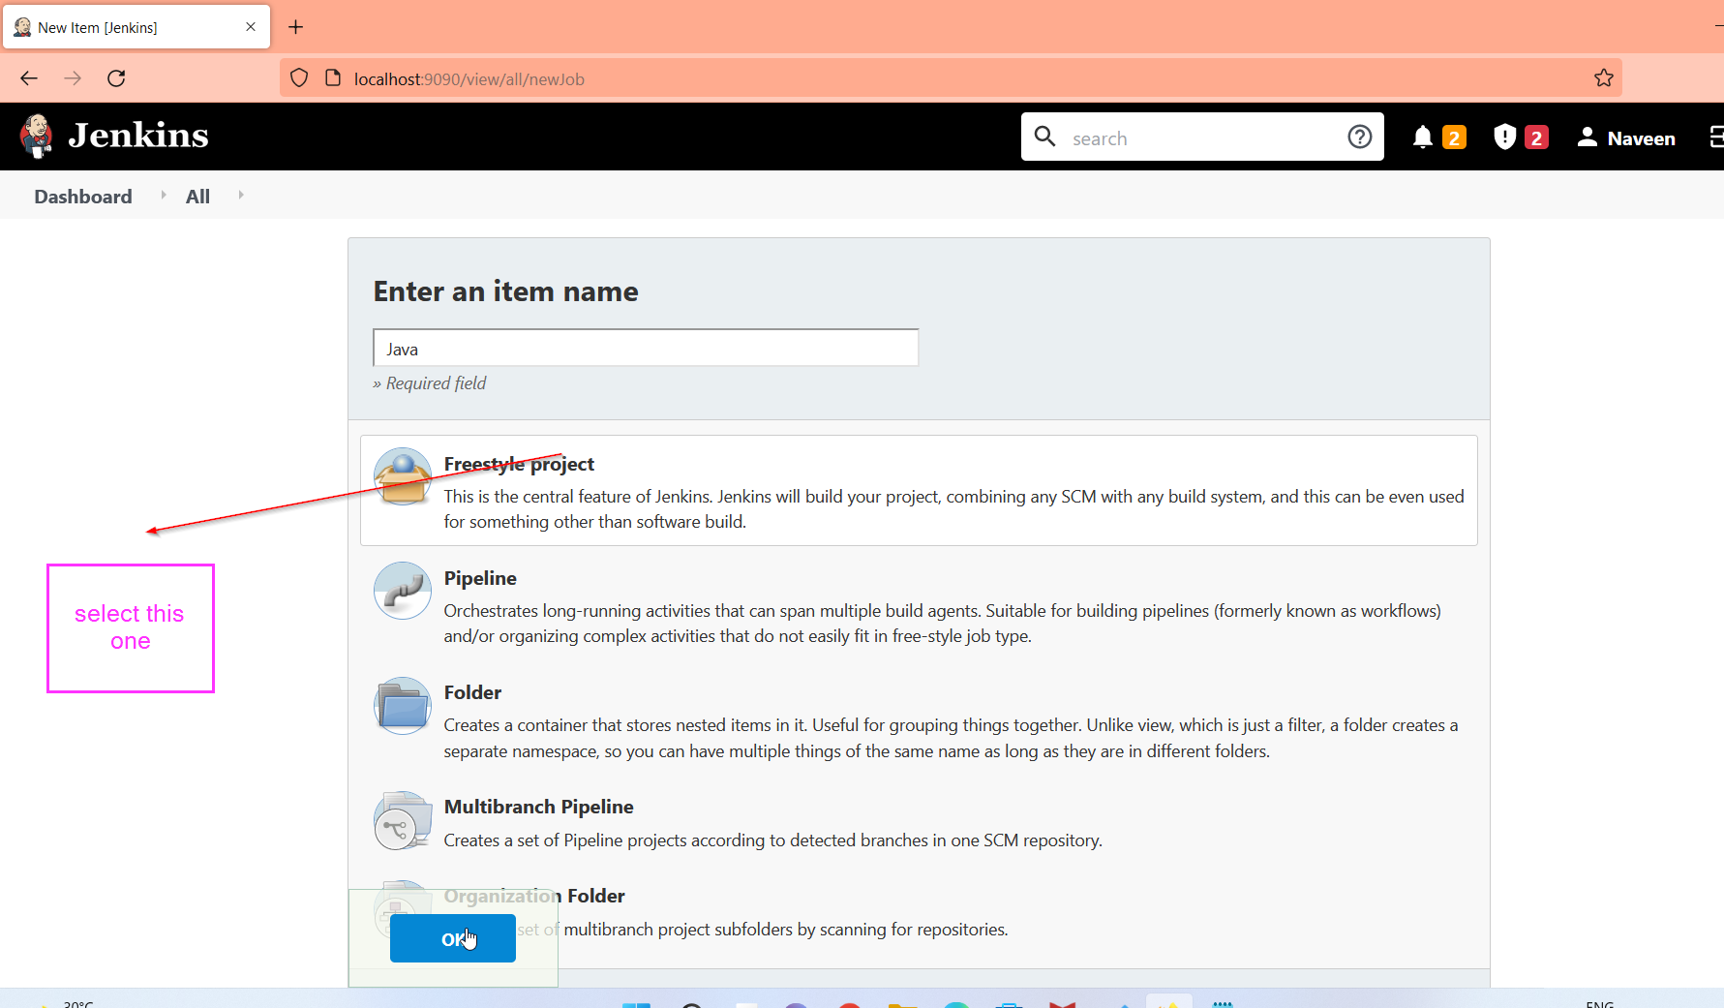

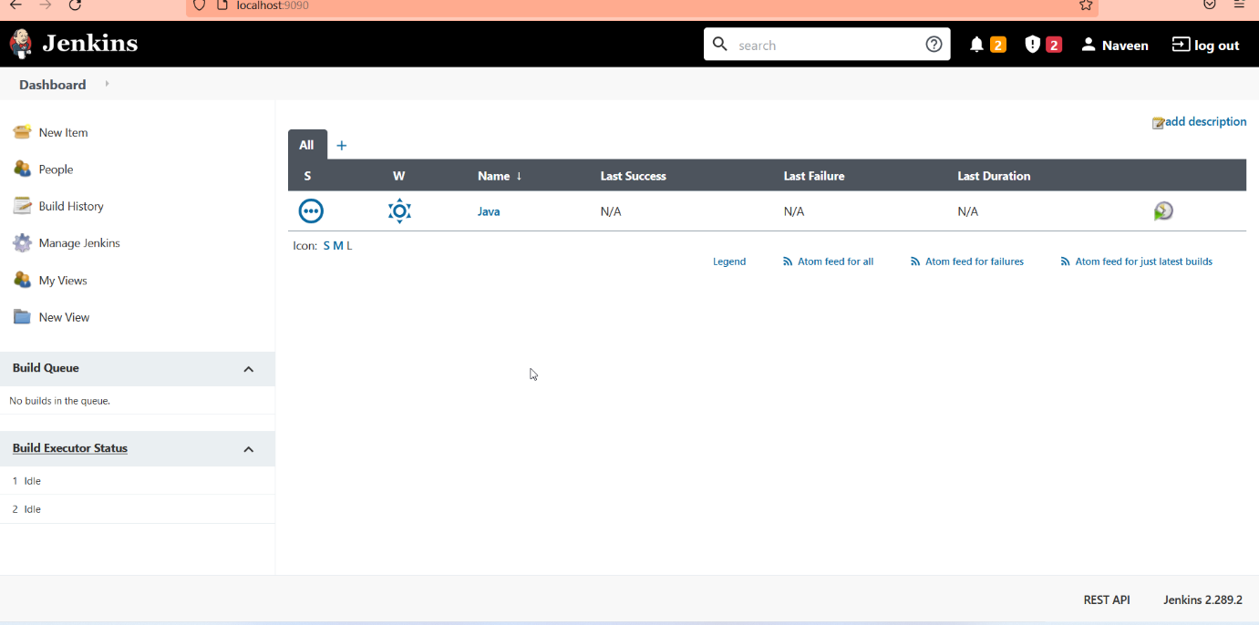

============================================================================]=======

SQL INSTALLATION PROCEDURE:

DATE:23-03-2022

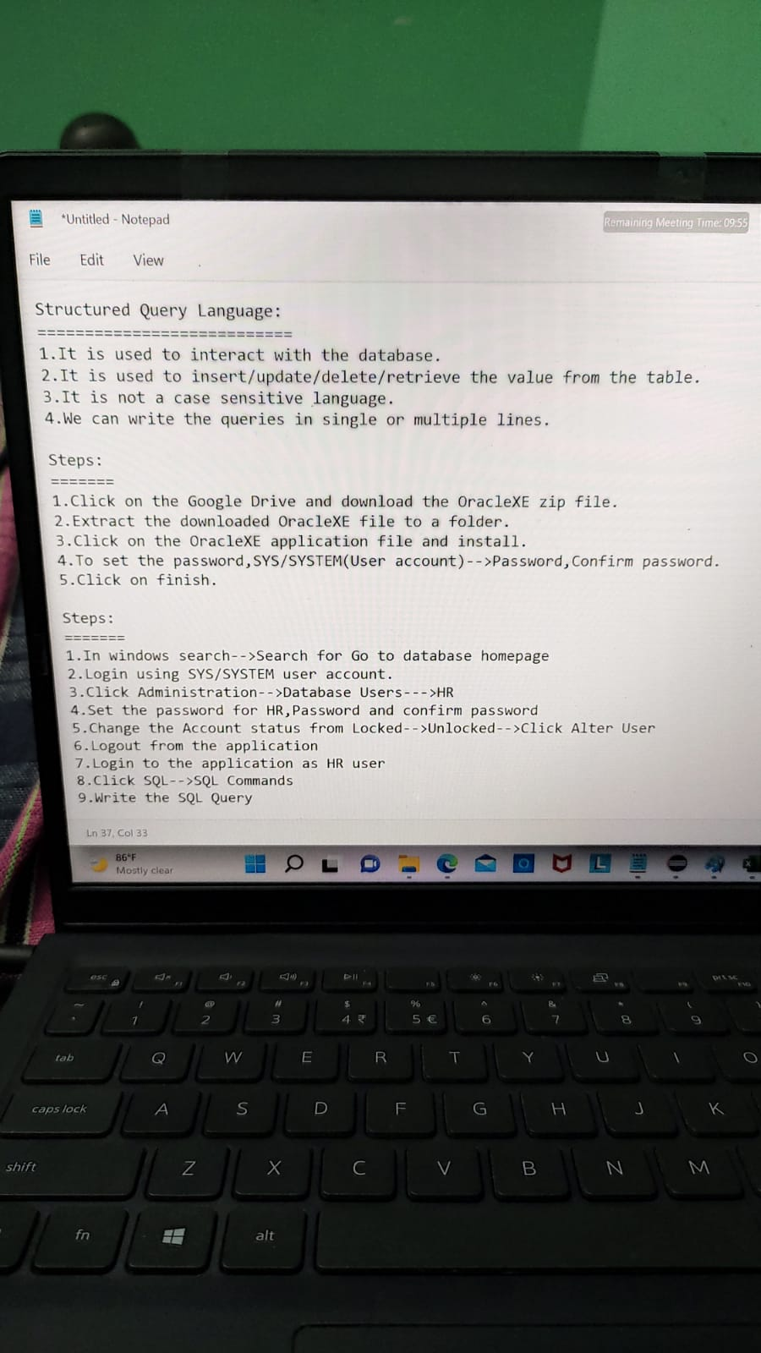

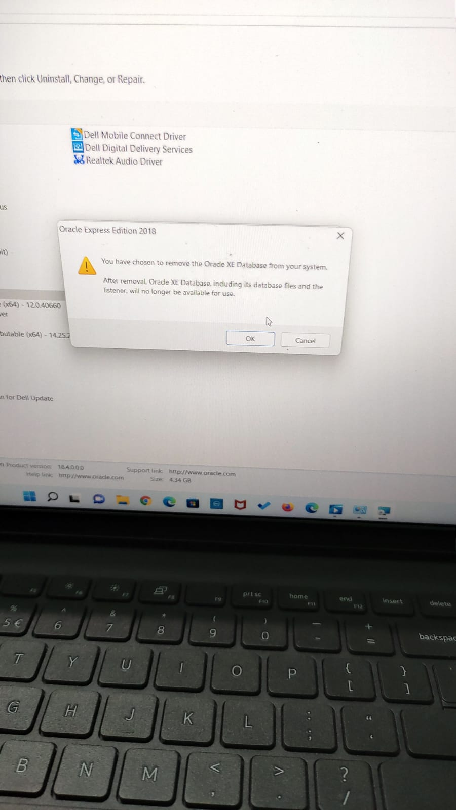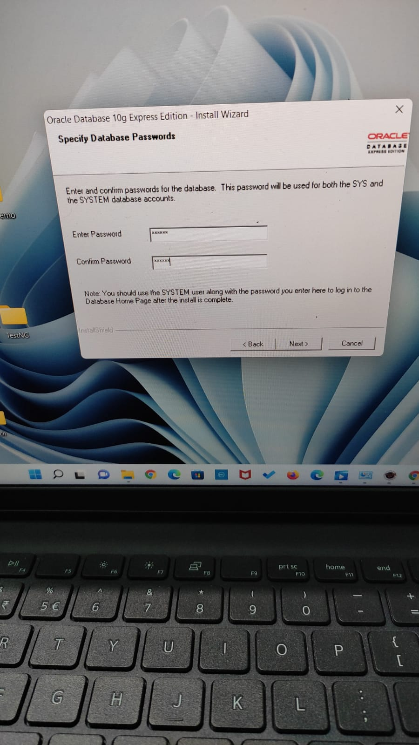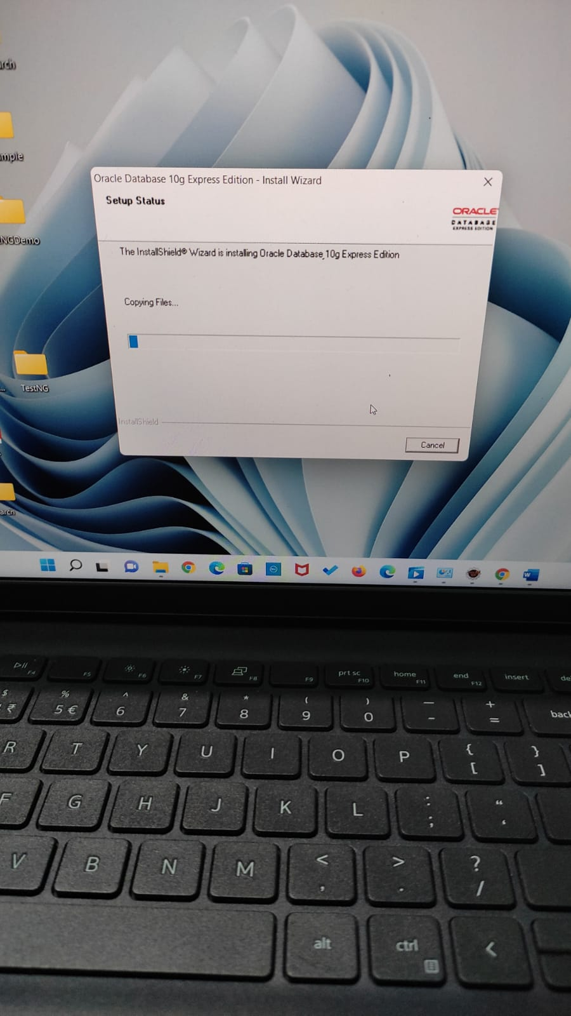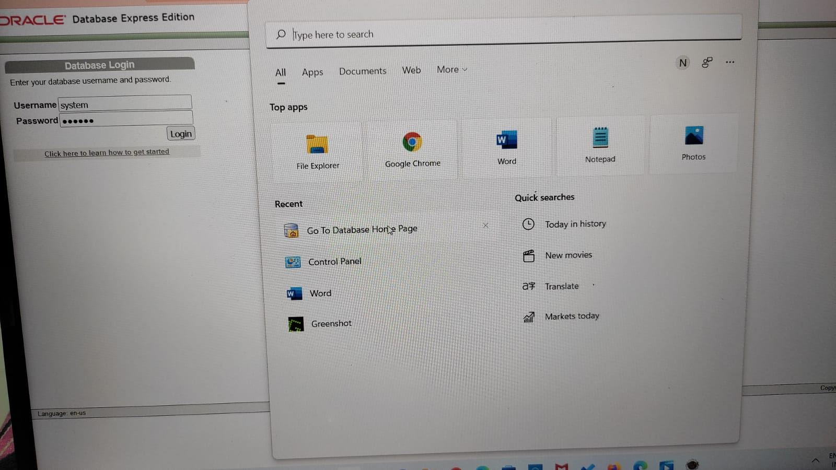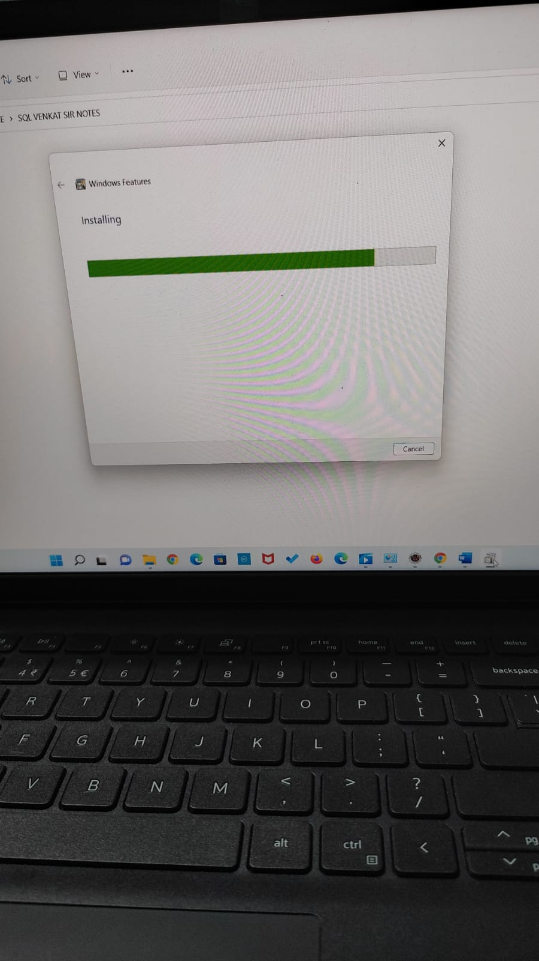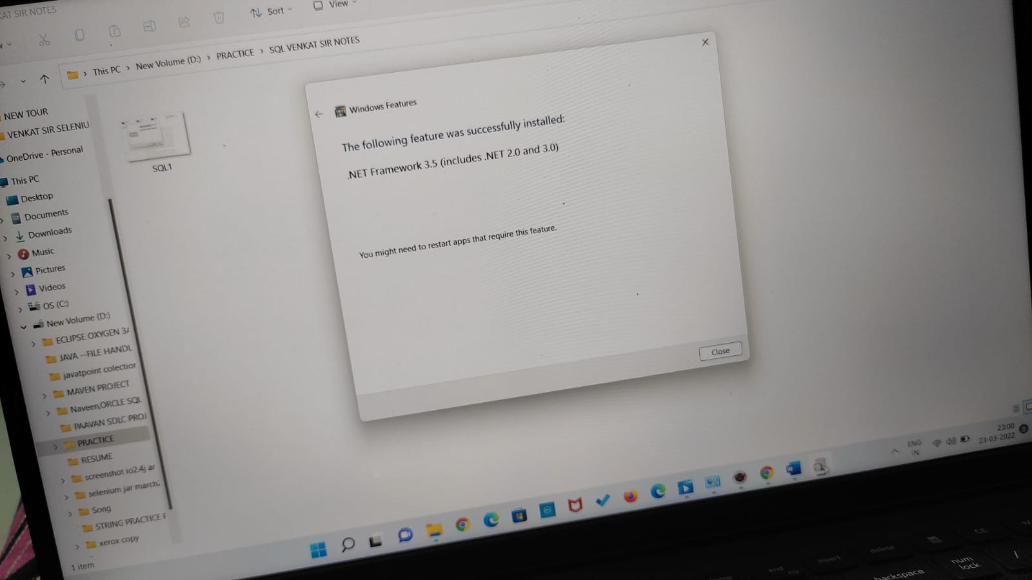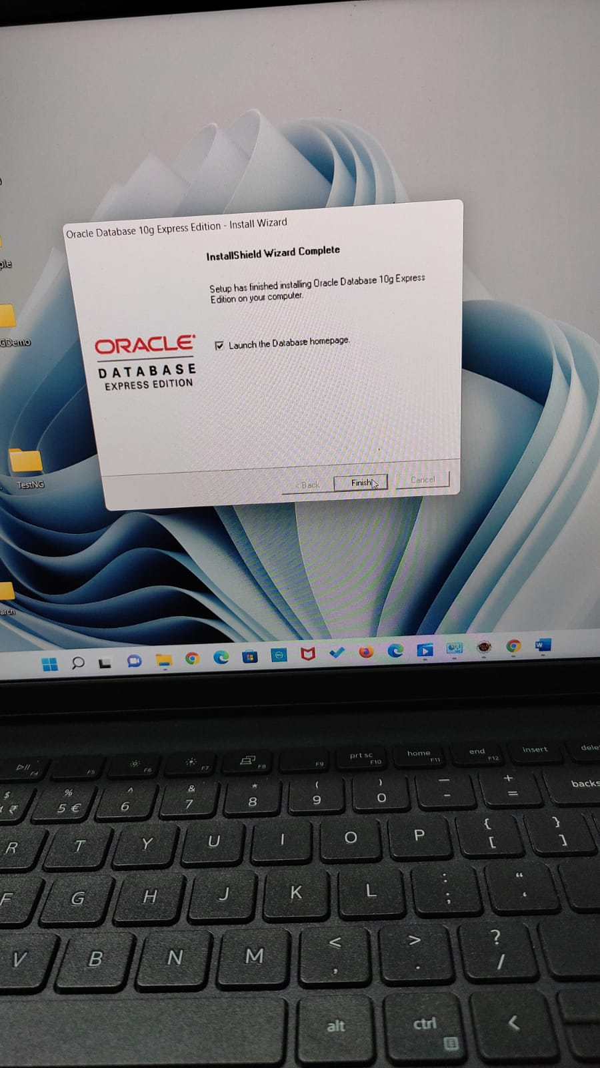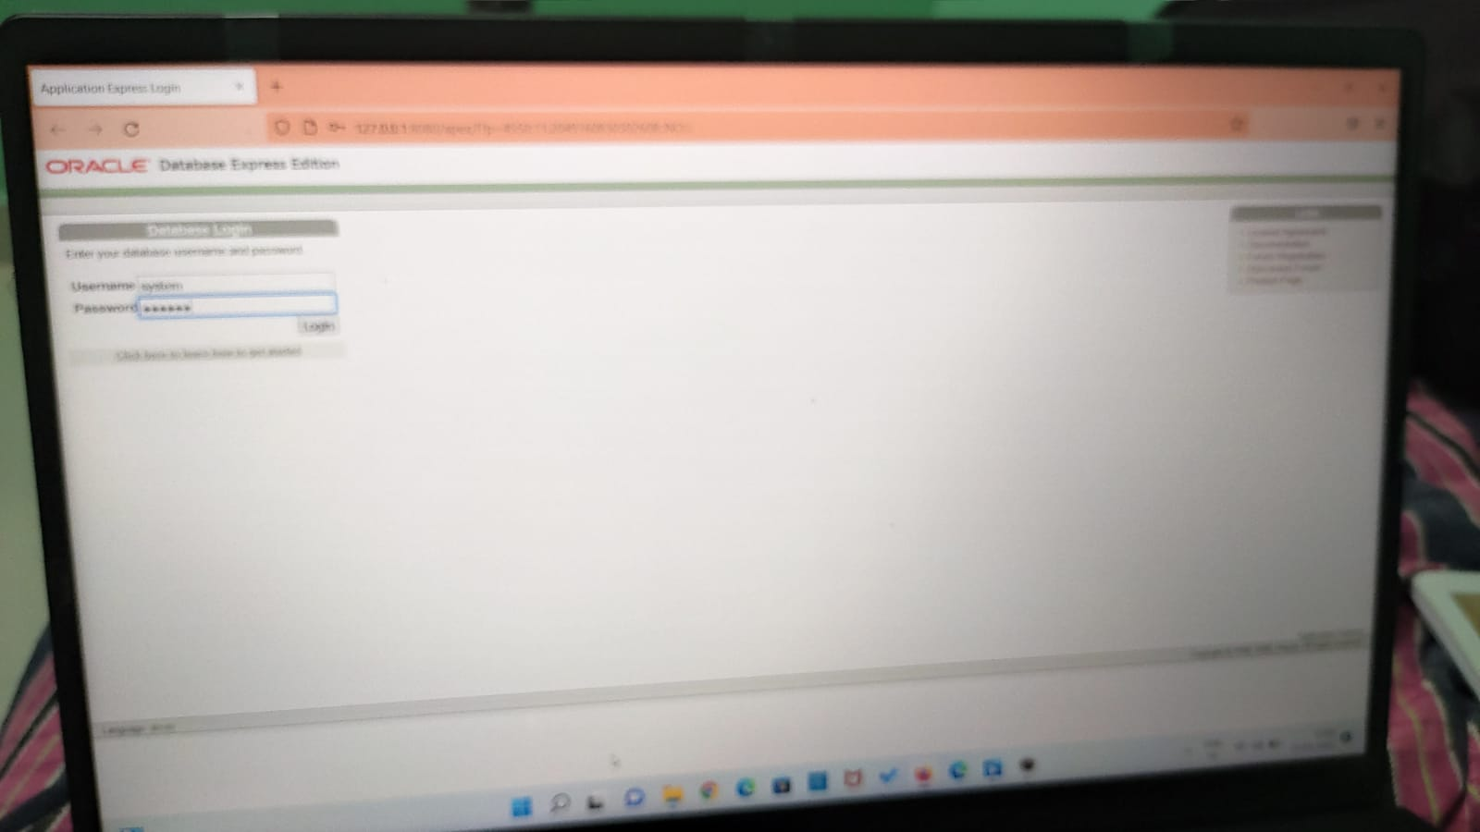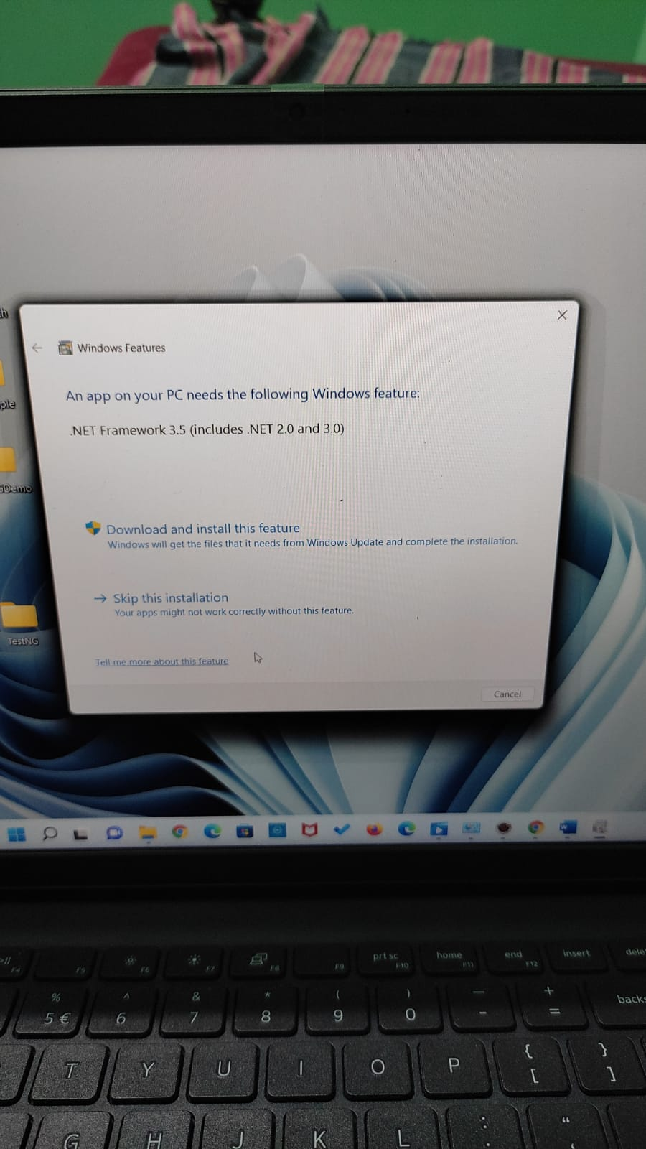

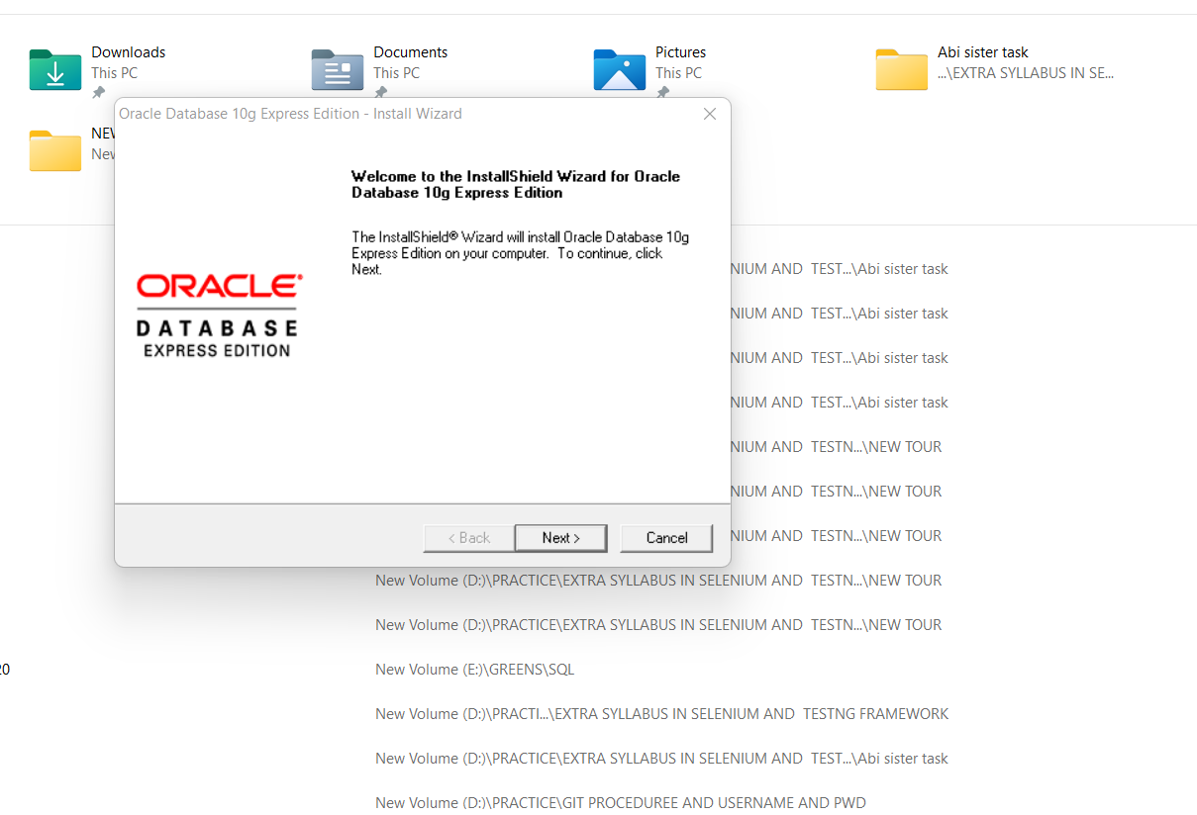

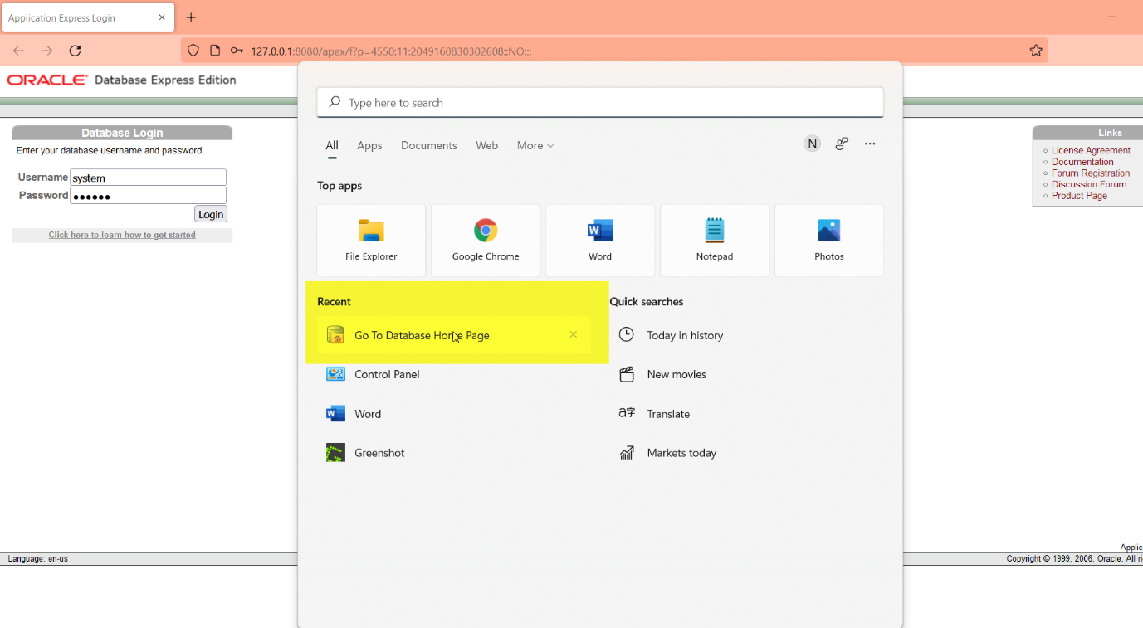

Initial set : Usename:system,password:system [For temporary only]

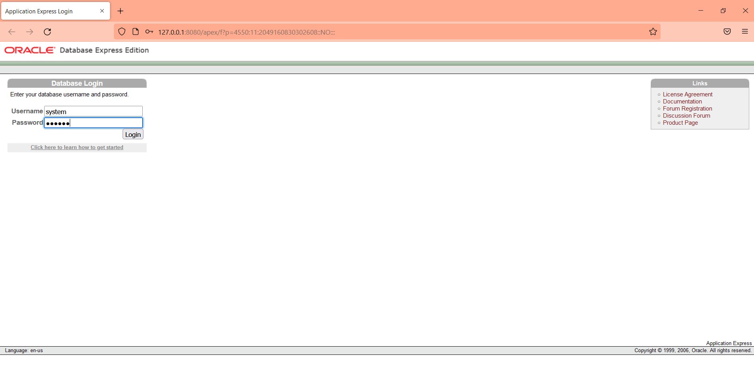

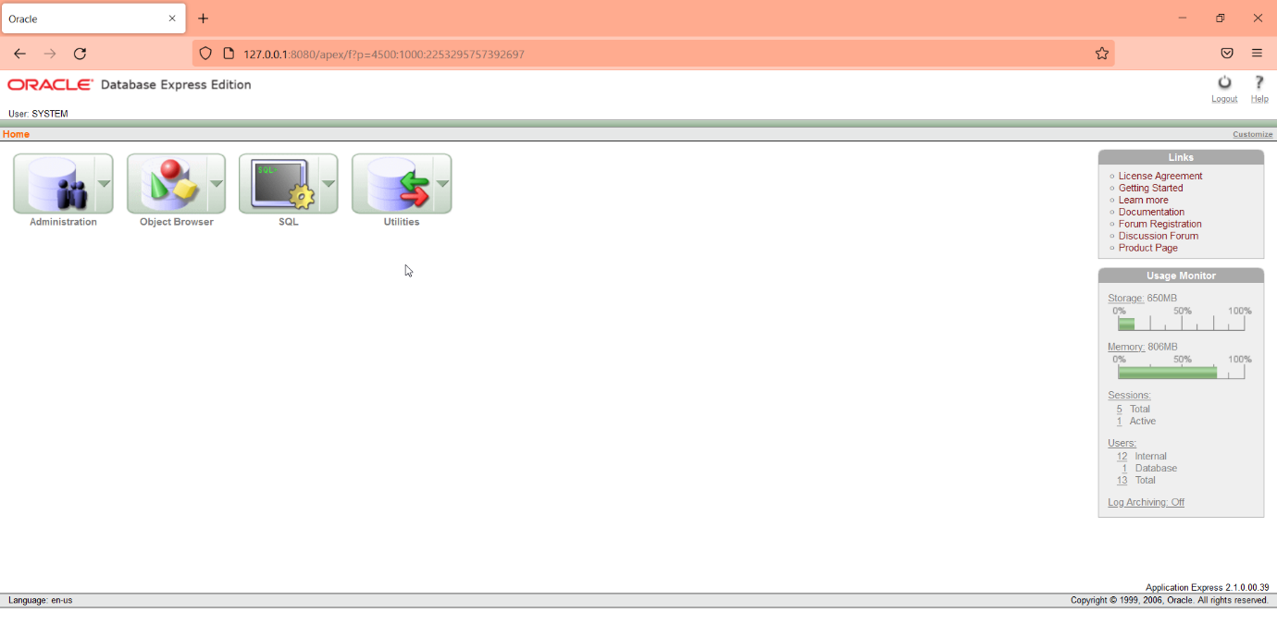

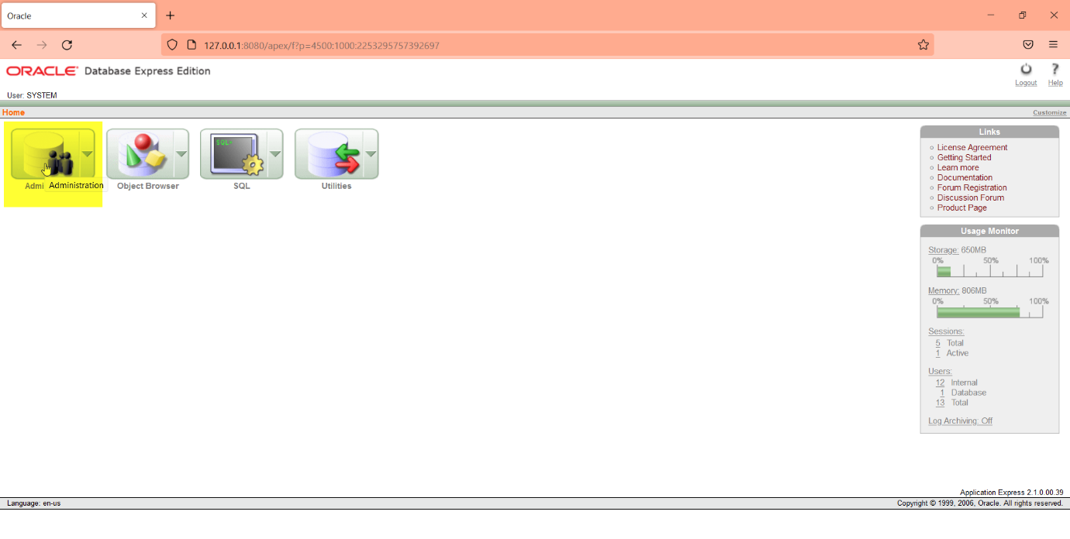

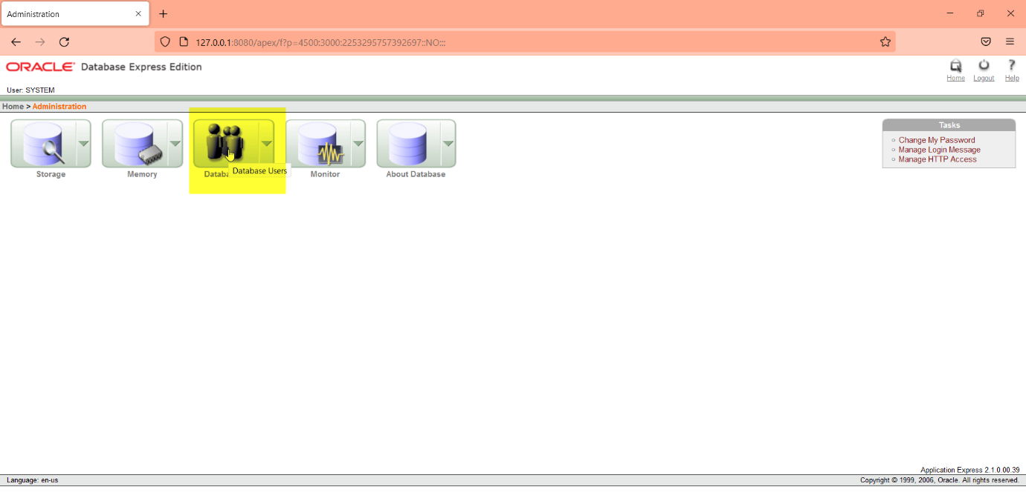

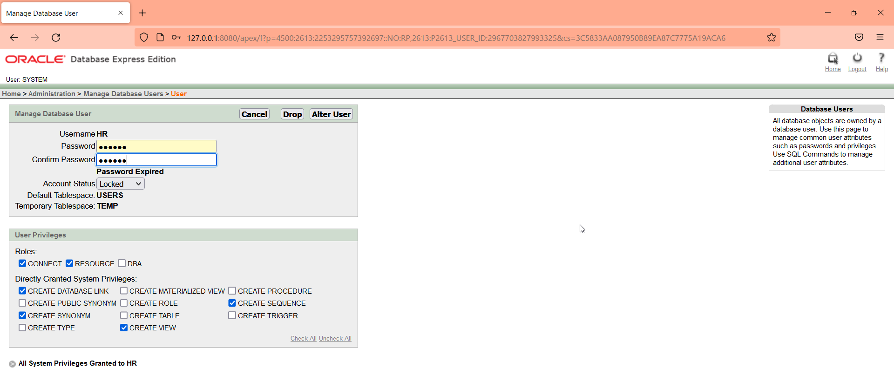

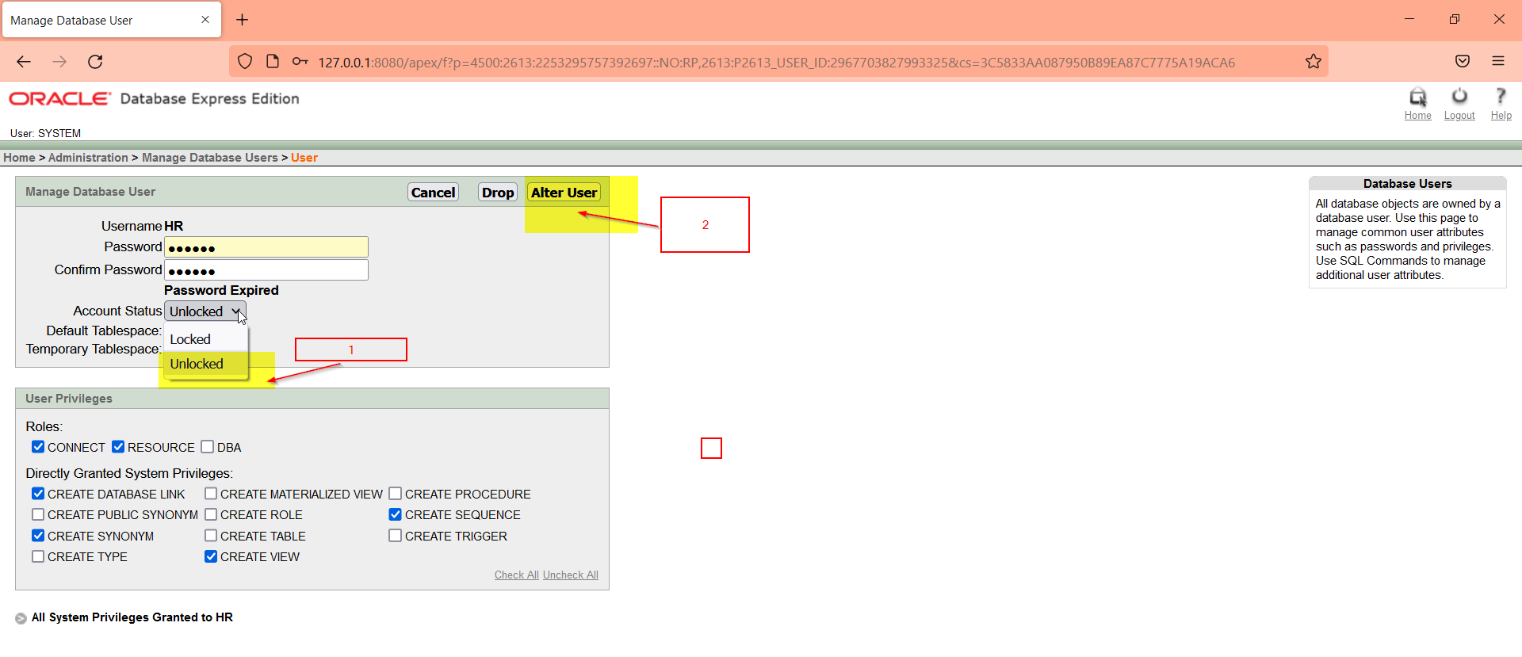

Password:system



